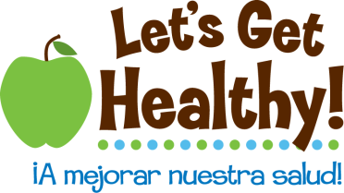

**Your Baby’s Genome, Epigenome and More Oh My!**

**Overview of Lesson Plan:** This lesson begins with the Desert Vista High School Genotype to Phenotype Simulation Booklet that can be downloaded at:

<http://www.dvbiology.org/biologyweb/genetics_activity_making_a_baby/make_a_baby_simulation_booklet>

Once the students have selected their baby’s genome they will add a layer of epigenetics onto their baby’s DNA and draw the resulting adult.

**Background**: The Epigenome is a layer of markers that are placed on, or taken off of, your DNA when you’re exposed to certain environmental factors. Your DNA is set at birth and does not change unless mutated but your Epigenome is more fluid and affects the way your DNA is expressed. (For more information, see Online Resources and Teacher References at the end of this lesson)

**Grades:** 6th – 8th grade

**Subjects:** Science, Health, Language Arts, Social Studies, Art

**Time Required:** 2 – 3 class periods

**Objective:** To learn how genes are passed down from parents to child; how genes determine traits, and how environmental factors affect the expression of the genome.

**Materials:**

**Download**

* Genotype to Phenotype Simulation Booklet from <http://www.dvbiology.org/biologyweb/genetics_activity_making_a_baby/Genetics_lab_New_Baby.htm>

**Lesson Worksheets**

* + Your Baby’s Genotype, Phenotype and More, Oh My! Table
  + Epigenetic Scenarios Sheet
  + Scenario Cards (print one-sided)
  + Your Baby’s Environment and Epigenome
  + Drawing of Adult

**Procedure:**

1. Students use **‘Genotype to Phenotype Simulation Booklet’** from Desert Vista High School site to create their baby’s genome.
2. (Optional) Each student fills in the **‘Your Baby’s Genotype, Phenotype and More, Oh My!’ table** and calculates the probability of each genotype and phenotype. It can also be used as a table to draw all of the baby’s individual phenotypes in order to facilitate the final drawing of the baby.
3. In groups, students read the **Epigenetic Scenario sheet** and underline the environmental factors that caused the child’s epigenetic result.
4. Cut the **Scenario Cards** along the solid lines and fold them along the dotted line. Drop each card 3 times and record the number of times each card fell on the Negative scenario in the **‘Your Baby’s Environment and Epigenome’** . Complete the chart by circling the resulting epigenetic result.
5. Each student draws their baby’s adult body based on what they have learned about its genetics and epigenetics. Organs and body shape should be included in order to show the epigenetics effects.

**Reflection (optional):** Student can write a biography of their child’s life and how it was impacted by genetics, lifestyle choices and other environmental factors.

Your Baby’s Genotype, Phenotype and More, Oh My!

|  |  |  |  |  |  |  |
| --- | --- | --- | --- | --- | --- | --- |
| Trait | Punnett Square | Genotype of Baby | Probability (in%) of Genotype | Phenotype of Baby | | Probability (in%) of Phenotype |
| Face Shape | |  |  |  | | --- | --- | --- | |  |  |  | |  |  |  | |  |  |  | |  | 25 50 75 100 |  | 25 50 75 100 | |
| Chin Prominence | |  |  |  | | --- | --- | --- | |  |  |  | |  |  |  | |  |  |  | |  | 25 50 75 100 |  | 25 50 75 100 | |
| Chin Shape | |  |  |  | | --- | --- | --- | |  |  |  | |  |  |  | |  |  |  | |  | 25 50 75 100 |  | 25 50 75 100 | |
| Cleft Chin | |  |  |  | | --- | --- | --- | |  |  |  | |  |  |  | |  |  |  | |  | 25 50 75 100 |  | 25 50 75 100 | |
| Skin Color | |  |  |  | | --- | --- | --- | |  |  |  | |  |  |  | |  |  |  | |  |  |  |  | |
| Hair Color | |  |  |  | | --- | --- | --- | |  |  |  | |  |  |  | |  |  |  | |  |  |  |  | |
| Eye color | |  |  |  | | --- | --- | --- | |  |  |  | |  |  |  | |  |  |  | |  |  |  |  | |
| Red Hair | |  |  |  | | --- | --- | --- | |  |  |  | |  |  |  | |  |  |  | |  | 25 50 75 100 |  | 25 50 75 100 | |
| Hair Type | |  |  |  | | --- | --- | --- | |  |  |  | |  |  |  | |  |  |  | |  | 25 50 75 100 |  | 25 50 75 100 | |
| Widow’s Peak | |  |  |  | | --- | --- | --- | |  |  |  | |  |  |  | |  |  |  | |  | 25 50 75 100 |  | 25 50 75 100 | |
| Eyebrow Thickness | |  |  |  | | --- | --- | --- | |  |  |  | |  |  |  | |  |  |  | |  | 25 50 75 100 |  | 25 50 75 100 | |
| Eyebrow Placement | |  |  |  | | --- | --- | --- | |  |  |  | |  |  |  | |  |  |  | |  | 25 50 75 100 |  | 25 50 75 100 | |

|  |  |  |  |  |  |
| --- | --- | --- | --- | --- | --- |
| Trait | Punnett Square | Genotype of Baby | Probability (in%) of Genotype | Phenotype of Baby | Probability (in%) of Phenotype |
| Eye Distance | |  |  |  | | --- | --- | --- | |  |  |  | |  |  |  | |  |  |  | |  | 25 50 75 100 |  | 25 50 75 100 |
| Eye Size | |  |  |  | | --- | --- | --- | |  |  |  | |  |  |  | |  |  |  | |  | 25 50 75 100 |  | 25 50 75 100 |
| Eye Shape | |  |  |  | | --- | --- | --- | |  |  |  | |  |  |  | |  |  |  | |  | 25 50 75 100 |  | 25 50 75 100 |
| Eyelashes | |  |  |  | | --- | --- | --- | |  |  |  | |  |  |  | |  |  |  | |  | 25 50 75 100 |  | 25 50 75 100 |
| Mouth Size | |  |  |  | | --- | --- | --- | |  |  |  | |  |  |  | |  |  |  | |  | 25 50 75 100 |  | 25 50 75 100 |
| Lips: Thickness | |  |  |  | | --- | --- | --- | |  |  |  | |  |  |  | |  |  |  | |  | 25 50 75 100 |  | 25 50 75 100 |
| Dimples | |  |  |  | | --- | --- | --- | |  |  |  | |  |  |  | |  |  |  | |  | 25 50 75 100 |  | 25 50 75 100 |
| Nose Size | |  |  |  | | --- | --- | --- | |  |  |  | |  |  |  | |  |  |  | |  | 25 50 75 100 |  | 25 50 75 100 |
| Earlobe Attachment | |  |  |  | | --- | --- | --- | |  |  |  | |  |  |  | |  |  |  | |  | 25 50 75 100 |  | 25 50 75 100 |
| Hairy Ears | |  |  |  | | --- | --- | --- | |  |  |  | |  |  |  | |  |  |  | |  | 25 50 75 100 |  | 25 50 75 100 |
| Freckles Cheeks | |  |  |  | | --- | --- | --- | |  |  |  | |  |  |  | |  |  |  | |  | 25 50 75 100 |  | 25 50 75 100 |
| Freckles Forehead | |  |  |  | | --- | --- | --- | |  |  |  | |  |  |  | |  |  |  | |  | 25 50 75 100 |  | 25 50 75 100 |

Epigenetic Scenarios

* *Directions: As you read the following scenarios, underline the environmental factors and lifestyle choices that led to the epigenetic results.*

**Mom’s Pregnancy**

* **Mom’s Pregnancy Diet**
* Whole Food:

While the child’s mom is pregnant, she takes on a whole food diet and is off the charts in healthiness. Her meals include: loads of fruits and veggies, whole grains, nonfat milk, lean proteins, foods low in sodium, seafood, and very few solid fats. During the day she drinks close to 64 fluid ounces of water. Result: the baby is born normal sized and with healthy organs.

Junk Food/Starvation:

While the child’s mom is pregnant, she decides to throw all caution to the wind and eats whatever and whenever she wants. Ordering a large pizza, with all the toppings, in the middle of night and consuming it all by herself, all at one time, becomes the norm. That little snack is often followed by a pint of Ben and Jerry’s, while watching Dr. Oz, in order to drown her sorrows. Result: the baby is born underweight with small organ and diabetes, but then becomes obese in childhood.

**Mom’s Stress During Pregnancy**

Win the Lottery:

Every day on the way to work, the child’s mom stops in at the corner market. She would pet the resident dog, grab a healthy sandwich for lunch, buy her two lottery tickets, and chat with the owner. And then on the day of each lottery drawing, her and her husband would listen diligently to the reading of each number. “Maybe today”, they would whisper to each other. Miraculously that day came. After checking and rechecking, and rechecking again, they discovered that their bank account balance was about to have a few extra zeroes at the end. Suddenly, all financial worries of having a baby disappeared. Result: stress free pregnancy = healthy baby.

Job Loss:

While the child’s mom is pregnant, she’s a waitress at a local diner. She’s a hard worker and well-liked by her customers. Unfortunately, much of her earnings relies on tips – which sometimes are few and far between. So when her husband is laid off from his job of over ten years due to downsizing, the stress begins. Month after month they are late on their rent, and every last penny is spent on food. She spends her days worried and anxious about the future. Result: baby is born underweight with malformed organs.

**Child’s Life Choices and Environment**

**Nutrition**

Whole Food:

Early on, the child learns the importance of eating healthy whole foods. Meals for an average day often look like the following: breakfast - whole grain cereal with skim milk; lunch - grilled chicken, carrots, and an apple; dinner - vegetable stir fry with brown rice; and dessert - a slice of watermelon. Result: child maintains a healthy weight.

Junk Food:

Each and every day the child follows a very unhealthy eating routine. Breakfast is skipped in order to have time for the lengthy hair routine; lunch is a slice of cheese pizza, tater tots, and a bag of M&M’s; dinner is whatever microwave meal is in the freezer; and dessert, eaten while doing homework, is a handful of Oreo cookies. Result: child is malnourished and has diabetes.

**Smoking**

Non-smoking Parents:

Neither of the child’s parents smokes. In fact, they are very concerned about second hand smoke and so make an effort to keep their child away from smokers in public areas. Result: a healthy child with low vulnerability to developing asthma.

Parent smokes:

The child’s father started smoking in high school and continues throughout adulthood. What started as a few cigarettes a day develops into a three pack a day habit. He smokes all through the house and in the car, even on cold days when all the windows are rolled up. Everything smells of smoke – clothes, furniture, and even the food. Result: the child’s lifespan is shorter than average.

**Air Quality**

Country:

After college, the child moves to small town way out in the country – hundreds of miles from the nearest big city. Everything is close together, so everyone is able to bike or walk to everything. A vehicle of any sort on the road is as rare as a summer snowstorm. The air is fresh and the sky is clear. Result: the child has healthy lungs and is cancer free.

City:

After college, the child moves to one of the most polluted cities in the world – Mexico City. Pollutants are everywhere and from seemingly everything – cars, trucks, trains, buses, mopeds, planes, factories, and fires. While the job is good and the lifestyle fun, the child (now a young adult) one day finds that it is hard to breathe and visits a doctor. Result: the child develops lung cancer.

**Sleep**

Regular Work Schedule:

Each morning the child, now an adult, wakes up to the rising of the sun and the singing of the birds. An alarm clock goes off but the child’s circadian rhythm does a much better job of announcing the morning. After an eight-hour day, the child returns home and is in bed by a reasonable time to get at least eight hours of sleep. Result: healthy.

Shift Work:

Every evening the child, now an adult, walks through the busy hallways of the local hospital to the pediatric wing to begin a twelve-hour shift as a pediatric nurse. Children are there due to fevers, food poisoning, stomachaches, and unknown illnesses. It is a hard but extremely rewarding job. Then, in the light of the following day, the child goes home to a darkened bedroom and tries to sleep. Result: due to a sleep schedule that is the opposite of human circadian rhythms the child develops breast cancer.

**Exercise**

Athlete:

As an adult, every morning the child wakes up, stretches, and goes for a jog. This is followed by a mellow bike ride to work. Weekends are reserved for long hikes with the dog or a game of tennis with friends. Throughout the child’s life, regular exercise is a part of the routine. Result: healthy.

Couch Potato:

As an adult, the child has an office job that consists of sitting at a desk and working on a computer for hour after hour. After a long day, the child is too tired to exercise and so likes to go home, open a family size bag of chips and a few cans of Coke, and watch TV. First is all the entertainment news shows, then a few sitcoms, followed by a police crime show, and finally a late night talk show. Five hours later the child switches to playing video games and then climbs exhausted into bed at 2 a.m. Result: heart disease and depression.

**Chronic Stress**

Works at Disneyland:Anytime an athlete wins a major sports event on TV, he or she lets the audience know about the plan to go to Disneyland. The child also decides to go to Disneyland, the happiest place on Earth, but to find a job. There the child wears a different Disney character outfit each day, sings and dances in the daily shows, marches in the parade, and interacts with happy families filled with giggling children. Every day is a joy. Result: healthy.

Air-Traffic Controller:

Hour after hour, day after day, the child watches the computer screen filled with dots and codes of numbers and letters. As an air traffic controller, the child is responsible for navigating planes through air space and making split-second decisions to avoid midair collisions. It is a mentally challenging job and incredibly stressful. Result: obesity, malnutrition, and hair loss.

SENARIO CARDS

Cut along solid lines and fold along dashed lines to make your scenario cards. This page must be printed 1-sided



Cut along solid lines and fold along dashed lines to make your scenario cards. This page must be printed 1-sided



Your Baby’s Environment and Epigenome*

***Drop each Scenario Card 3 times and circle the number of times it landed***

***on the negative-side. Circle the child’s epigenetic result.***

|  |  |  |  |
| --- | --- | --- | --- |
| **Environmental Factor** | # of **(-)** Results out of 3 Drops | **Lifestyle** | **Child’s Epigenetic Result** |
| **Mom’s Diet During Pregnancy** | 0 - 1 | Whole Food | Healthy |
| 2 |  | At Risk |
| 3 | Junk Food/Starvation | Obesity  Small Organs |
| **Mom’s Stress During** **Pregnancy** | 0 - 1 | Win the Lottery | Healthy |
| 2 |  | At Risk |
| 3 | Husband’s Job Loss | Malformed and Inefficient Organs |
| **Nutrition** | 0 - 1 | Whole Food | Healthy |
| 2 |  | At Risk |
| 3 | Junk Food | Obesity |
| **Smoking** | 0 - 1 | Non-smoking Parents | Healthy |
| 2 |  | At Risk |
| 3 | Parent Smokes | Asthma |
| **Air Pollution** | 0 - 1 | Country | Healthy |
| 2 |  | At Risk |
| 3 | City | Cancer |
| **Sleep** | 0 - 1 | Regular Schedule | Healthy |
| 2 |  | At Risk |
| 3 | Shift Work | Breast Cancer |
| **Exercise** | 0 - 1 | Athlete | Healthy |
| 2 |  | At Risk |
| 3 | Couch Potato | Heart Disease  Depression |
| **Chronic Stress** | 0 - 1 | Works at Disneyland | Healthy |
| 2 |  | At Risk |
| 3 | Air-Traffic Controller | Heart Disease  Hair Loss |

Child in Adulthood

Your child’s name ____________________

*Draw your child’s organs, body shape, and face below taking into account the epigenetics they have acquired over a lifetime. For instance if they have become obese be sure to add the weight to the body outlined below and if they have smaller organs or cancer be sure to show the effects inside the body.*

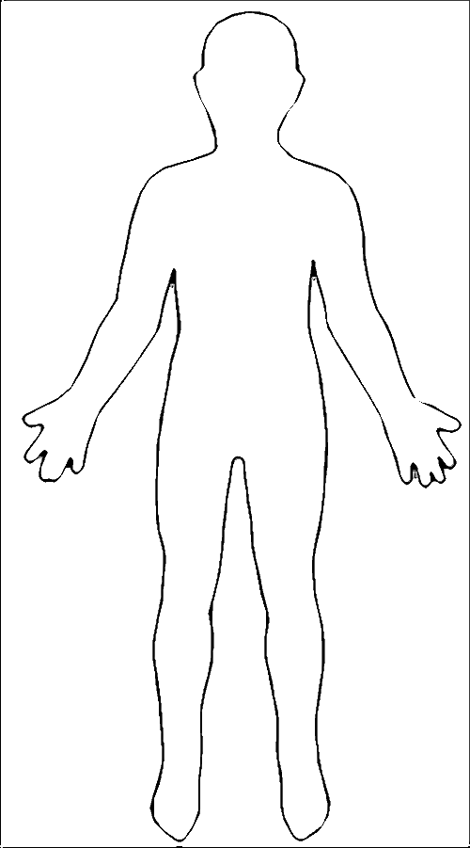

[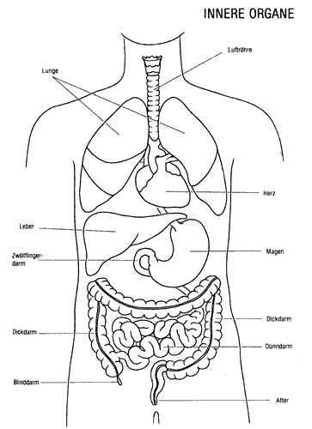](http://www.google.com/url?sa=i&rct=j&q=&esrc=s&frm=1&source=images&cd=&cad=rja&docid=5iX7nMrpyrMc4M&tbnid=uMPQFJjI2U4oUM:&ved=0CAUQjRw&url=http://www.wisarts.com/design/anatomy.html&ei=hi_NUcDbB8SSiALb-4GgCw&bvm=bv.48572450,d.cGE&psig=AFQjCNEvIMnHzqu_8fm5bCg4t5pBvaibyg&ust=1372487918257340)Drawing Aids

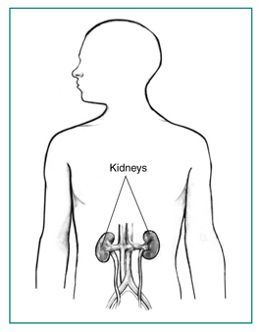

[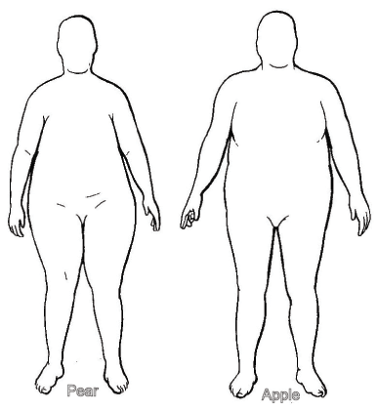](http://www.google.com/url?sa=i&rct=j&q=&esrc=s&frm=1&source=images&cd=&cad=rja&docid=d-jR9dz9PmVFhM&tbnid=Qn70kkgQc0SMuM:&ved=0CAUQjRw&url=http://www.natural-weight-loss-myths-revealed.com/body-measurements.html&ei=6jDNUZ73LoKTiAL0mYGwAw&psig=AFQjCNF_EcQ2J2aHVV7kBGE-DdmI-OlJlQ&ust=1372488189821546)

|  |  |
| --- | --- |
| **Environmental Factor** | **Reference for Child’s Epigenetic Result** |
| **Mom’s Diet During Pregnancy** | Developmental Origins of Disease [http://ohsu.dev.gravitatedesign.com/wp-content/uploads/2013/06/FetalOriginsofDisease_Thornburg.docx](https://legacy.ohsu.edu/owa/redir.aspx?C=_uBrRkCOwEyHErxzubdKW6MEMGK-R9BI1vkIFNazAChqRcuiJs98NCY1wSnzTWD5iaC3g-oz3Ig.&URL=http%3a%2f%2fohsu.dev.gravitatedesign.com%2fwp-content%2fuploads%2f2013%2f06%2fFetalOriginsofDisease_Thornburg.docx) (note: link will change to lgh.ohsu.edu and can be found under “Healthy Choices for Schools” lesson)  “Fetal Origins Of Disease Talk”- Kent Thornburg OHSU Professor of Medicine PhD  Susan Bagby –OHSU Professor of Medicine MD  Nutrition, Diet and Agouti Mice: <http://learn.genetics.utah.edu/content/epigenetics/nutrition/> |
| **Mom’s Stress During** **Pregnancy** | Developmental Origins of Disease [http://ohsu.dev.gravitatedesign.com/wp-content/uploads/2013/06/FetalOriginsofDisease_Thornburg.docx](https://legacy.ohsu.edu/owa/redir.aspx?C=_uBrRkCOwEyHErxzubdKW6MEMGK-R9BI1vkIFNazAChqRcuiJs98NCY1wSnzTWD5iaC3g-oz3Ig.&URL=http%3a%2f%2fohsu.dev.gravitatedesign.com%2fwp-content%2fuploads%2f2013%2f06%2fFetalOriginsofDisease_Thornburg.docx) (note: link will change to lgh.ohsu.edu and can be found under “Healthy Choices for Schools” lesson)  “Fetal Origins Of Disease Talk”- Kent Thornburg OHSU Professor of Medicine PhD |
| **Nutrition** | “Fetal Origins Of Disease Talk”- Kent Thornburg OHSU Professor of Medicine PhD  Susan Bagby –OHSU Professor of Medicine MD  Nutrition Epigenetics: <http://learn.genetics.utah.edu/content/epigenetics/nutrition/> |
| **Smoking** | TED Talk  Epigenetics of cigarette smoking during pregnancy (Knopik et al, 2012) <http://www.ncbi.nlm.nih.gov/pubmed/23062304> |
| **Air Pollution** | Cancer – Catherine Klien  Environmental Epigenetics:  <http://learn.genetics.utah.edu/content/epigenetics/> |
| **Sleep** | Circadian epigenetics on breast cancer risk (Fu et al., 2012) <http://www.ncbi.nlm.nih.gov/pubmed/22006848>  Shiftwork and Epigenetics (Zhu et al., 2011) <http://www.ncbi.nlm.nih.gov/pubmed/22080730> |
| **Exercise** | Heart Disease (Lisa says ???)  Depression (Lisa says???  Exercise changing muscle function (Barres et al., 2012): [http://www.ncbi.nlm.nih.gov/pubmed/22405075?dopt=Abstract](https://legacy.ohsu.edu/owa/redir.aspx?C=_uBrRkCOwEyHErxzubdKW6MEMGK-R9BI1vkIFNazAChqRcuiJs98NCY1wSnzTWD5iaC3g-oz3Ig.&URL=http%3a%2f%2fwww.ncbi.nlm.nih.gov%2fpubmed%2f22405075%3fdopt%3dAbstract) |
| Chronic Stress | Heart Disease (PTSD study)  Hair Loss (Zhao et al., 2012)  [http://www.ncbi.nlm.nih.gov/pubmed/21936853](https://legacy.ohsu.edu/owa/redir.aspx?C=U2j759ZeOkquU_0RuPENKT_A95S8R9BIFlhhDMhtM_1Fr0BisHTv3uymN6C-NFF8rbYDuUqx8Y4.&URL=http%3a%2f%2fwww.ncbi.nlm.nih.gov%2fpubmed%2f21936853)  Biology of Hair Diversity (Westgate et al., 2013)  [http://www.ncbi.nlm.nih.gov/pubmed/23363384](https://legacy.ohsu.edu/owa/redir.aspx?C=U2j759ZeOkquU_0RuPENKT_A95S8R9BIFlhhDMhtM_1Fr0BisHTv3uymN6C-NFF8rbYDuUqx8Y4.&URL=http%3a%2f%2fwww.ncbi.nlm.nih.gov%2fpubmed%2f23363384) |

*References for Your Baby’s Environment and Epigenome

**Online Resources for Epigenetics**

|  |  |  |
| --- | --- | --- |
| **VIDEO Title** | **Source** | **Link** |
| *Epigenetics* | PBS - NOVA | <http://www.pbs.org/wgbh/nova/body/epigenetics.html> |
| *Epigenetics I and II* | PBS - NOVA (via youtube) | <http://www.youtube.com/watch?v=wFsxVkuChdU> (7:  <http://www.youtube.com/watch?v=Xjq5eEslJhw> (6:19) |
| *Epigenetics* | scishow (via Youtube) | <http://www.youtube.com/watch?v=kp1bZEUgqVI&feature=youtube_gdata_player> |
| *Epigenetics makes you unique:**Courtney Griffins at TEDxOU* | TEDxTALKS (via Youtube) | <http://www.youtube.com/watch?v=JTBg6hqeuTg> |
| *(Audio slide show)* *A Tale of Two Mice* | PBS – NOVA | <http://www.pbs.org/wgbh/nova/body/epigenetic-mice.html>  Audio slide show and supporting web page about the aguti mice and epigenetics. |
| *Utah Twins* | The University of Utah - Genetic Science Learning Center | <http://learn.genetics.utah.edu/content/epigenetics/twins/> |
| **ARTICLES Title** | **Source** | **Link** |
| *How the First Nine Months Shape the Rest of Your Life* | Time Magazine  - By Annie Murphy Paul | <http://www.time.com/time/magazine/article/0,9171,2021065,00.html#ixzz2Wn5nO1wE> |
| *Why Your DNA Isn't Your Destiny.* | Time Magazine  - By John Cloud | <http://www.time.com/time/magazine/article/0,9171,1952313,00.html> |
| *Beyond DNA: Epigenetics - Deciphering the link between nature and nurture.* | Natural History  - By Nessa Carey | <http://www.naturalhistorymag.com/features/142195/beyond-dna-epigenetics> |
| *Epigenetics: Tales of Adversity.* | Nature - International Weekly Journal  of Science | <http://www.nature.com/nature/journal/v468/n7327_supp/full/468S20a.html> |
| **WEB SITES Title** | **Source** | **Link** |
| *Learn Genetics and Teach Genetics* | The University of Utah - Genetic Science Learning Center | <http://learn.genetics.utah.edu/content/epigenetics/> |

**Student Background on Epigenetics**

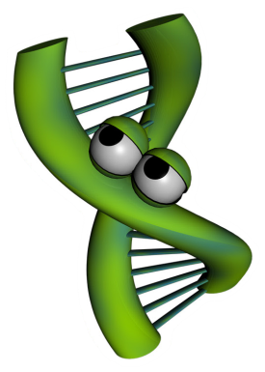Imagine for a moment you wrote a song that rivals (insert famous singer here) and it is going viral on the Internet. People love the impressive guitar solo, which proves you can swing like the heavy hitters of the rock world. You published the music and lyrics, but unfortunately you did not protect the rights to your song. Rock n roll wannabees are taking your song and doing their best to play like you do. The results are disastrous. Even though the tune is the same, the song sounds completely different from yours. You ask yourself, “How is this possible?!” The difference comes in the interpretation of the music. Even though a note may be the same on the page, the way a note is strummed, loud or soft, at a specific moment in the song can change the overall impression the song creates. This is one way artists distinguish themselves from amateurs. Artists know where to place the musical inflections to produce musically pleasing songs. Amateurs, on the other hand, lack the artistic abilities you posses so when they play your song, the result sounds more like cats calling.

Now let’s see how music can relate to science. Interestingly, how DNA is expressed to create you is very similar to how music is played. Just like song lyrics and music can be written on paper, but sound very different based on the person playing the song, DNA can be identical, but the way DNA is “played” makes a difference in how your functions. Epigenetics is the study of how DNA is “played” and the subsequent results.

To study epigenetics, scientists use model systems. Model systems could be as simple as a Petri dish of cells or as complex as an animal. Scientists choose the lowest possible model study in order to answer their questions. For example, scientists have studied bacteria, mice and even humans to understand the mechanisms of epigenetics. One such model are identical twins. Identical twins are studied because the DNA of identical twins is, as the word indicates, identical. From birth to age three, these twins are very similar in appearance and in their behaviors, but as they grow older, the similarities between the twins begin to differ in appearance, and can even differ in their overall health. Why are identical twins different if their DNA is identical? Scientists, suspecting epigenetics, set out to find the answer to this question. Watch the following NOVA ScienceNow video to see what they discovered: <http://www.pbs.org/wgbh/nova/body/epigenetics.html>

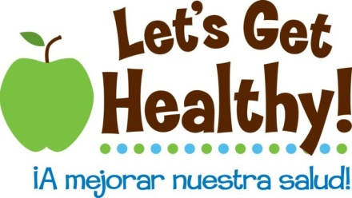

**Teacher Background on Epigenetics**

# What is epigenetics

Epigenetics is the study of the environment’s influence on our genes’ activity. DNA is often referred to as the blueprint or instruction manual for our bodies. DNA is the hardware, but epigenetics are the software. Epigenetics tell our bodies which section of the blueprint (or which page of the instruction manual) to read at a given time. Epigenetic changes do not alter the letters of our DNA, but instead change its punctuation – think like an exclamation point (!), **bold,** ~~strikethrough~~, footnote, or comma (i.e. “Let's eat Grandpa.” this phrase with an epigenetic change might be “Let's eat, Grandpa”).

# Why is it important

These “punctuation” changes can turn genes “on” or “off”, a process called gene regulation. Gene regulation is required for normal development throughout our lives. Genes that are expressed instruct cells what to become, how our organs form, how we remember material for a math test, how our bodies respond to disease and infection, and much, much more. Epigenetics is the study of how environmental factors impact gene regulation which controls gene expression. Gene regulation influences our health throughout our lifespan and new research is suggesting that epigenetic changes may extend across multiple generations to affect the health of our children, grandchildren, and possibly even great-grandchildren. Epigenetic changes are reversible, so our life choices may reverse or mitigate the effects of early epigenetic marks and prevent them from being transmitted to further generations. This is like playing a card game. Even if you are dealt a bad hand it is possible to play it well. It is also possible to mess up a good hand with the wrong life choices. This is an important concept for adolescents because it suggests that we aren’t just a product of our genes, but our environment and the choices that we make, too. We need to “nurture our nature”.

# How does it work? –– Molecular Mechanisms

The mechanism of how epigenetics works is fascinating. Stretched end to end, our DNA is about 6 feet long (2 meters) and shoved into practically every cell in our bodies. It is shaped like a long ladder, twisted like a spiral staircase, then wrapped around proteins (histones) like string around spools (see diagram on next page). These wrappings (nucleosomes) are then further condensed into chromosomes. Think of our DNA like a set of encyclopedias where each chromosome is one of its volumes. If you want to “read” any of the instructions contained in one of these volumes, you need to “unfold” the DNA. Not all the DNA can be unwound at the same time, so only parts of the instructions can be accessed at any one time. Only 2-3% of our DNA is made up of genes. Genes are the instructions to make proteins (called gene expression) that make our body function. The remaining 97% of our DNA was previously thought to be “junk DNA” with no known function, though the Encyclopedia of DNA Elements Project (ENCODE) found in 2012 that at least 80% of our genome is active at some point during our lives and is likely involved with regulating gene activity. 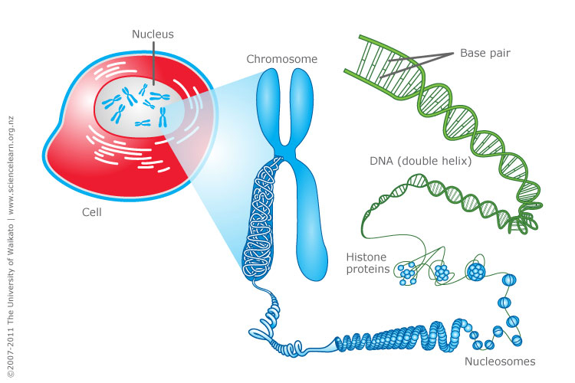

http://www.sciencelearn.org.nz/var/sciencelearn/storage/images/contexts/uniquely-me/sci-media/images/cell-chromosomes-and-dna/464336-1-eng-NZ/Cell-chromosomes-and-DNA.jpg

Epigenetics works by ‘tagging’ or making punctuation changes to our DNA. Two of the best known mechanisms are:

* *Histone acetylation* -- DNA is wound around chemical spools called histones. This saves space in the cell, but tightly wrapped DNA can't be read for gene expression. Chemical triggers can attach an “acetyl group” to an external part of the spool core that causes the core to open the DNA and make it available to reading. Histone acetylation refers to more gene access. Histone deacetylation removes the acetyl group and closes the DNA, so less gene access.
* *DNA Methylation* -- In other cases, a methyl group can be added to the DNA to “tag” it. With several methyl groups added, machinery cannot access the DNA to read it and the resulting gene is not expressed. This serves as a chemical “skip this part”. Methyl tags can be added or removed throughout the lifespan by various environmental factors discussed below.
* *Note*: Research is constantly finding new epigenetic mechanisms. For example, histones can be methylated or acetylated in different loci for different functions. RNA was recently found to be methylatable, too. But, the general thought is the same. Epigenetics is all about turning gene activity up or down, on or off.

# How is a person impacted by epigenetics

Epigenetics affects our bodies throughout our lives because gene expression occurs every day throughout our lifespan. The epigenetic effects on our health depend on when (in our development) and where (in our bodies) our genes are turned “on” and “off”. We have learned from historical famines and population-wide studies that long-term health effects can be observed following a variety of environmental exposures. Current research suggests that the following environmental factors can affect how our genes are regulated.

Sun (ultraviolet light)

Drinking water pollutants

Auto exhaust

Radiation

Diet (methionine, choline, folate, B12)

Hormones (bisphenol A, DES, estrogen, dioxins)

Pesticides

Metals (Ni, Cr, As, Cd, Hg)

Tobacco Smoke

Social interaction

## Fetal development

The experience of a fetus in the womb is a critical time for affecting development and future disease risk. For example, our kidneys are normally formed in the womb between 33 and 36 weeks. We now understand that if diet, toxins or other environmental factors disrupt growth during that critical period, the kidney cells won’t form properly and health effects can be seen later in adulthood due to low-functioning kidneys. Kidney problems can also be seen earlier in childhood, depending on the extent of the disruption. Research is now finding that there are “developmental origins of disease”, where the surrounding environment of the growing baby can affect its susceptibility to chronic disease later in life. Adult risks for obesity, cardiovascular disease, diabetes and metabolic syndrome have been linked to these early fetal development periods. Interestingly birth weight seems to be predictive of this effect, where low birth weight babies have a higher risk of obesity later in life. Babies born around eight-nine pounds seem to have the lowest risk of future disease risk. The increased risk doesn't just happen in low birth weight babies but in high birth weight babies, which may not have had the right nutrients. This "over fed, undernourished" syndrome is a special concern and is currently being studied. We have learned that effects that occur during pregnancy may persist for generations because a female’s eggs are all developed during a short time that she is in her mother's womb. These eggs will become the sons and daughters of the baby girl. The nutrition during pregnancy can not only effect a woman's baby, but also her grandchildren. Men aren’t immune to this as new evidence is suggesting epigenetic effects may occur on the sperm as well.

## Early life epigenetics

A newborn or toddler exposed to bis-phenol A (a chemical formerly used in plastic bottles and still used in the lining of tin cans) becomes vulnerable to obesity in later life. Research in rats has also shown that young rat pups groomed (licked) more frequently by their mothers had a better ability to handle stress as adults than pups groomed less frequently, a result of epigenetic control of glucocorticoid (stress) genes in the brain. Research is currently underway related to how other social interactions can affect our health – bullying, growing up with siblings, abuse, etc. A 2012 paper by Tung and colleagues showed that the dominance rank of rhesus macaques (a type of primate) was strongly associated with gene expression in their immune system, with the magnitude of gene expression actually predicting the macaques’ rank in their group over time. This effect hasn’t been explored in humans, though it highlights an important biological 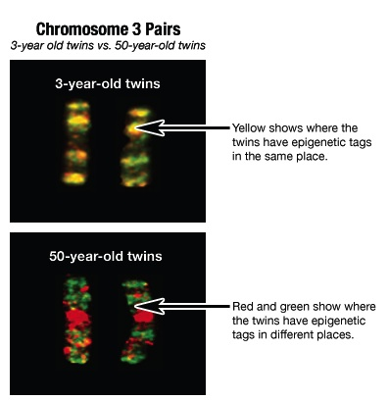mechanism for how our physiology and health can interact.

## Epigenetics in later life

It is fairly easy to see how something a person is exposed to might modify their epigenome. Identical twins have been used most frequently to study the long-term effects of the environment on our genes since they share the same DNA. When identical twins are young, their epigenetic tags are mostly the same. But as they age and experience different lives, their epigenetic tags are different (see image on right). Likewise, with our different environmental exposures as we age, current cancer research is looking at the epigenetic control of genes related to cell growth that may have been improperly turned “on” or “off” by the environment.

http://learn.genetics.utah.edu/content/epigenetics/twins/

# Future research and unanswered questions

There are bound to be many news stories about epigenetics in the next few years. It is important to consider the credibility of the sources of these stories. Carefully designed studies from respected institutions with a clear statement of the limitations of the investigation backed up through review of other scientists are more credible than extreme claims made through the popular press without details of how the investigation was conducted or reviewed. Especially suspicious are claims made in relation to products which claim to have health benefits through epigenetic effects. Other than general dietary recommendations, it is just too early to be able to manufacture such products. Such things will take a number of years of development and would be tested in carefully controlled studies. Currently, there is solid scientific evidence of epigenetic impacts on vulnerability to hypertension, kidney disease, obesity, type II diabetes, cholesterol problems, stroke, and osteoporosis. Under investigation are links between epigenetics and vulnerability to autism, depression, and schizophrenia. Right now, the best advice is to eat a healthy diet, sleep well, avoid stress, and avoid exposure to environmental toxins. All these are familiar bits of advice that your grandmother may have given you, but now we are beginning to understand the deep molecular biology for how they work and we will be able to use that understanding to give more specific epigenetic help.

For more information on genetics or epigenetics, visit the Genetic Science Learning Center

<http://learn.genetics.utah.edu> and http://teach.genetics.utah.edu