Lesson: What is Your Epigenetic IQ?

Overview of Lesson Plan: Students test their knowledge and understanding of epigenetics by answering 18 true and false questions.

Big Understanding: The epigenome is a set of chemical switches and markers that influence gene expression. Diet, environmental stressors, physical activity, and exposure to toxins can activate these chemical switches that regulate gene expression without changing the underline genetic code. Epigenetics is the study of changes in gene activity that do not involve changes to the genetic code.

Essential Questions: How much do you know about epigenetic?
Grades: 5-8
Subjects: General
Time required: 15 minutes
Background: Online Resources
Objectives: Students test their knowledge and understanding of epigenetics
Materials: Each student needs copies of “HOW MUCH DO YOU KNOW ABOUT EPIGENETICS?”
Preparation: Can be used as a pre-assessment or post-assessment activity
Activities/Procedures: Have students answer the true and false questions and “What can change your epigenome?”
Assessment/Reflection: All of the answers are TRUE and ALL of the items listed can change your epigenome
Activity Extension: Have each student chose 3 statements from “HOW MUCH DO YOU KNOW ABOUT EPIGENETICS?” the and explain why the statement is true using epigenetics

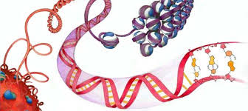 | HOW MUCH DO YOU KNOW ABOUT EPIGENETICS?  Take this TRUE or FALSE quiz and find out
 | - A parent's experiences, in the form of epigenetic tags, can be passed down to future generations.
 | - In a pregnant mother, three generations are directly exposed to the same environmental conditions at the same time.
 | - Identical twins are genetic carbon copies, yet physically they become increasingly different over time.
 | - An epigenetic change that was triggered by environmental conditions may be reversed when environmental conditions change again.
 | - Epigenetic changes can happen in many individuals at once.
 | - The effects of smoking on health can also be passed to grandchildren, as evidenced from studies where grandmothers but not mothers smoked.
 | - The amount and quality of food a grandfather had between the ages of 9-12 can be especially important in how faithfully the epigenome is copied for future generations.
 | - Rat pups who receive high or low nurturing from their mothers develop epigenetic differences that affect their response to stress later in life.
 | - Stress, diet, behavior, toxins and other factors activate chemical switches that regulate gene expression.
 | - Your mother's diet during pregnancy and what you're fed as an infant can cause critical changes that stick with you into adulthood.
 | - Unlike behavior or stress, diet is one the more easily studied, and therefore better understood, environmental factors in epigenetic change.
 | - When researchers fed pregnant yellow mice a methyl-rich diet, most of the resulting pups were brown and healthy and stayed that way for life.
 | - Our diets and lifestyles can change the expression of our genes.
 | - Epigenomes can change in function of what we eat, of what we breathe, or of what we drink.
 | - You can impact your genes and health as well as your future children and grandchildren’s genes and health.
 | - The ability of environmental conditions to cause epigenetic changes varies with time during our life, and also with the amount of exposure at these vulnerable periods of time.
 | - Researchers have found that it takes only the addition of a methyl group to change an epigenome and the gene’s expression.
 | - Epigenetics isn’t a mutation and doesn’t change DNA. It represents a biological response to an environmental stressor that can be inherited via epigenetic marks.
Which of the following can change your epignome? (Circle all that apply)
broccoli | smoking | sleep | obesity | malnutrition
strawberries | spinach | pollution | viruses | prenatal nutrition
anxiety | exercise | social interaction | stress | parents

Student Background on Epigenetics
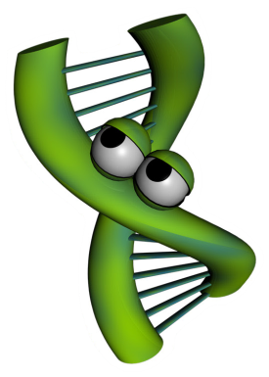
Imagine for a moment you wrote a song that rivals (insert famous singer here) and it is going viral on the Internet. People love the impressive guitar solo, which proves you can swing like the heavy hitters of the rock world. You published the music and lyrics, but unfortunately you did not protect the rights to your song. Rock n roll wannabees are taking your song and doing their best to play like you do. The results are disastrous. Even though the tune is the same, the song sounds completely different from yours. You ask yourself, “How is this possible?!” The difference comes in the interpretation of the music. Even though a note may be the same on the page, the way a note is strummed, loud or soft, at a specific moment in the song can change the overall impression the song creates. This is one way artists distinguish themselves from amateurs. Artists know where to place the musical inflections to produce musically pleasing songs. Amateurs, on the other hand, lack the artistic abilities you posses so when they play your song, the result sounds more like cats calling.
Now let’s see how music can relate to science. Interestingly, how DNA is expressed to create you is very similar to how music is played. Just like song lyrics and music can be written on paper, but sound very different based on the person playing the song, DNA can be identical, but the way DNA is “played” makes a difference in how your functions. Epigenetics is the study of how DNA is “played” and the subsequent results.
To study epigenetics, scientists use model systems. Model systems could be as simple as a Petri dish of cells or as complex as an animal. Scientists choose the lowest possible model study in order to answer their questions. For example, scientists have studied bacteria, mice and even humans to understand the mechanisms of epigenetics. One such model are identical twins. Identical twins are studied because the DNA of identical twins is, as the word indicates, identical. From birth to age three, these twins are very similar in appearance and in their behaviors, but as they grow older, the similarities between the twins begin to differ in appearance, and can even differ in their overall health. Why are identical twins different if their DNA is identical? Scientists, suspecting epigenetics, set out to find the answer to this question. Watch the following NOVA ScienceNow video to see what they discovered: http://www.pbs.org/wgbh/nova/body/epigenetics.htm
Sources: HOW MUCH DO YOU KNOW ABOUT EPIGENETICS? True / False Handout
Online Resources for Epigenetics
VIDEO Title | Source | Link
Epigenetics | PBS - NOVA | http://www.pbs.org/wgbh/nova/body/epigenetics.html
Epigenetics I and II | PBS - NOVA (via youtube) | http://www.youtube.com/watch?v=wFsxVkuChdU (7:  http://www.youtube.com/watch?v=Xjq5eEslJhw (6:19)
Epigenetics | scishow (via Youtube) | http://www.youtube.com/watch?v=kp1bZEUgqVI&feature=youtube_gdata_player
Epigenetics makes you unique:  Courtney Griffins at TEDxOU | TEDxTALKS (via Youtube) | http://www.youtube.com/watch?v=JTBg6hqeuTg
(Audio slide show)  A Tale of Two Mice | PBS – NOVA | http://www.pbs.org/wgbh/nova/body/epigenetic-mice.html  Audio slide show and supporting web page about the aguti mice and epigenetics.
Utah Twins | The University of Utah - Genetic Science Learning Center | http://learn.genetics.utah.edu/content/epigenetics/twins/
ARTICLES Title | Source | Link
How the First Nine Months Shape the Rest of Your Life | Time Magazine  - By Annie Murphy Paul | http://www.time.com/time/magazine/article/0,9171,2021065,00.html#ixzz2Wn5nO1wE
Why Your DNA Isn't Your Destiny. | Time Magazine  - By John Cloud | http://www.time.com/time/magazine/article/0,9171,1952313,00.html
Beyond DNA: Epigenetics - Deciphering the link between nature and nurture. | Natural History  - By Nessa Carey | http://www.naturalhistorymag.com/features/142195/beyond-dna-epigenetics
Epigenetics: Tales of Adversity. | Nature - International Weekly Journal  of Science | http://www.nature.com/nature/journal/v468/n7327_supp/full/468S20a.html
WEB SITES Title | Source | Link
Learn Genetics and Teach Genetics | The University of Utah - Genetic Science Learning Center | http://learn.genetics.utah.edu/content/epigenetics/

Teacher Background on Epigenetics

What is epigenetics
Epigenetics is the study of the environment’s influence on our genes’ activity. DNA is often referred to as the blueprint or instruction manual for our bodies. DNA is the hardware, but epigenetics are the software. Epigenetics tell our bodies which section of the blueprint (or which page of the instruction manual) to read at a given time. Epigenetic changes do not alter the letters of our DNA, but instead change its punctuation – think like an exclamation point (!), bold, strikethrough, footnote, or comma (i.e. “Let's eat Grandpa.” this phrase with an epigenetic change might be “Let's eat, Grandpa”).

Why is it important
These “punctuation” changes can turn genes “on” or “off”, a process called gene regulation. Gene regulation is required for normal development throughout our lives. Genes that are expressed instruct cells what to become, how our organs form, how we remember material for a math test, how our bodies respond to disease and infection, and much, much more. Epigenetics is the study of how environmental factors impact gene regulation which controls gene expression. Gene regulation influences our health throughout our lifespan and new research is suggesting that epigenetic changes may extend across multiple generations to affect the health of our children, grandchildren, and possibly even great-grandchildren. Epigenetic changes are reversible, so our life choices may reverse or mitigate the effects of early epigenetic marks and prevent them from being transmitted to further generations. This is like playing a card game. Even if you are dealt a bad hand it is possible to play it well. It is also possible to mess up a good hand with the wrong life choices. This is an important concept for adolescents because it suggests that we aren’t just a product of our genes, but our environment and the choices that we make, too. We need to “nurture our nature”.

How does it work? –– Molecular Mechanisms
The mechanism of how epigenetics works is fascinating. Stretched end to end, our DNA is about 6 feet long (2 meters) and shoved into practically every cell in our bodies. It is shaped like a long ladder, twisted like a spiral staircase, then wrapped around proteins (histones) like string around spools (see diagram on next page). These wrappings (nucleosomes) are then further condensed into chromosomes. Think of our DNA like a set of encyclopedias where each chromosome is one of its volumes. If you want to “read” any of the instructions contained in one of these volumes, you need to “unfold” the DNA. Not all the DNA can be unwound at the same time, so only parts of the instructions can be accessed at any one time. Only 2-3% of our DNA is made up of genes. Genes are the instructions to make proteins (called gene expression) that make our body function. The remaining 97% of our DNA was previously thought to be “junk DNA” with no known function, though the Encyclopedia of DNA Elements Project (ENCODE) found in 2012 that at least 80% of our genome is active at some point during our lives and is likely involved with regulating gene activity. 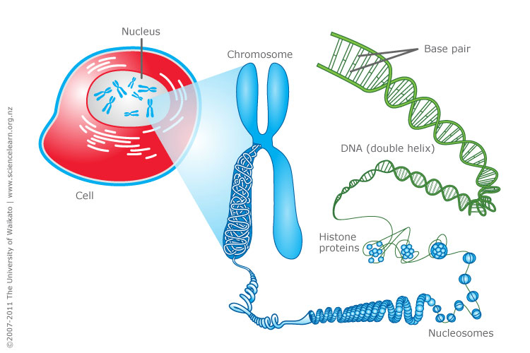
http://www.sciencelearn.org.nz/var/sciencelearn/storage/images/contexts/uniquely-me/sci-media/images/cell-chromosomes-and-dna/464336-1-eng-NZ/Cell-chromosomes-and-DNA.jpg

Epigenetics works by ‘tagging’ or making punctuation changes to our DNA. Two of the best known mechanisms are:
- Histone acetylation -- DNA is wound around chemical spools called histones. This saves space in the cell, but tightly wrapped DNA can't be read for gene expression. Chemical triggers can attach an “acetyl group” to an external part of the spool core that causes the core to open the DNA and make it available to reading. Histone acetylation refers to more gene access. Histone deacetylation removes the acetyl group and closes the DNA, so less gene access.
- DNA Methylation -- In other cases, a methyl group can be added to the DNA to “tag” it. With several methyl groups added, machinery cannot access the DNA to read it and the resulting gene is not expressed. This serves as a chemical “skip this part”. Methyl tags can be added or removed throughout the lifespan by various environmental factors discussed below.
- Note: Research is constantly finding new epigenetic mechanisms. For example, histones can be methylated or acetylated in different loci for different functions. RNA was recently found to be methylatable, too. But, the general thought is the same. Epigenetics is all about turning gene activity up or down, on or off.

How is a person impacted by epigenetics
Epigenetics affects our bodies throughout our lives because gene expression occurs every day throughout our lifespan. The epigenetic effects on our health depend on when (in our development) and where (in our bodies) our genes are turned “on” and “off”. We have learned from historical famines and population-wide studies that long-term health effects can be observed following a variety of environmental exposures. Current research suggests that the following environmental factors can affect how our genes are regulated.

Sun (ultraviolet light)
Drinking water pollutants
Auto exhaust
Radiation
Diet (methionine, choline, folate, B12)
Hormones (bisphenol A, DES, estrogen, dioxins)
Pesticides
Metals (Ni, Cr, As, Cd, Hg)
Tobacco Smoke
Social interaction

Fetal development
The experience of a fetus in the womb is a critical time for affecting development and future disease risk. For example, our kidneys are normally formed in the womb between 33 and 36 weeks. We now understand that if diet, toxins or other environmental factors disrupt growth during that critical period, the kidney cells won’t form properly and health effects can be seen later in adulthood due to low-functioning kidneys. Kidney problems can also be seen earlier in childhood, depending on the extent of the disruption. Research is now finding that there are “developmental origins of disease”, where the surrounding environment of the growing baby can affect its susceptibility to chronic disease later in life. Adult risks for obesity, cardiovascular disease, diabetes and metabolic syndrome have been linked to these early fetal development periods. Interestingly birth weight seems to be predictive of this effect, where low birth weight babies have a higher risk of obesity later in life. Babies born around eight-nine pounds seem to have the lowest risk of future disease risk. The increased risk doesn't just happen in low birth weight babies but in high birth weight babies, which may not have had the right nutrients. This "over fed, undernourished" syndrome is a special concern and is currently being studied. We have learned that effects that occur during pregnancy may persist for generations because a female’s eggs are all developed during a short time that she is in her mother's womb. These eggs will become the sons and daughters of the baby girl. The nutrition during pregnancy can not only effect a woman's baby, but also her grandchildren. Men aren’t immune to this as new evidence is suggesting epigenetic effects may occur on the sperm as well.

Early life epigenetics
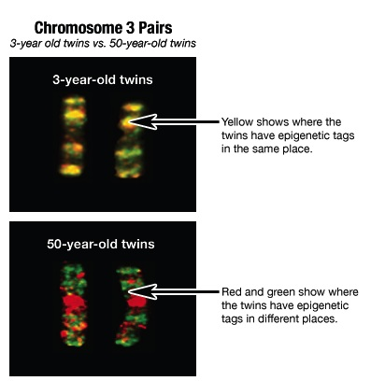
A newborn or toddler exposed to bis-phenol A (a chemical formerly used in plastic bottles and still used in the lining of tin cans) becomes vulnerable to obesity in later life. Research in rats has also shown that young rat pups groomed (licked) more frequently by their mothers had a better ability to handle stress as adults than pups groomed less frequently, a result of epigenetic control of glucocorticoid (stress) genes in the brain. Research is currently underway related to how other social interactions can affect our health – bullying, growing up with siblings, abuse, etc. A 2012 paper by Tung and colleagues showed that the dominance rank of rhesus macaques (a type of primate) was strongly associated with gene expression in their immune system, with the magnitude of gene expression actually predicting the macaques’ rank in their group over time. This effect hasn’t been explored in humans, though it highlights an important biological mechanism for how our physiology and health can interact.

Epigenetics in later life
It is fairly easy to see how something a person is exposed to might modify their epigenome. Identical twins have been used most frequently to study the long-term effects of the environment on our genes since they share the same DNA. When identical twins are young, their epigenetic tags are mostly the same. But as they age and experience different lives, their epigenetic tags are different (see image on right). Likewise, with our different environmental exposures as we age, current cancer research is looking at the epigenetic control of genes related to cell growth that may have been improperly turned “on” or “off” by the environment.

Future research and unanswered questions
There are bound to be many news stories about epigenetics in the next few years. It is important to consider the credibility of the sources of these stories. Carefully designed studies from respected institutions with a clear statement of the limitations of the investigation backed up through review of other scientists are more credible than extreme claims made through the popular press without details of how the investigation was conducted or reviewed. Especially suspicious are claims made in relation to products which claim to have health benefits through epigenetic effects. Other than general dietary recommendations, it is just too early to be able to manufacture such products. Such things will take a number of years of development and would be tested in carefully controlled studies. Currently, there is solid scientific evidence of epigenetic impacts on vulnerability to hypertension, kidney disease, obesity, type II diabetes, cholesterol problems, stroke, and osteoporosis. Under investigation are links between epigenetics and vulnerability to autism, depression, and schizophrenia. Right now, the best advice is to eat a healthy diet, sleep well, avoid stress, and avoid exposure to environmental toxins. All these are familiar bits of advice that your grandmother may have given you, but now we are beginning to understand the deep molecular biology for how they work and we will be able to use that understanding to give more specific epigenetic help.

For more information on genetics or epigenetics, visit the Genetic Science Learning Center
http://learn.genetics.utah.edu and http://teach.genetics.utah.edu

