Student Background on Epigenetics
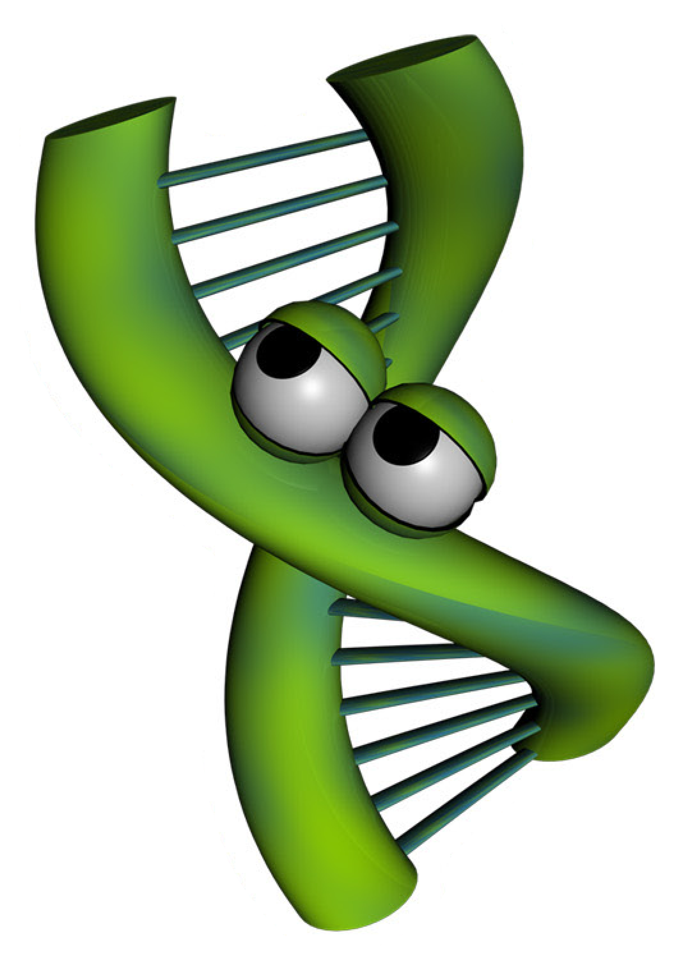
Imagine for a moment you wrote a song that rivals (insert famous singer here) and it is going viral on the Internet. People love the impressive guitar solo, which proves you can swing like the heavy hitters of the rock world. You published the music and lyrics, but unfortunately you did not protect the rights to your song. Rock n roll wannabees are taking your song and doing their best to play like you do. The results are disastrous. Even though the tune is the same, the song sounds completely different from yours. You ask yourself, “How is this possible?!” The difference comes in the interpretation of the music. Even though a note may be the same on the page, the way a note is strummed, loud or soft, at a specific moment in the song can change the overall impression the song creates. This is one way artists distinguish themselves from amateurs. Artists know where to place the musical inflections to produce musically pleasing songs. Amateurs, on the other hand, lack the artistic abilities you posses so when they play your song, the result sounds more like cats calling.
Now let’s see how music can relate to science. Interestingly, how DNA is expressed to create you is very similar to how music is played. Just like song lyrics and music can be written on paper, but sound very different based on the person playing the song, DNA can be identical, but the way DNA is “played” makes a difference in how your functions. Epigenetics is the study of how DNA is “played” and the subsequent results.
To study epigenetics, scientists use model systems. Model systems could be as simple as a Petri dish of cells or as complex as an animal. Scientists choose the lowest possible model study in order to answer their questions. For example, scientists have studied bacteria, mice and even humans to understand the mechanisms of epigenetics. One such model are identical twins. Identical twins are studied because the DNA of identical twins is, as the word indicates, identical. From birth to age three, these twins are very similar in appearance and in their behaviors, but as they grow older, the similarities between the twins begin to differ in appearance, and can even differ in their overall health. Why are identical twins different if their DNA is identical? Scientists, suspecting epigenetics, set out to find the answer to this question. Watch the following NOVA ScienceNow video to see what they discovered: http://www.pbs.org/wgbh/nova/body/epigenetics.html

