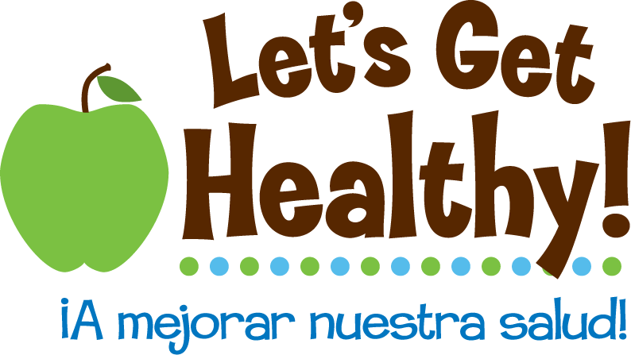

“Nurture your Nature”
Epigenetics and your Health

Game Duration:
15m

Game Story:
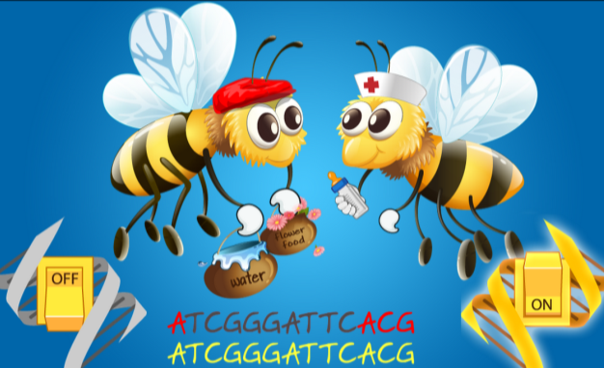
How do we know what we know? A lot of it comes from work with model systems! Honeybees taught us that it’s not just our genes, but what we’re exposed to in the environment that also makes a difference by changing the way our genes work! Mice have taught us that fur color, obesity and disease risk are all influenced by what we eat (and what our parents ate)! And studies on identical twins have taught us that “environment” means a lot more than we previously thought – diet, stress, and even social interactions with our family and friends can all make a big difference in how our genes are turned on and off – all without changing the letters that make up our genetic code. It’s all epigenetics – how our environment and the choices we make can affect our health by changing the way our DNA works.

Game Play:
Tour three game levels about bees, mice and humans where you’ll learn about genetics (which refers to the DNA we get from our parents) and epigenetics (which describes how DNA’s activity can be changed in our bodies). In the fourth game level, create an avatar and twin-ize them. Select the behaviors for you and your twin to see how different you can become. Fast forward in time to see how your genomes remain the same, but your epigenomes become different. But what else is changing? We’ve learned that identical twins aren’t so identical after all. Your choices matter!
