From Genetics to Epigenetics

DNA has come a long way over the millennia. Here’s a quick time-travelling tour of DNA through history.

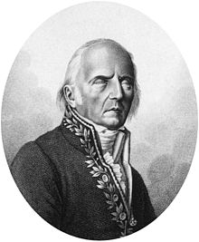 | 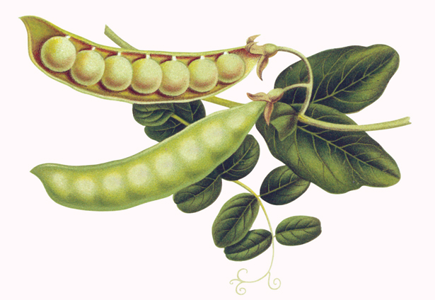 | 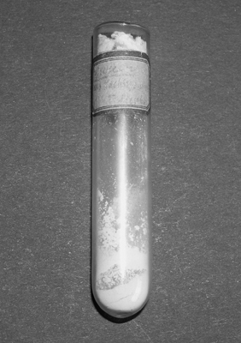
400 BC – 1900 AD  Hippocrates, Aristotle and most Western scholars believed in “inheritance of acquired characteristics”, a hypothesis made famous by Lamarck in 1809, which described that bodily changes acquired over the lifespan can be passed to offspring. | 1866  Austrian Monk Gregor Mendel publishes his famous paper on pea genetics, showing inheritance patterns, dominant and recessive traits, and how visible pea characteristics are passed to future generations. His findings are largely ignored by scientists for 35 years. | 1869  Friedrich Miescher first identifies DNA (which he called “nuclein”) as an acidic substance found in the nucleus of cells. The significance of DNA is not appreciated for over 70 years despite chromosomes being linked to heredity in 1902 and the term “genetics” being coined in 1905!
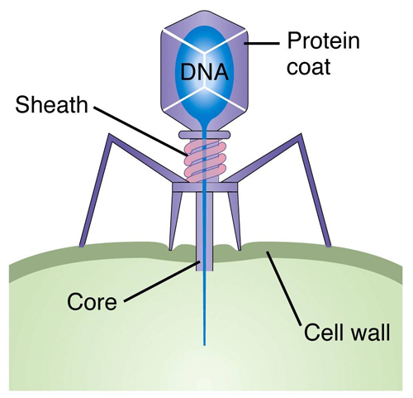 |  | 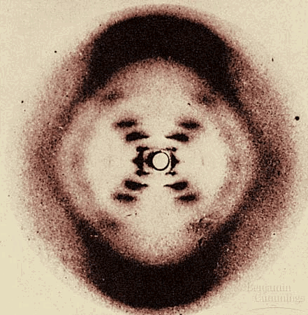  
1941  One gene encodes one protein, as described by Beadle and Tatum. Messenger RNA (mRNA) is discovered in 1959 as the intermediate between DNA and protein. In 1944, DNA is finally discovered as the molecule that mediates heredity though most people were skeptical of these findings until 1952 when scientists used labeled bacteriophages to demonstrate this conclusively. | 1942  Conrad Waddington first coins the term “epigenetics” to describe how genetics and developmental biology were related. Epigenetic mechanisms are unknown for 30 years. Riggs updates the definition in 1996 to describe “heritable changes in gene function that cannot be explained by changes in DNA sequence”. | 1953  The structure of DNA is discovered to have the shape of a double helix with antiparallel nucleotide chains and specific base pairing. This was deduced by Watson and Crick, who used Rosalind Franklin's data provided by Maurice Wilkins. Watson and Crick win the Nobel Prize in 1962 for their discovery.
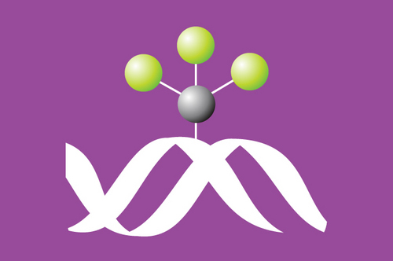 | 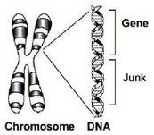 | 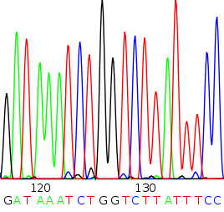
1969  Griffith & Mahler are first to suggest that DNA methylation (tagging a gene with a methyl group) may be biologically important. This is recognized in 1975 to be an important mechanism for turning genes on and off, as well as a model for how gene activity could be passed to offspring. | 1972  The term “Junk DNA” is first coined by Ohno, which continues to be an outdated label used to describe portions of the genome sequence that have no known function. Scientists have calculated that 97% of the human genome is non-coding DNA! | 1977  DNA sequencing technology is developed. This launches genome sequencing projects in the 1990s, microarrays, DNA fingerprinting, genetic screening, gene therapy, and genetically modified foods. In 2007, “Next Generation Sequencing” opens the door to personal genome sequencing.
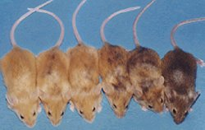 | 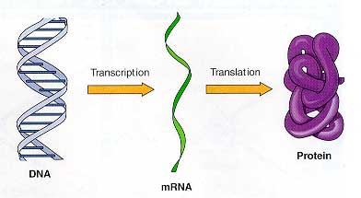 | 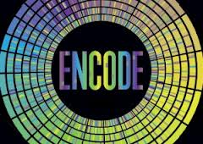
1987  First evidence that epigenetic information can be passed to future generations. Since the 1990s, scientists have studied the role of nutrition during pregnancy and puberty as important times for influencing disease risk in future generations. | 2011    Methylation of mRNA is shown to have a critical role in energy balance in humans, opening the previously unknown field of RNA epigenetics. | 2012  The Encyclopedia of DNA Elements Project (ENCODE) identifies 4 million previously unknown sites involved in regulating gene activity. Instead of 97% of our genome with no known function, it now appears that at least 80% of our genome is active at some point during our lives.

References:

- From Dr. Hales “Timeline of the History of Genetics” (http://www.bio.davidson.edu/people/kahales/301Genetics/timeline.html) last modified August 27, 2009 by K. Hales
- http://circgenetics.ahajournals.org/content/3/6/567/F2.large.jpg
- http://www.washingtonpost.com/national/health-science/junk-dna-concept-debunked-by-new-analysis-of-human-genome/2012/09/05/cf296720-f772-11e1-8398-0327ab83ab91_story.html
- http://www.landesbioscience.com/journals/epigenetics/hollidayEPI1-2.pdf
- http://www.ncbi.nlm.nih.gov/pubmed/22290458

