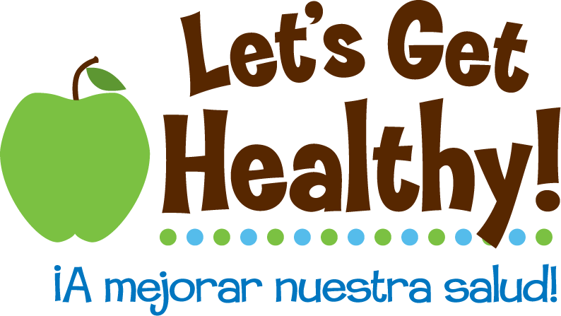
Standards Met by the Lesson
Lesson Title: Sharks and Ice Cream
Grades: 6-8
Subject: Correlation / Cause and Effect

Standards: The standards listed were identified using key concepts from each individual lesson. These key concepts were aligned with the specific Oregon State Standards, Common Core Standards, and Next Generation Science Standards that apply specifically to each individual lesson.
Teachers may consult the Oregon Department of Education’s website for additional terms related to each lesson. http://www.ode.state.or.us/teachlearn/real/standards/standards_keywordsearch.aspx

Sixth Grade
Math | Language Arts | Social Science | Health/PE | Science
6.SP.1  6.SP.2  6.SP.3  6.SP.4  6.SP.5a  6.SP.5c  6.SP.5d  6.RP.3c |  | 6.23 |  | 6.3S.1  6.3s.2  6.3s.3

Seventh Grade
Math | Language Arts | Social Science | Health/PE | Science
7.SP.2  7.SP.3  7.SP.4  7.SP.5  7.SP.6  7.SP.7.b  7.RP.2d  N.RN.1  7.SP.1 | EL.07.WR.34  EL.07.WR.12 | 7.6  7.7  7.8  7.9 |  | 7.3S.1  7.3S.3

Eighth Grade
Math | Language Arts | Social Science | Health/PE | Science
8.SP.1  8.SP.2  8.SP.3  8.SP.4  F.LE.1a  6.SRT.2 |  | 8.25 |  | 8.3S.1  8.3S.2  8.3S.3  8.3S.4

Applies to all grade levels
Technology |  | Key terms from this lesson’s Overview of the Lesson Plan
ET.1.b
ET.3.d
ET.4.c

