
Before You Go to Let’s Get Healthy!
Grades: 5-8
Subjects: Science, Health
Overview of Lesson Plan: This lesson consists of a power point showing the students what to expect at the Let’s Get Healthy! fair, notes embedded in the powerpoint to give the teacher some background on the various stations, a worksheet for the students to fill out during the power point, and worksheet for them to summarize what they learned at the Let’s Get Healthy! fair to enhance understanding and promote interest in various stations of the Let’s Get Healthy! fair.
Suggested Time Allowance: 20 – 40 minutes depending on the length of your summarizing discussion.
Objectives: To prepare students for the Let’s Get Healthy! fair so they can gain the maximum benefit from their participation in the fair.
Materials:
Pre-lesson power point
Pre-lesson student worksheets #1 and #2

Activities/Procedures:
Day 1
Activity –

- Hand out the student worksheets #1 and explain that they are to be filled in as you show the power point.

- Show the pre-lesson power point, using the notes as a guide.

Evaluation/Assessment -
Have students summarize what they have just learned using Worksheet #1 and discuss what it is they would like to learn at the Let’s Get Healthy! fair. Ask students to fill out the first two columns in worksheet #2. Remind students that they will be filling in the third column (“what you have learned”) after they have participated in the Let’s Get Healthy! fair.

Resources: The links below are for printable versions of articles that provide background information relating to the various stations of the Let’s Get Healthy! fair. To search the wealth of resources at Kids Health, go directly to their website at http://kidshealth.org/teen/

Body Mass Index (BMI)
- “What’s the Right Weight for my Height” (5 pages) http://websrv01.kidshealth.org/PageManager.jsp?dn=KidsHealth&lic=1&ps=207&cat_id=20131&article_set=20284
Body Fat
- “When Being Overweight is a Health Problem” (3 pages) http://kidshealth.org/PageManager.jsp?dn=KidsHealth&lic=1&ps=207&cat_id=20131&article_set=30222
Blood Pressure
- “Hypertension (High Blood Pressure)” (5 pages) http://kidshealth.org/PageManager.jsp?dn=KidsHealth&lic=1&ps=207&cat_id=20160&article_set=21016
Sleep Time
- “How Much Sleep Do I Need” (3 pages) http://websrv01.kidshealth.org/PageManager.jsp?dn=KidsHealth&lic=1&ps=207&cat_id=20132&article_set=20448
Fat Consumption
- “Figuring Out Fat and Calories” (4 pages) http://websrv01.kidshealth.org/PageManager.jsp?dn=KidsHealth&lic=1&ps=207&cat_id=20132&article_set=20448

Academic Content Standards:
National Science Standards Grades 5 – 8

NS.5-8.1 SCIENCE AS INQUIRY

ALL STUDENTS SHOULD DEVELOP UNDERSTANDINGS ABOUT SCIENTIFIC INQUIRY
- Identify questions that can be answered through scientific investigations
- Current scientific knowledge and understanding guide scientific investigations.
- Technology used to gather data enhances accuracy and allows scientists to analyze and quantify results of investigations.
- Scientific explanations emphasize evidence.
- Scientific investigations sometimes result in new ideas and phenomena for study, generate new methods or procedures for an investigation, or develop new technologies to improve the collection of data. All of these results can lead to new investigations.

NS.5-8.3 LIFE SCIENCE

STRUCTURE AND FUNCTION IN LIVING SYSTEMS
- The human organism has systems for digestion, respiration, reproduction, circulation, excretion, movement, control, and coordination, and for protection from disease. These systems interact with one another.

REPRODUCTION AND HEREDITY
- The characteristics of an organism can be described in terms of a combination of traits. Some traits are inherited and others result from interactions with the environment.

NS.5-8.5 SCIENCE AND TECHNOLOGY

STUDENTS SHOULD DEVELOP UNDERSTANDINGS ABOUT SCIENCE AND TECHNOLOGY
- Science and technology are reciprocal. Science helps drive technology, as it addresses questions that demand more sophisticated instruments and provides principles for better instrumentation and technique.

NS.5-8.6 PERSONAL AND SOCIAL PERSPECTIVES

PERSONAL HEALTH
- Regular exercise is important to the maintenance and improvement of health. The benefits of physical fitness include maintaining healthy weight, having energy and strength for routine activities, good muscle tone, bone strength, strong heart/lung systems, and improved mental health. Personal exercise, especially developing cardiovascular endurance, is the foundation of physical fitness.
- The use of tobacco increases the risk of illness. Students should understand the influence of short-tem social and psychological factors that lead to tobacco use, and the possible long-term detrimental effects of smoking and chewing tobacco.
- Food provides energy and nutrients for growth and development.

SCIENCE AND TECHNOLOGY IN SOCIETY
- Science influences society through its knowledge and world view.
- Societal challenges often inspire questions for scientific research, and social priorities often influence research priorities through the availability of funding for research.
- Scientists and engineers work in many different settings, including colleges and universities, businesses and industries, specific research institutes, and government agencies.
- Scientists and engineers have ethical codes requiring that human subjects involved with research be fully informed about risks and benefits associated with the research before the individuals choose to participate. This ethic extends to potential risks to communities and property. In short, prior knowledge and consent are required for research involving human subjects or potential damage to property.
NS.5-8.7 HISTORY AND NATURE OF SCIENCE
- It is part of scientific inquiry to evaluate the results of scientific investigations, experiments, observations, theoretical models, and the explanations proposed by other scientists.

National Health Standards Grades 5 - 8
Standard 1: Students will comprehend concepts related to health promotion and disease prevention to enhance health. Grades 6-8 Performance Indicators for Standard 1:
- 1.8.1 Analyze the relationship between healthy behaviors and personal health.
- 1.8.5 Describe ways to reduce or prevent injuries and other adolescent health problems.
- 1.8.7 Describe the benefits of and barriers to practicing healthy behaviors.
- 1.8.8 Examine the likelihood of injury or illness if engaging in unhealthy behaviors.
- 1.8.9 Examine the potential seriousness of injury or illness if engaging in unhealthy behaviors.
Name ________________________
Before You Go to Let’s Get Healthy!
Work sheet #1
Station Name | Notes | Picture of Station | Notes
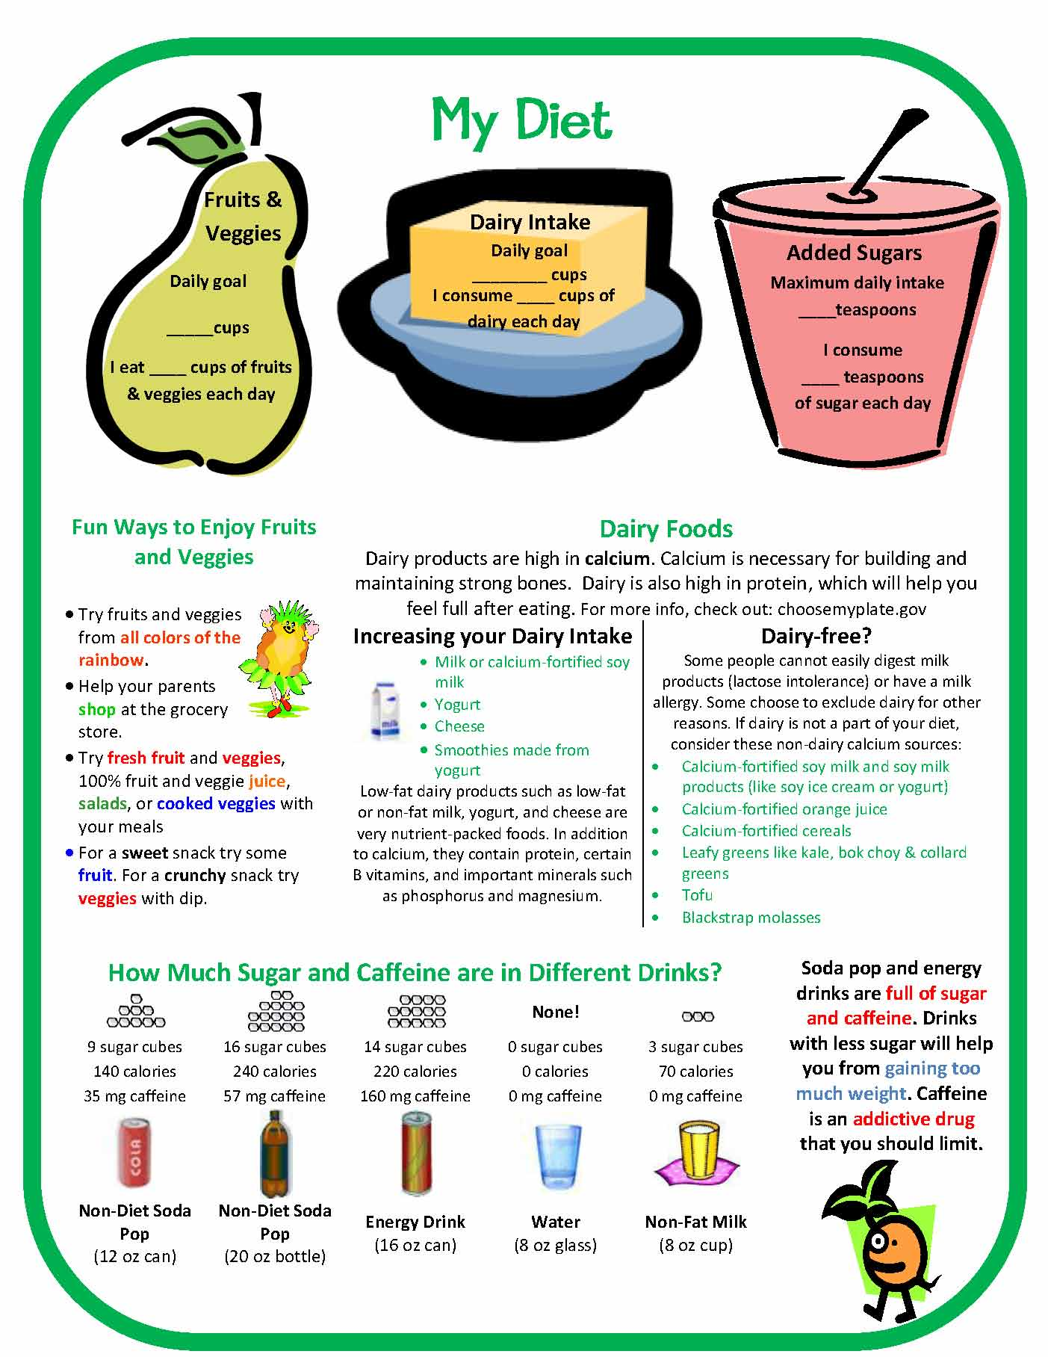 | __________________________________________________________________________________________________________________________________________________________ | 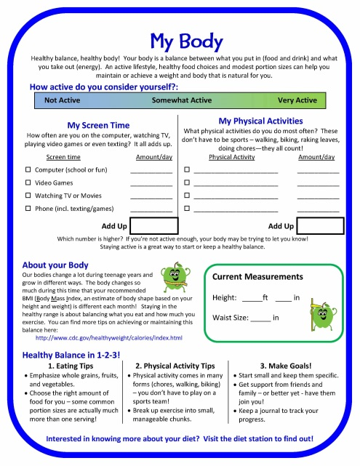 | ________________________________________________________________________________________________________________________________________________________________________________
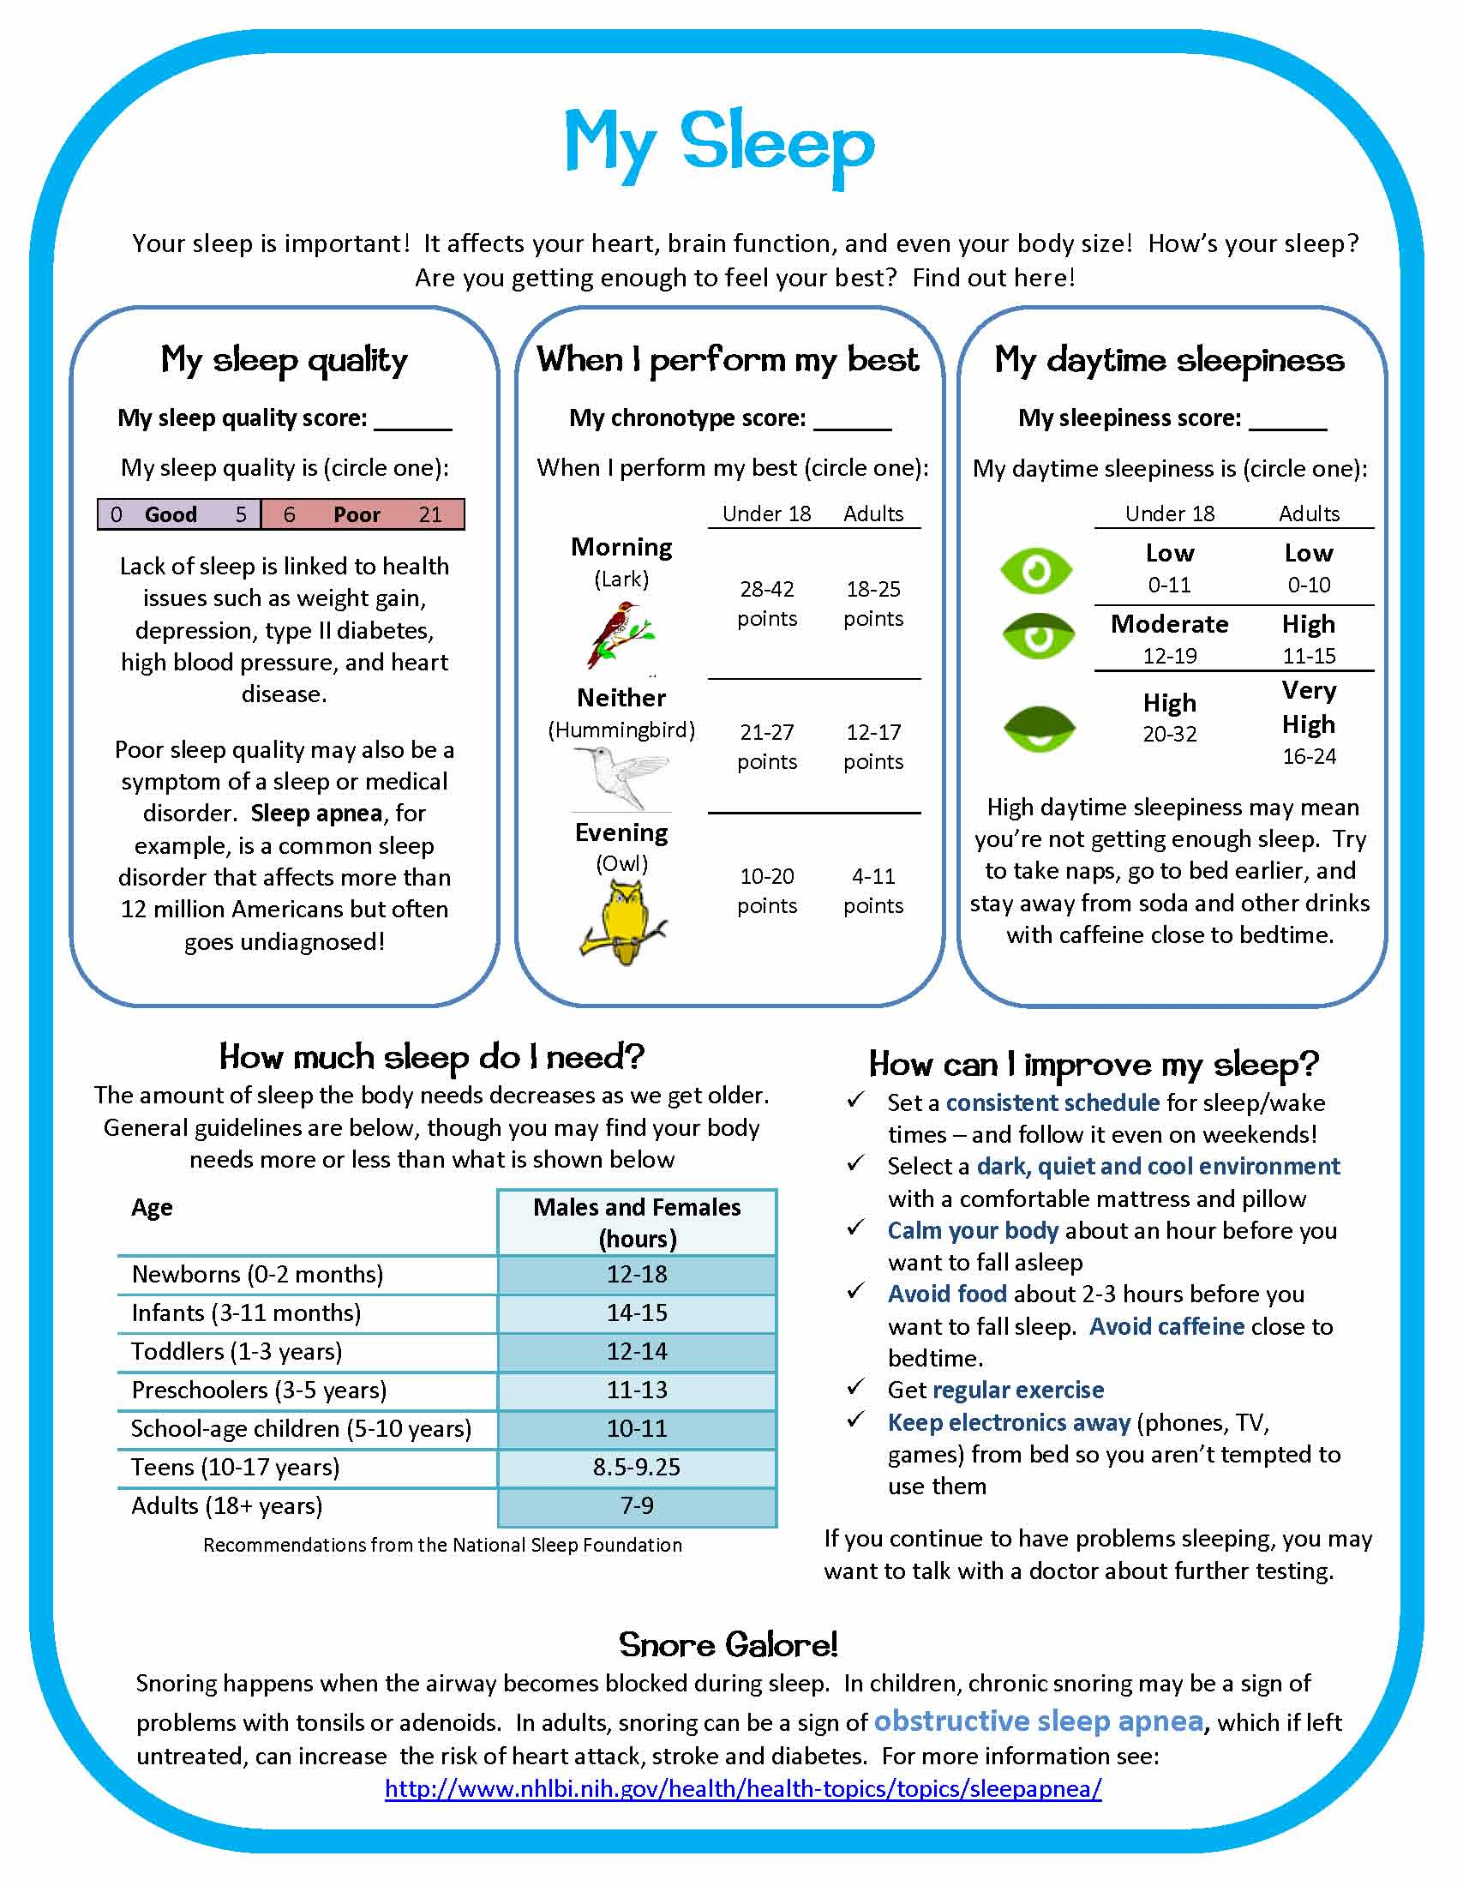 | ________________________________________________________________________________________________________________________________________________________________________________ | 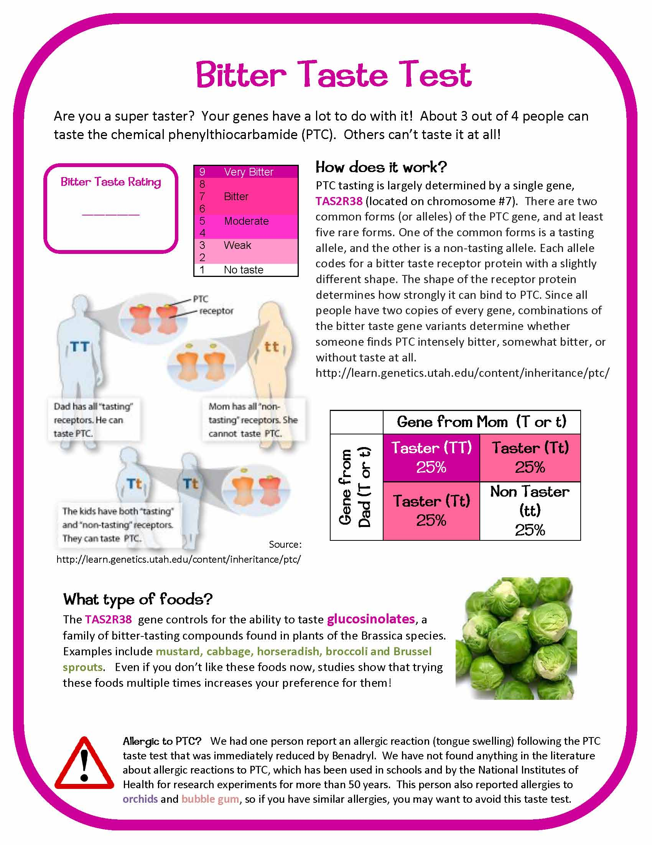 | ________________________________________________________________________________________________________________________________________________________________________________
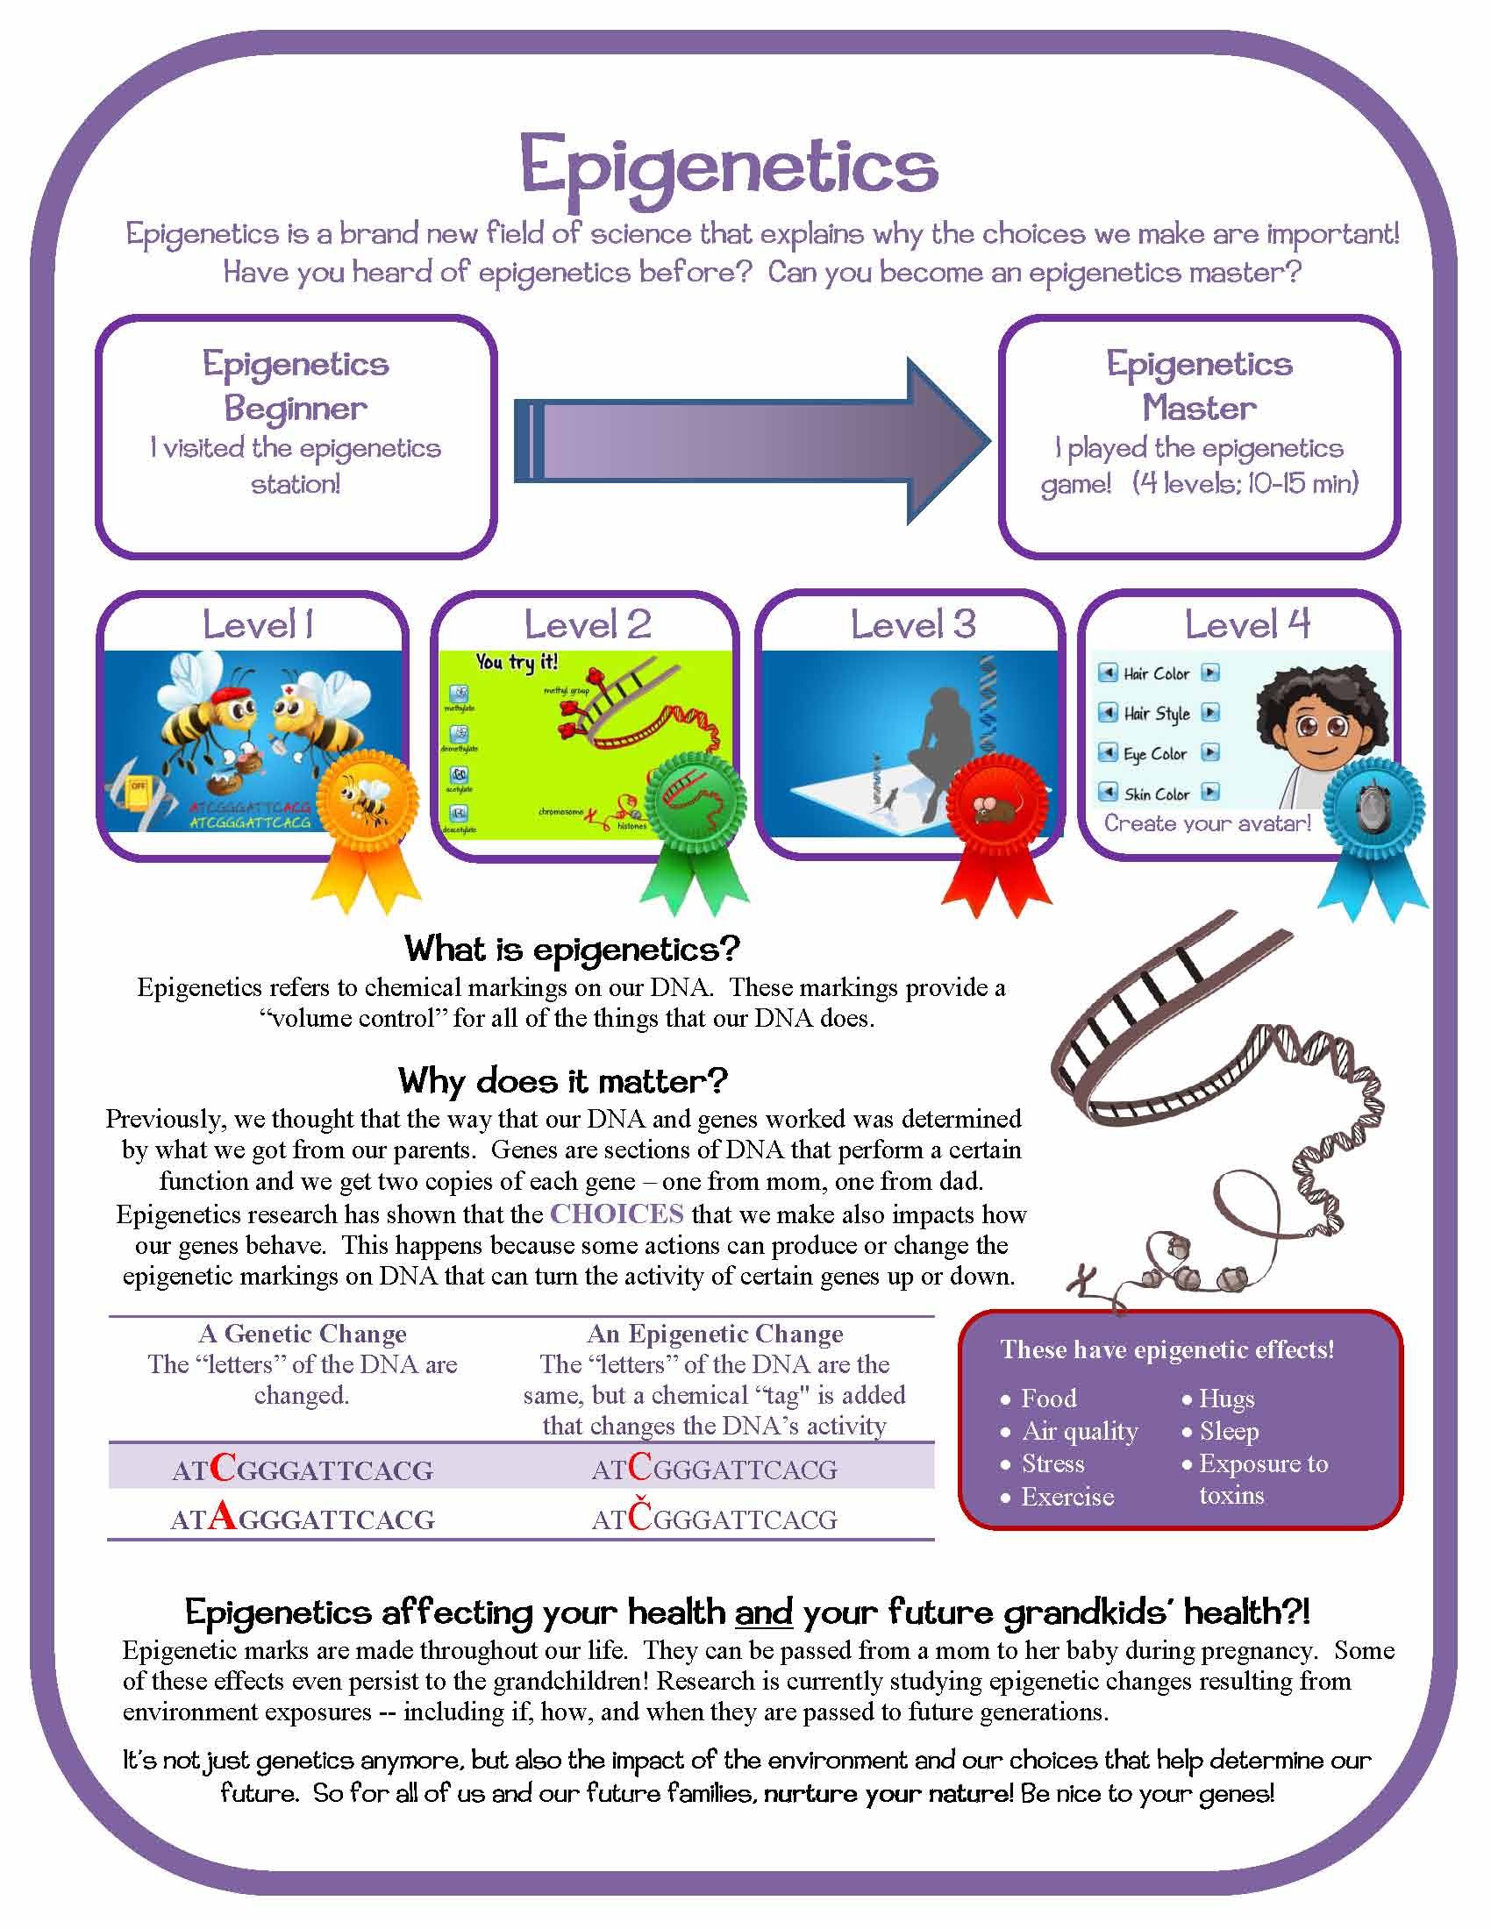 | ________________________________________________________________________________________________________________________________________________________________________________ | 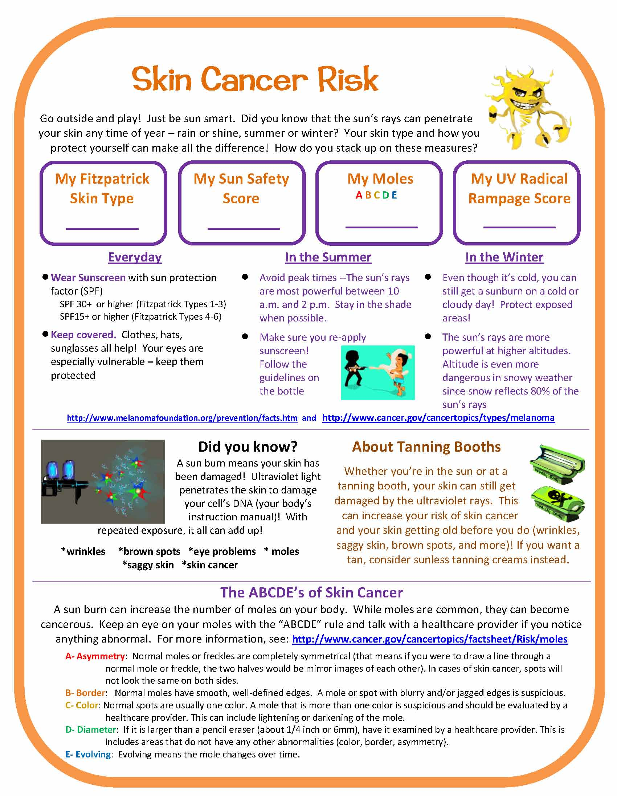 | ________________________________________________________________________________________________________________________________________________________________________________
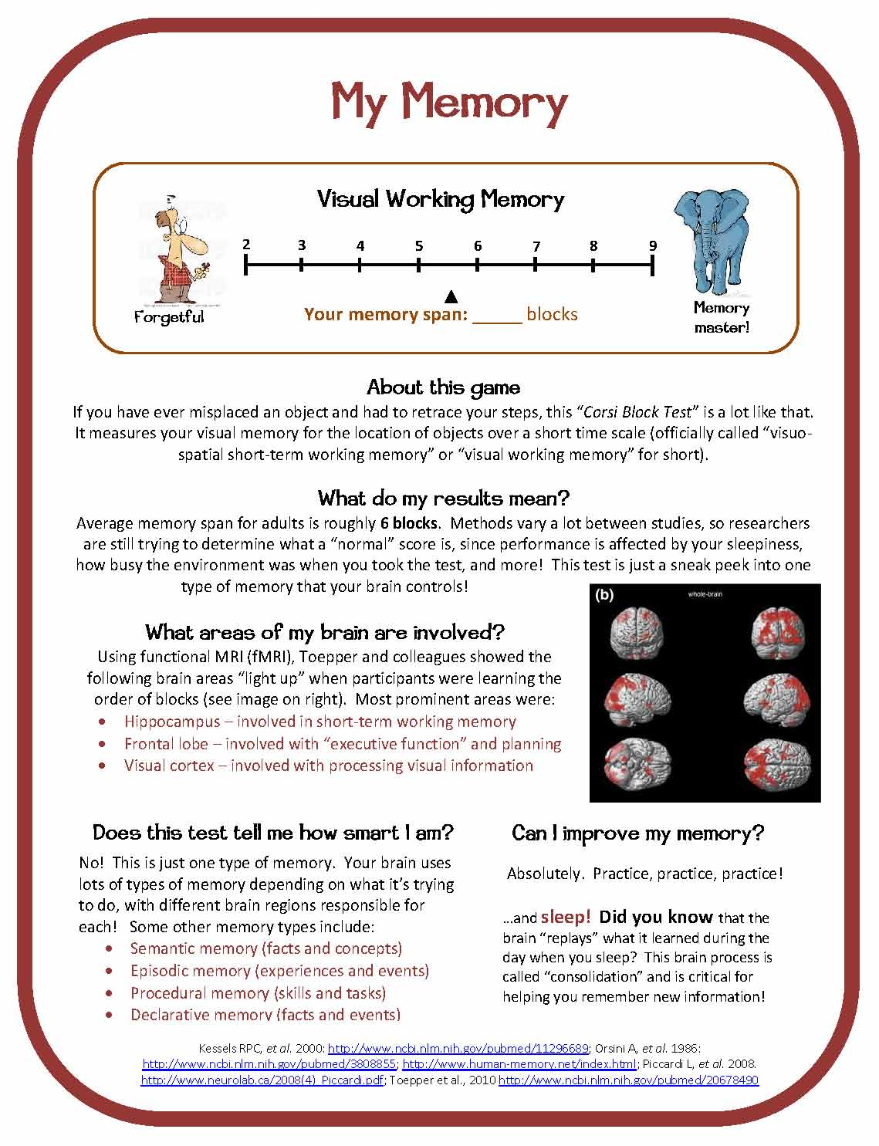 | ________________________________________________________________________________________________________________________________________________________________________________

Name ________________________
Before You Go to Let’s Get Healthy!
Work sheet #2
What I Know | What I want to learn during the Let’s Get Healthy! Fair | What I learned at the Let’s Get Healthy! Fair

