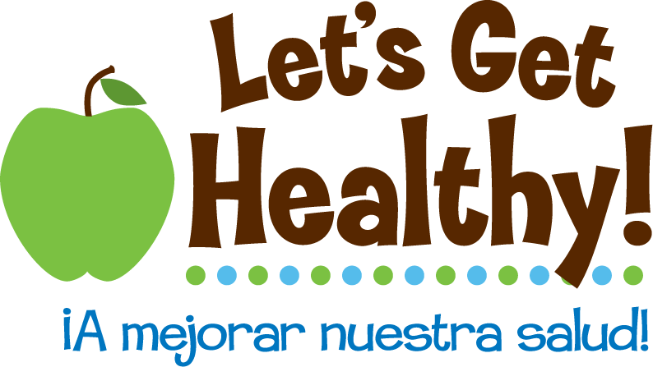
Trans-Generational Nutrition

Overview of Lesson Plan:

Students will learn about trans-generational nutrition through the metaphor of playing Go Fish. Students will understand the impact of trans-generational nutrition on their long-term health as well as the future health of their children and grandchildren. Students will conduct interviews of their mothers in order to begin investigating the effects of nutrition within their own family. Finally, by writing a letter to their future children, students will reflect on what they have learned and commit to better lifestyle choices today (diet and activity tips from the Let’s Get Healthy fair) that will positively impact the health for generations to come. A list of resources can be provided to students who wish to learn more on this topic and related scientific discoveries on the developmental origins of health and disease.

Big Understanding:

Trans-generational nutrition is the ongoing process by which the health of one generation is passed on to the next. A mother’s nutrition (food intake) and body composition (fat, muscle, and bones as well as metabolism/turnover) directly influences a child’s development and risk for disease later in life. Depending on the nutrition during a child’s first thousand days of life (conception to age two), a person will be more or less at risk for developing health problems later in life, such as coronary heart disease, type 2 diabetes, obesity, cancer, osteoporosis, etc. While no one has a fresh start, people’s daily choices (diet, exercise, etc.) make a significant difference on their long-term health outcomes and the nutrition they are able to provide for their children.

Essential Questions:

- What is trans-generational nutrition?
- How does a mother’s nutrition and body composition impact a child’s long-term health?
- How will my lifestyle choices today impact my health in the future and help determine the long-term health risks for my children?

Grades: 6-8

Subjects: Language Arts, Social Studies

Time Required: 1 or 2 class periods

Objectives:

- Students will understand the concept of trans-generational nutrition
- Students will gather and reflect upon health information from their mothers
- Students will commit to positive lifestyle changes (based on the Let’s Get Healthy fair)
- Students will articulate in writing what they have learned
- Students will develop a personal connection to this research and its powerful implications by considering their own lifestyle choices and the health of past and future generations

Materials:

- 5-7 standard decks of cards (depending on class size)
- Writing materials for each student

Preparation:

- Teacher should read the resources (listed below) on the developmental origins of health and disease in order to enhance understanding of trans-generational nutrition and related topics. Students may have questions and want more in-depth information, so it’s a good idea to direct them to these resources as well.
- Assign small groups for activity (below).

Activities/Procedures:

Go Fish (with a twist)
- Play 3 rounds of Go Fish in small groups

Debrief and Discuss
- Describe trans-generational nutrition and allow students to create the Go Fish metaphor, using the instructional strategy called Think-Pair-Share.
- Visually capture big ideas to validate students’ thinking and allow patterns to emerge.

Wrap up
- Summarize and say-back key points/examples to make sure everyone has a strong understanding of trans-generational nutrition.

Interview
- As homework, students will gather information from their mother in order to better understand the “cards” they have been dealt and “score” that is being passed on.
- Brainstorm, as a class, some examples of interview questions one might be interested in asking in order to gain insight into their mother’s nutrition and healthy lifestyle.
- Students write 15 or more original questions for their interview.
- To generate more ideas, have each student share out one question (no repeats). If students hear questions they like, they can add them to their own list.

Assessment/Reflection:

Letter to My Future Children
- Students write a letter to their future children, summarizing what they have learned and the impact of nutrition on the long-term health of their family across generations.
- Students should include personal commitments they are making (tips from LGH fair) to help create a healthier life for themselves and their children.

Resources: The following resources provide more in-depth information on trans-generational nutrition and related topics (in an interesting, understandable way). These recent scientific discoveries are changing the way doctors, researchers, mothers, and people around the world are thinking and acting in regards to nutrition and healthy living.


- TIME cover story by Annie Murphy Paul, 2010: “How the First Nine Months Shape the Rest of Your Life” http://www.time.com/time/magazine/article/0,9171,2021065,00.html. This article discusses the fetal origins of disease, the power to change behavior, and the impact of stress.

- David Barker's website: New insights into ending chronic disease http://www.thebarkertheory.org/. This site provides basic information on public health, nutrition in the womb, and nutrition-related health risks (coronary heart disease, high blood pressure, stroke, diabetes, obesity, osteoporosis, aging, breast and ovary cancer, etc.).

Oregon Education Standards:

English Language Arts
- EL.08.WR.03 Identify audience and purpose
- EL.08.WR.20 Demonstrate appropriate English usage

Social Studies
- SS.08.GE.06 Identify economic, cultural, and environmental factors that affect population, and predict how the population would change as a result
- SS.08.HS.01 Represent and interpret data and chronological relationships from history, using timelines and narratives
- SS.08.HS.03 Identify and give examples of chronological patterns and recognize them in related events over time

Go Fish Directions
- Goal: To collect the most sets of four
- Setup: 4-6 players in each group with one standard 52-card deck. Every student should have a paper and pencil to jot notes and keep score. Choose one official scorekeeper. Deal 5 cards to each player. All remaining cards are placed face down in a draw pile.
- Play: Choose a player to go first. On your turn, ask a player for a specific card (that you already have at least one of). For example, if I have a 9, I might say, “Sarah, do you have any 9’s?” If the player you ask has any cards you requested, he/she must give all of those cards to you. In the example, Sarah would have to give me all her 9’s. If you get one or more of the cards you request, you get another turn. You may now ask any player for any card you hold, including the same one you just asked for. When the person you ask has no relevant cards, they say, “Go Fish!” You then draw the top card from the pile. If you happen to draw a card that you just requested, show it to the other players and you get another turn. However, if you draw a card that’s not the one you asked for, add it to your hand, and it becomes the next player’s turn (go around the circle clockwise). When you collect a set of four cards, immediately show the set to the other players and place them face down in front of yourself.
- Score: Go Fish continues until either someone has no cards left or the draw pile runs out. Keep score by adding up the number of sets you had after each round (one set = 1 point). The score is cumulative, so the winner is the person who gets the most sets overall after three rounds (okay to tie).
- TWIST: After each initial dealing of cards (before the game begins), students write down (without others seeing) how they feel about their hand (confident, happy, worried, hopeless, not sure, etc.). At the end of each round, students write down how their hand turned out (positive/negative, similar/different to what they expected, feelings about how they played in relationship to the cards they were dealt). Don’t tell students why they are doing this part. They will find out after the activity.

Go Fish Metaphor
The cards you are dealt is similar to the way you are born with a certain level of vulnerability for health traits, risk for disease, etc. based on your mother’s nutrition (something out of your control just like the dealer passing out random cards). However, just like the hand you are dealt, your health risks are not set in stone (whether you’re dealt a great or lousy hand). Your strategies and actions during the game still has a significant impact on your outcome. Also, each round is a metaphor for each generation—it’s never a fresh start—but that doesn’t mean you cannot make a come back or go downhill after being in the lead. The score after each round, knowing it’s being carried over, physically, mentally, and emotionally influences the next round (or the next generation).

Think-Pair-Share

- Students write their feelings, opinions, and questions in response to the question, “How is trans-generational nutrition like Go Fish?”
- Students share with the person next to them, noticing similarities/differences and adding additional thoughts that arise.
- Students can share out with the class.

Note: Allow questions, contradictions, etc. because it’s opinion-based and debate will peak interest and push students to think more deeply about trans-generational nutrition.

Examples of Interview Questions
- Describe a typical dinner when you were my age. Where, when, what, and with whom did you usually eat?
- In a typical week growing up, how often did you eat fast-food? What were some of your favorite foods/drinks to order?
- Where did your family most often get food (grocery stores, farms, restaurants, fast-food chains, farmer’s markets, other)?
- Describe your diet and exercise when you were at your healthiest. When was this time in your life? What motivated you to make healthy choices?
- What was your diet and physical activity like just before and during your pregnancy?
- What foods were very traditional for certain holidays?

Notes and Tips for the Teacher
- Students who cannot interview their biological mother can interview a stepmother or another female relative/friend of that generation.
- While trans-generational nutrition focuses on maternal diet and body composition, current research suggests that sperm plays a role in this process as well.
- Emphasize that no matter what “hand one is dealt” it is still the individual’s choices and strategies that will help determine one’s outcome. Most importantly, their choices will directly impact their children’s “hand” the next round and so on across generations.
- Interview should be completed and brought back to class before students write the letter.
- Please be sensitive that the interviews and letters may be very personal, so if you want to have students share in some way, it’s best to keep it voluntary. Encourage kids to keep letters… maybe even one day give them to their children!
- Optional: Select key passages to share (from the resources listed on developmental origins of health and disease).
- Optional extensions: Students can interview their mother’s mother (grandma) as well. Students can do projects to visually capture the effects of trans-generational nutrition (timeline, poster, skit, etc.).

