
Physical Activity – How Healthy Are You?

Unit Overview: Students will analyze their own physical activity level, present their data, and compare it to the suggested activity level for adolescents.
Lesson 1: Gathering information – taking an activity survey
Lesson 2: What the Experts Say – Wed-based article review in a “Jigsaw” fashion
Lesson 3: Making data make sense – creating an organized display (graph, table, etc) from survey in lesson 1.
Lesson 4: Taking Bigger Steps with Data – mean of small group – prediction
Lesson 5: Making a pact – students will create a product that will show their commitment to better or continued health via physical activity.

Big Understanding:
- (Health) Physical activity is necessary to keep us healthy both now and into adulthood.
- There are recommended amounts and types of activities to attain and maintain optimal health.
- Physical activity can be fun!

Essential Questions:
- What is the recommended activity level for adolescents?
- What activities are considered beneficial for adolescents?
- What are the benefits of physical activity?
- How do we compare to the recommended levels of physical activity?
Grades: 4/5/6 (Can be modified easily for older students)
Subjects: Health, Science, Math, Language Arts
Time Required: 5 - 45 min class periods
Recourses:
- The Physical Activity Questionnaire for Older Children (PAQ-C) and Adolescents (PAQ-A) Manual, August 2004, College of Kinesiology, University of Saskatchewan
- Readwritethink, International Reading Association, 27 June 2012, <readwritethink.org>
- Grace, Elizabeth, “How Much Physical activity do Kids Need?”, kidsphysical activity, 14 July 2010
- Gavin, Mary L. (reviewer), “Why Physical activity Is Wise,” Kidshealth.org, February 2009
- “Success Stories,” Centers for Disease Control and Prevention, content source, “Division of Nutrition, Physical Activity, and Obsesity, Natinoal Center for Chronic Disease Prevention and Health Promotion”

Objectives:
- Students will examine their own activity levels and answer the attached survey.
- Students will compile the data from their classmates into a graph or table.
- Students will analyze the data and compare their finding to the recommended activity levels.
- Students will develop a display to share healthy physical activity recommendations with other students/family/community.

Lesson #1: Gathering the Information

Vocabulary to teach or review:
  - Aerobic/endurance physical activity - Brisk exercise that promotes the circulation of oxygen through the blood and is associated with an increased rate of breathing.
  - Flexibility Exercise – an exercise intended to elongate or stretch the connective tissues (tendons/ligaments)
  - Strength Training – exercises intended to strengthen major muscle groups

Teacher Preparation
- Review surveys and decide which survey is the best fit for you and your class.
- Decide on the method of delivery: paper/pencil, online survey tool, or perhaps clickers. (the latter two methods will provide immediate graphs, which you may not want to utilize for this particular lesson).
- Provide students time and guidelines to gather data. This will be different depending on which survey you decide to use and your method of delivery.

Note: There is no big anticipatory set with this activity, although I might suggest wearing your best workout gear or coaches outfit. An activity, talk, movie, or any kind of information tied to health and physical activity may skew student’s answers.
- Have students take one of the two attached surveys. The first survey is validated and is from as is from “The Physical Activity Questionnaire for Older Children (PAQ-C) and Adolescents (PAQ-A) Manual.” I have also included more elementary level survey that will be easier for students to pull data from for a later graphing activity.
- Use projection system to go over the survey with students prior to or during their survey time to allow clarifying questions.
- Provide students enough time to total their times if using the second survey.

Once they are finished with their survey, they can share and compare, if they choose, with an elbow partner (let’s face it, they are going to want to talk and compare their information). They will have more time to really dig in to this information later.
Gather surveys or ask them to put them in a safe place until Day #3.

Lesson #2 “What the Experts Say”
1. It’s time to find out what the “recommended dose” of daily activity is for an adolescent.
2. Ask student’s to make a prediction as to the amount of physical activity they should be getting in a day. Does it matter what kind of physical activity one does? Record their answers to revisit later.
3. Use the Jigsaw Reading Comprehension Strategy Activity to read and share the following web-based articles. For a good review on the Jigsaw lesson, visit the Read, Write Think Website. http://www.readwritethink.org/professional-development/strategy-guides/using-jigsaw-cooperative-learning-30599.html

Suggested guiding questions for this activity (recorded in a journal or other format):
1. How much should you be exercising each day?
2. Are there certain kinds of physical activities that you should be doing?
3. List three benefits of physical activity?
4. How are we doing, as a class(es), compared to the suggestions you have just learned about in regards to physical activity?

The first article is from Kidsphysical activity.co.uk, “How Much Physical activity do Kids Need?” This article is not as lengthy article, but it is geared towards adults. However, students reading on-grade level should be able to access the information for the grades indicated.
http://www.kidsphysical activity.co.uk/howmuchphysical activitydokidsneed.html

The second article is from the web site KidsHealth, “Why Physical activity is Wise.” This article is a longer article, but it has two distinct advantages for your struggling readers and ELD students. First, it has an audio component so students can listen to it. Additionally, it is available in both written and oral form in Spanish as well.
http://kidshealth.org/teen/nutrition_fitness_center/fitness/physical activity_wise.html#
http://kidshealth.org/kid/stay_healthy/fit/work_it_out.html
(second one is even easier – kids vs. teens)

Lesson #3: “Making Data Make Sense – Baby Steps”
1. Students will work in a pair or trio to discuss their individual findings on their surveys as well as their reflections in their journal.
2. As a team, what did they find out about time requirement and types of physical activity? It may help to record what they have found somewhere visible, so as they go into the next steps it is clear to all.

Task:
Create a graph, table, or chart that clearly shows their own weekly physical activity/activity level in the following areas.

- Aerobic/endurance
- Muscle Building
- Flexibility

Other things they may want to consider:
  - Days of the week
  - Total minutes
Anticipate this being a trial and error for students. Although their product should be based on their individual data, allowing them to work together will help some get the creative juices going and reduce frustration and downtime for some of your struggling learners.

They can use the simple scoring guide found with these lessons or you can create your own. This is step one of the data gathering adventure.

Lesson #4: Making Data Make Sense – Bigger Steps
Journal task:
Once students have compiled their information, ask them to work in groups of 4 to total their minutes of physical activity daily.
1. What is the mean number of minutes physical activity daily in their team?
2. Make a prediction: Will this be the same for other groups in the class? Why or why not?

As a class, gather the data from each group. Now ask them to figure out the mean minutes for the classroom. How are they doing compared to the suggested amount of physical activity?

Extension: You may decide to do this same math with the students, but in each category of physical activity.

Lesson #5: Lifelong Healthy Choices – Making a Pact
Students will make a “plan” to attain or maintain their health by taking part in a regular physical activity routine. To review a couple of examples of how other students are doing this, visit the Center for Disease Control (CDC) Website and review Harold’s and Maria’s fitness routines.
http://www.cdc.gov/physicalactivity/everyone/guidelines/children.html/

Students can create this plan any way that you choose. Here are a few ideas.

- Display boards (display their current data, recommended data – displayed in same format as their data, with suggested activities that they can easily do and can maintain).

- A letter to an influential adult (parents, teacher, guardian, principal), outlining what they found and what they plan on doing in the future.

- Creating a table, similar to those seen on the CDC website.

- Creating and signing a contract.

Once these are created, display your “pacts” in school or in the classroom. Celebrate by an extra long recess break.

Always remember, you are an influential model in this process. It’s always good to “Walk (or run), the talk.”

Physical Activity Questionnaire (Elementary School)
We are trying to find out about your level of physical activity from the last 7 days (in the last week). This includes sports or dance that make you sweat or make your legs feel tired, or games that make you breathe hard, like tag, skipping, running, climbing, and others.
Remember:
1. There are no right and wrong answers — this is not a test.
2. Please answer all the questions as honestly and accurately as you can — this is very important.

School Name: ______________________ Teacher Name: _______________________

Age: |  | Grade: |  | Gender | O M | O F

1. Physical activity in your spare time: Have you done any of the following activities in the past 7 days (last week)? If yes, how many times? (Mark only one circle per row.)

 | No | 1-2 | 3-4 | 5-6 | 7 times or more
Skipping | O | O | O | O | O
Rowing/canoeing | O | O | O | O | O
In-line skating | O | O | O | O | O
Tag | O | O | O | O | O
Walking for physical activity | O | O | O | O | O
Bicycling | O | O | O | O | O
Jogging or running | O | O | O | O | O
Aerobics | O | O | O | O | O
Swimming | O | O | O | O | O
Baseball, softball | O | O | O | O | O
Dance | O | O | O | O | O
Football | O | O | O | O | O
Badminton | O | O | O | O | O
Skateboarding | O | O | O | O | O
Soccer | O | O | O | O | O
Street hockey | O | O | O | O | O
Volleyball | O | O | O | O | O
Floor hockey | O | O | O | O | O
Basketball | O | O | O | O | O
Ice skating | O | O | O | O | O
Cross-country skiing | O | O | O | O | O
Ice hockey/ringette | O | O | O | O | O
Other: | O | O | O | O | O
 | O | O | O | O | O

2. In the last 7 days, during your physical education (PE) classes, how often were you very active (playing hard, running, jumping, throwing)? (Check one only.) |  | 3. In the last 7 days, what did you do most of the time at recess? (Check one only.)
O I don’t do PE  O Hardly ever  O Sometimes  O Quite often  O Always |  | O Sat down (talking, reading, doing schoolwork  O Stood around or walked around  O Ran or played a little bit  O Ran around and played quite a bit  O Ran and played hard most of the time

4. In the last 7 days, what did you normally do at lunch (besides eating lunch)? (Check one only.) |  | 5. In the last 7 days, on how many days right after school, did you do sports, dance, or play games in which you were very active? (Check one only.)
O Sat down (talking, reading, doing schoolwork  O Stood around or walked around  O Ran or played a little bit  O Ran around and played quite a bit  O Ran and played hard most of the time |  | O None  O 1 time last week  O 2 or 3 times last week  O 4 times last week  O 5 times last week

6. In the last 7 days, on how many evenings did you do sports, dance, or play games in which you were very active? (Check one only.) |  | 7. On the last weekend, how many times did you do sports, dance, or play games in which you were very active? (Check one only.)
O None  O 1 time last week  O 2 or 3 times last week  O 4 or 5 times last week  O 6 or 7 times last week |  | O None  O 1 time  O 2 - 3 times  O 4 - 5 times  O 6 or more times

8. Which one of the following describes you best for the last 7 days? Read all five statements before deciding on the one answer that describes you.
A. All or most of my free time was spent doing things that involve little physical effort O

B. I sometimes (1-2 times last week) did physical things in my free time (e.g. played sports,
went running, swimming, bike riding, did aerobics O

C. I often (3-4 times last week) did physical things in my free time O

D. I quite often (5-6 times last week) did physical things in my free time O

E. I very often (7 or more times last week) did physical things in my free time O

9. Mark how often you did physical activity (like playing sports, games, doing dance, or any other physical activity) for each day last week.

 | None | Little bit | Medium | Often | Very Often
Monday | O | O | O | O | O
Tuesday | O | O | O | O | O
Wednesday | O | O | O | O | O
Thursday | O | O | O | O | O
Friday | O | O | O | O | O
Saturday | O | O | O | O | O
Sunday | O | O | O | O | O

10. Were you sick last week, or did anything prevent you from doing your normal physical activities? (Check one.)
O Yes  O No |  | If Yes, what prevented you?

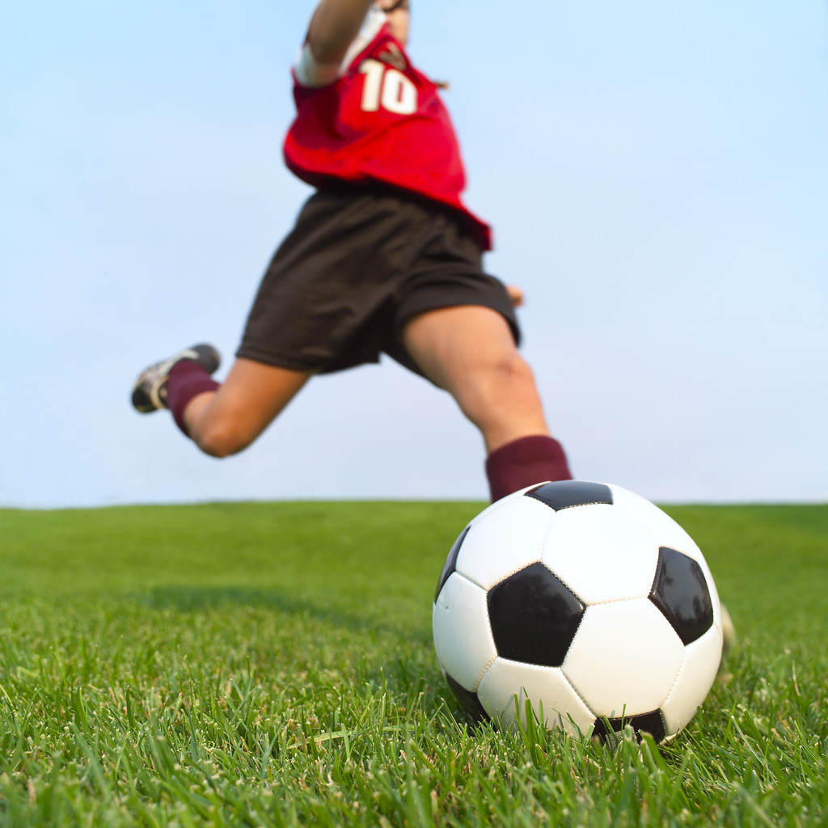
Physical Activity Survey How Active Are You?

Name: _______________ Age:_____ Grade: _____ Date: _____________________

For 1 and 2, choose the ONE that fits the best for each recess.
1. In the last 5 school days, what did you do at your lunch recess?
___ Walked around and talked with friends.
___ Sat down and read or talked to friends.
___ Played on the swing or monkey bars.
___ Played tag or soccer.
How long is your lunch recess? _______ Total time: ______

2. In the last 5 school days, if you had a second recess, what did you do?
___ Walked around and talked with friends.
___ Sat down and read or talked to friends.
___ Played on the swing or monkey bars.
___ Played tag or soccer.
How long is your second recess? _______ Total time: ______

3. During your P.E. (physical education) classes in the last 5 school days: (check ALL that apply).
____ Played a vigorous game that made me sweat for most or all of the time (soccer, capture the flag, field hockey).
____ Ran, jogged, jumped rope, or walked VERY quickly all or most of the time (aerobic).
____ Worked on muscle strengthening skills such as push-ups, sit-ups, or tumbling for most or all of the class.
____ Learned a skill such as dribbling a soccer ball, throwing a Frisbee, or other skill that did not cause you to sweat or breathe hard.
___ I did not take part in gym during this time.
How long is your gym class? _____ How many classes? ____ Total time:_____

4. In the last 5 school days, after school, did you take part in any of the following activities?
____ Soccer, football, swimming, running
How many nights per week? ____ How many minutes per night? _____
Total minutes: _____
____ Dancing, riding bike (include to and from school), walking (include to and from school)
How many nights per week? ____ How many minutes per night? _____
Total minutes: _____
____ Strengthening sports such as Martial Arts or gymnastics.
How many nights per week? ____ How many minutes per night? _____
Total minutes: _____
_____ Other activity: Please write it in here: __________________________
____ I do not do any activities after school.

Thinking about last weekend (Saturday and Sunday):
5. Did you take part in any of the following? Choose all that apply.
____ Soccer, football, swimming, running
Total minutes: _____
____ Dancing, riding bike (include to and from school), walking (include to and from school)
Total minutes: _____
____ Strengthening sports such as Martial Arts or gymnastics.
Total minutes: _____
____ Other activity: Please write it in here: __________________________
Total minutes: _____
Individual Data Display - How Active Are You?

Each item is scored with a 1 – 5 rating.
1 – Did you READ this scoring guide???? Hello!!!!!
2 – I read it but really didn’t feel like doing it, so I tried… just a little.
3 – Fair attempt. Could be neater or perhaps check spelling.
4 – You are darn close to perfect here.
5 – You did it, did it well, and your BEST effort is evident.

1. Title (The subject should be clear and obvious, spelled correctly, neat) _____

2. Axis or keys are clearly marked (reader should be able to know what they are looking at without asking) _____

3. Categories of physical activity are clearly labeled _____

4. Colored (you decide – I like color and it should help the readers understand your display) _____

5. Your name is clearly displayed (This should be a freebie!) ___

Total: _____/25 points

