

Thank you for your interest in Let’s Get Healthy!. This document contains more information about our program so you can plan an event that’s right for you.

Contents
Planning Your Fair 2
Audience 2
Space Needs 2
Set-Up and Break-Down Needs 3
Attendance by Other Groups/Partners 3
Computer Needs 4
Volunteer Needs 4
Publicizing the Event 5
Returning Results 5
Information for Schools 6
How does the event work in schools? 6
Notification and Communication with Parents 6
Method for Student Participation 6
Volunteers and Parent Teacher Organizations 7
Counselors Present 7
Maximizing Student Impact 7
Day of Fair 7
Returning Results 8
Evaluation Options 8
Additional Questions? 8
Example Permission Slips 9

Planning Your Fair

Each Let’s Get Healthy! fair is different and can be completely tailored to your event. To decide what fair is right for you, here is some more information about what to expect.

Audience
The audience makes a big difference in the equipment we bring. We try to tailor each event to the audience (schools, community event for adults, community event for families, etc.) If you’re hosting a school event, there are several additional pieces you’re going to want to keep in mind. Please see “Information for Schools” at the bottom of this document.

Space Needs
Facilities: Most of our events are held in gymnasiums or large banquet spaces. We can be as small as one table (for one station) or take up an entire 8000 square foot gymnasium or ballroom. The venue is up to you and what you would like to have available at your event. Communities and schools provide the venue, unless another agreement has been made with Let’s Get Healthy! organizers. We have held outdoor events for groups (though tents must also be provided by host organizers to protect equipment).

In order to plan for your event, we ask for the floor plan of your location, with dimensions and locations of doors and outlets. These logistics are critical for our planning purposes, which we load into Google Sketchup for a 3D rendering of your event. This helps us to determine what we can bring and how many additional groups can attend. Also, please keep in mind that we transport everything on rolling racks, so handicap access is necessary to bring in equipment and supplies in a timely and efficient manner.

Table and Chair needs: Tables and chairs are provided by the hosting organization. These tables must be available at set-up time so we can set-up computers, etc. The number of tables and chairs is determined based on the stations requested and the space available. See examples below:

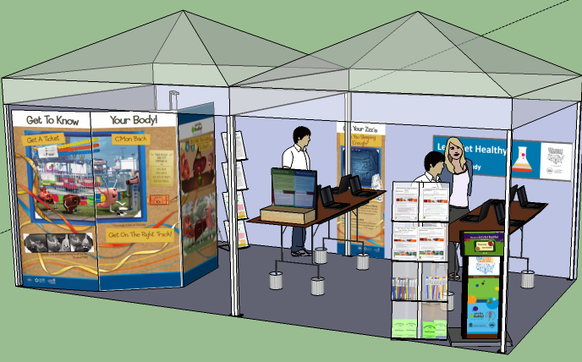 | 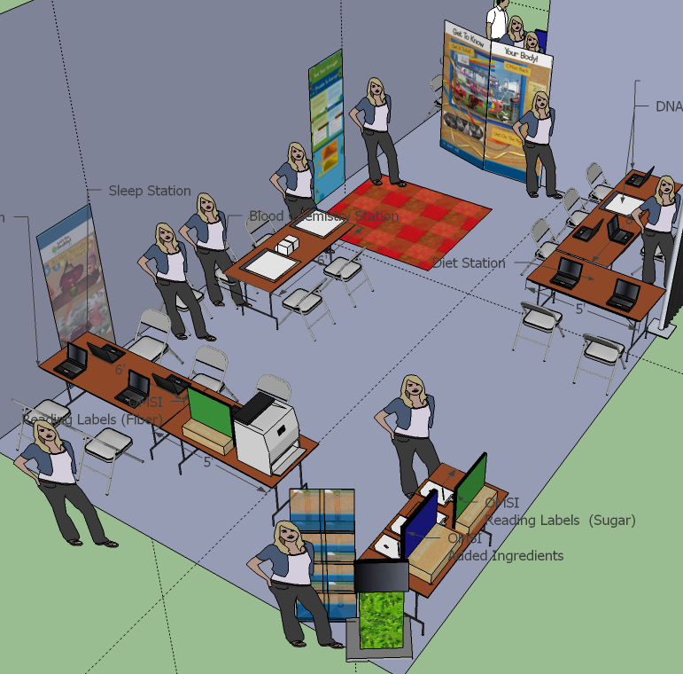 | 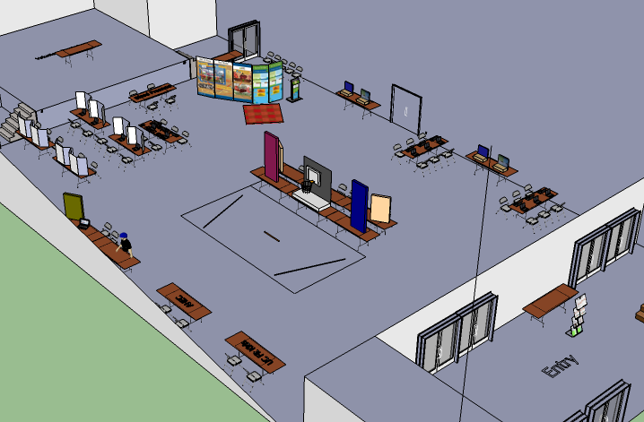
200 sq ft exhibit in Washington DC  Community audience  2 tables, 2 chairs  3 stations (tight) | 2000 sq ft exhibit in Hermiston, OR  Community audience  8 tables, 16 chairs  All stations (tight) | 8000 sq ft exhibit in La Grande, OR  School audience  17 tables, 35 chairs  All stations, extra groups

Set-Up and Break-Down Needs
It takes a long time to set up (4-6 h) and break down (2-3 h) the exhibit. Therefore, it’s critical that the venue is available prior to and after the event to accommodate this additional time.

Set-Up Needs: For morning events, we typically request the venue be reserved the afternoon prior so that we can set-up in the evening (important that the facility is able to be locked and secured). For afternoon and evening events, we’re able to set up in the morning. Again, each fair is different, so please talk to a Let’s Get Healthy! fair organizer about your event. Please let us know where you’d like us to unload if parking is an issue (must be handicap accessible). Also, we request that all tables/chairs and additional computers be available at this time for set-up and testing.

In order to plan for your event (especially when setting up the day before), it is important for us to have an after-hours contact – someone who you would like us to contact if there is an after-hours question or issue. This could range from table issues to electricity to getting locked out. We've only needed this person once before, but having this number in hand on the off-chance that something happens is hugely helpful and mind-relieving if the situation does arise. We've found custodial staff are our good, good friends. Likewise, who would you like to be our main contact during the fair that day in case any fair-related issues come up (ranging from easy issues to more concerning ones, like incidents of child/elder abuse which must be reported by law.)

Having tables already set up for us when we arrive makes things go much, much faster, though we know this isn’t always possible.

Break-Down Needs: We have volunteer shifts extend 30 minutes past the close of an event to help us break down their stations. We can get a lot done in 15 minutes. Still, it typically takes 2-4 hours to get things packed and loaded. If you have additional help who can speed things along during the initial break-down time, we would welcome it though it is not required.

Attendance by Other Groups/Partners
We have a number of partners with education and/or research exhibits who may be available to attend your event. You are able to choose which of these groups you would like to attend. We will then ask to see if they are available. Some of our partners include:
- Portland Alcohol Research Center (PARC) -- Provides education about the effects of alcohol in the brain. They have vision-shift goggles and a basketball demonstration that is a huge hit with kids to illustrate the effects of alcohol on the brain.
- Behavioral Neuroscience – Education and research group that helps kids understand learning and the brain. They use whack-a-mole and “memory island” games that the kids enjoy to also study the effects of being left or right handed on memory.
- Methamphetamine Abuse Research Center (MARC) – Educational group that helps kids understand the effects of drugs on the brain.
- ThinkFirst - Education group who promote helmet and head safety. They have several games that promote brain safety as well as education materials for kids.
- Area Health Education Center (AHEC) - Provide education about body systems as part of "In a Boxes“ that are available for free teacher loan. These boxes cover the gut, brain, eyes, ears, etc. They typically bring one or more of these boxes for the kids and teachers to explore
- Orthopedics and Knee Strength -- Education and research group who educate kids about osteoarthritis in student athletes. Kids learn how their knees work and how osteoarthritis develops. They also have a knee survey which they link to our body composition data, thereby allowing them to study the relationship between knee strength and body weight.
- Other – Have other interests? Let us know, we may be able to find a group to address your needs.

Computer Needs
We bring ~17 laptop and touchscreen computers to events (~2-6 computers/station) and learned that we can boost throughput if the host organization has additional computers to loan. This is especially effective at school events to reduce lines. We can add up to 80 computers for your event based on our current server capacity. Our programmer would load the program for your event during set-up time and remove it before we leave. If you would like to have additional computers at your event, below are the specifications needed.

SYSTEM REQUIREMENTS
Windows
• Intel® Pentium 4 or faster Processor
• Microsoft® Windows® XP / Vista / 7
• 1GB RAM
Macintosh
• Intel Core™ Duo or faster processor
• Mac OS X v10.4.9 or later
• 1GB RAM
Linux
• Intel Pentium 4 or faster processor
• Fedora Core 12, Ubuntu 9.10, or openSUSE® 11.2
• 1GB of RAM

We request that you let Let’s Get Healthy! fair staff know if you would like to use additional computers so that we can plan space accordingly and let our programmer know. If you have any computer-related questions about the program of the specifications described above, you or your IT person can contact Stephano directly (Cetola@ohsu.edu).

Volunteer Needs
All of our events are completely volunteer-run. Volunteers come from all backgrounds, including medical professionals, pre-professional and undergraduate students, community members and parents of students going through the exhibit.

Volunteer Registration: We ask that host organizations begin the recruiting process and have potential volunteers register on our online site. This online registration site allows volunteers to indicate their availability and station preference, as well as if they have additional needs (like transportation, etc.) or background experience (as an expert, translator, etc.). Let’s Get Healthy! fair organizers will assign volunteers to stations based on interest and experience.

Link to our website (with more information and link to volunteer registration):
www.letsgethealthy.org

Direct link to volunteer registration:
http://healthdiscoveries.wufoo.com/forms/lets-get-healthy-volunteer-registration/

Volunteer Training: All volunteers are required to have Responsible Conduct of Research (RCR) training as well as station training before they work with any fair participant. RCR training can be taken online in advance or Let’s Get Healthy! fair staff can train all volunteers on-site. Depending on the time of fair, training is either immediately before a shift (most events) or the day before (for large events)

Volunteer Break Area: Since shifts are several hours in length, we ask host organizers for a space where volunteers can go when they need a break. We typically provide light snacks (granola bars, bananas, etc) and water for our volunteers in this area. Volunteers can bring additional food with them as needed, or if there’s a location nearby that you recommend where volunteers can buy food to eat something more substantial (e.g. school cafeteria), please let us know so volunteers can plan accordingly.

Publicizing the Event
Hosting organizations usually are the ones who promote their event. We have flyers available in English and Spanish that you can adapt for your event. Two flyers are available: one that promotes the event and the other that requests volunteers. Both are available for your use. Please contact Let’s Get Healthy! to obtain these flyers.

Returning Results
Results to Participants: All participants will receive tailored feedback at each of the stations they visit. This information is typically printed on a sheet that is labeled only with wristband ID number, so no information can be used to identify a person if dropped.

We have plans to develop an online site that allows participants to view their results after the fair and see how they compare to national recommendations and other results from their region; however, this feature is not yet available.

Results to Organizers: One of the key features of this program is that summary data are returned to fair organizers so they can improve the health of their school/community. We have plans to develop an algorithm to have this automatically generated at the end of the event, but this feature is not yet available and is calculated by staff after the event. If you are interested in the data, please let Let’s Get Healthy! staff know.

Also, we have approval to allow release of raw data for approved research projects and student analysis (e.g. for classroom lessons in statistics, analysis by masters projects, etc). There are regulatory approvals that must first be made in order to release any data, so if this is something that is of interest to you, please contact Let’s Get Healthy! staff. If summary data is preferred, that is also available and easier to release. We take privacy of our participants very, very seriously.

Information for Schools

How does the event work in schools?
School events are very different than community events in terms of planning. It is critical that parents are well-notified about the upcoming event since Let’s Get Healthy! is an education and RESEARCH exhibit. Also, some of the information that students learn about their health may be sensitive in nature (body size, in particular), so proper planning helps minimize unanticipated issues. Principals must be aware and approve of the event at their school and/or with their students. Our motto is ‘no surprises’.

Notification and Communication with Parents
Most of the schools with whom we have partnered have indicated that sending home a letter to parents that notifies them about the event has been very helpful. In the past, we used opt-out forms for student participation; however, we now use opt-in forms (permission slips) so that parents are more informed about who we are and what we measure. Again, since Let’s Get Healthy! is an education and RESEARCH exhibit and some of the information that students learn may be sensitive in nature (body size, in particular), it is really important that parents know what is coming so they can opt their child out of the event. We have examples of this text for you to use at the end of this document.

Some previous examples of how schools communicated the event to parents include:
- Providing information about the event with permission slip (see example)
- Use of automated phone call
- Including information in school newsletter
- Email from school (including listservs, etc)
- Information on school’s website
- Link to our website that has a 3-minute video on what we’re all about (available through our website: www.letsgethealthy.org )

Parents are welcome to contact us at any time if they have any questions about us, our mission or goals. Also, we encourage parents to volunteer at the event, which allows them to see first-hand what we’re all about.

Method for Student Participation
All information collected during Let’s Get Healthy! is anonymous and we do not “track” students in the literal sense. We use the combined data to look at how the whole student body changes over time, not individual students (which we have no way of knowing). Maintaining anonymity while ensuring parents are appropriately notified is a constant balance. For that, we rely on the school’s help.

    - Overall: Inclusion of students should be an opt-in so that parents are notified. Teachers would manage these permission slips and who can attend the event. Teachers would distribute wristbands and information sheets to students who return permission slips just before coming to the gym to maintain anonymity of students. Wristbands are imprinted with a random 8 digit number, so that no student can be identified from their number.
    - Time: Permission slips should be given at least one week in advance.
    - Method: Our parent advisory board recommended the use of paper and electronic options since not all parents have email or would get the permission slip the child brings home. We would love to use an online permission slip to make things easier for parents, if this exists at the schools. Information letters are kept short with links for more information.
    - Day of Event: Teacher will handout bracelets in class just before students come to the event. There should be an alternate activity for kids who don’t return permission slips. Please see our teacher guide and lessons for examples.

Note: Some school events are held during the school day with community-wide events that evening. We request permission slips only for the school-based event. We have IRB approval to conduct the event with participants of all ages once verbal assent (approval) is obtained from the potential participant.

Volunteers and Parent Teacher Organizations
School events take lots of volunteers. We encourage you to recruit parents to help and sign up on our registration page (see information above). Also, we have found Parent Teacher Organizations (PTOs) to be very helpful in recruiting volunteers.

Counselors Present
Some of the information is very sensitive to students (especially body composition information). We have a panel of child psychology experts who have reviewed our material; however, we encourage teachers to talk with their students about what to expect. Also, we recommend that schools have their school counselor and/or health teacher present to help kids with any issues that may arise. Students are going to want to compare results despite our best efforts to stop this, so it’s important that teachers are well-informed about the event and what to expect.

Maximizing Student Impact
Learning impact has been reported to be highest when the event is bookended by lessons and discussions in the classroom. We have a teacher guide and a series of teacher-created lessons from which teachers can choose to supplement their curriculum and classroom goals. We would love to hear your feedback about how you talked with your students about the event and what they learned. We also welcome suggestions to improve our future efforts.

Day of Fair
Attendance and Flow: We can accommodate 100 students/hour on average; however, we've done anywhere between 80-150 students per class period. We understand that some class periods are just larger than others. Anywhere under 125 is very easy to accommodate and provides a nice "critical mass" where students can really start feeling the energy of the event. 150 can be done, but it is busy and kids have to wait for stations much longer than we'd like. Again, lines can be reduced if the school has extra computers to loan for the event. In the past, we've done events that are 50 minute class periods with 5 minute breaks in between (though we’ve also done 60 minute periods with no breaks – more hectic). 50-60 minutes is the minimum time you'll want because it takes about 5-7 minutes for kids to get there before they're allowed into the gym to visit the stations (some of which easily take 7 minutes when there is no line). Despite the amount of time allotted, we always get requests for extra time. We use a whistle to help kids know when 10 and 5 minutes are left. This also helps teachers know when it's time to start rounding up the students. Again, every event has been different and we are completely fine working with your number of students and schedule that you'd like to use (many schools have created special schedules for the day). Another option used by St Helens Middle School was to allow some kids to come back during lunch time (they had no classes coming through during this time otherwise, so it was a nice option) and after school. Short version: however you'd like to send your kids through is fine by us. We just need to know the schedule, as it helps us plan for each wave of students.

Wristbands and Information Sheets: These will be passed out by the teacher in the classroom. A member of our staff can talk with students if you’d like. Time to distribute these will vary, somewhere between 5-10 minutes before students will get to the gym. Wristband numbers are a randomly-generated 8 digit code, with wristbands being passed out randomly to students. These features help keep the event anonymous for participants.

Attendance by Other Groups: We highly recommend other groups attending. At first, we thought it may take time/attention away from the research stations, but it turned out not to be that way at all. Since the research stations are voluntary, it provided some relief for kids who didn't want to do the stations. Plus, it gave students something to see when they were between stations and it made the flow better as there was always something for a student to do.

Returning Results
Please see general information for details on student and teacher access to summary and raw data.

Evaluation Options
We work with schools to evaluate the effectiveness of the event with students. Our program handles the printing, processing and analysis of surveys. Schools are welcome to use the results, which are also used for publication purposes. We different types of pre/post surveys available which are typically administered one week before the fair (pre-survey) and two weeks after the fair (post-survey):

- Evaluation Survey: Assesses the overall impact of the fair and attitudes towards research (for grades 7-8; takes 10 minutes to complete)
- Diet Survey: Assesses student interest in diet and changing dietary patterns. (for grades 4-9; takes 10 minutes to complete)
- Sun Safety Survey: Assesses student behaviors, attitudes and knowledge about sun safety (for grades 4-9; takes 10 minutes to complete)

Matching Pre/Post Responses: In order for students to remain unidentified but to allow researchers to link pre- and post-fair survey responses, students create a unique identifier number using a derived code that is known only to them. The 6 digit derived code uses two numbers of the day of birth, the first two letters of their mother’s first name and the last two digits of their phone number. For example, a student whose birthday is “March 12^{th”}, their mother’s name is “Jane” and their phone number is “123-4567” would have a derived code of “12JA67”. For students who do not know their mother’s first name or their phone number, they can choose alternate numbers and letters to derive their code. Only the students will know their derived codes. Student pre/post survey results are NOT linked to data collected as part of the health fair.

Additional Questions?
Please contact us! We are more than happy to answer any questions you may have.

Example Permission Slips
While we are not required to use permission slips for students to participate, we find that this process helps to inform parents so that there are no surprises. Below are two options, which you’re welcome to adapt to fit your needs. Please note that teachers are required to manage permission slips to maintain anonymity of students to OHSU. If you would like our information sheet or any other documents to include, please let us know.

Example Letter Option #1 -- to be edited and put on your school’s letterhead:

Date

Dear Parent,

Personalized health and healthy lifestyle information is important for our students. We formed a unique partnership with Oregon Health and Science University to allow students learn about their own health while contributing to science. Researchers will be coming to our school on __________ so students can visit six health stations and a variety of hands-on exhibits to learn about their overall health. The exhibit (Let’s Get Healthy!) is an education and research exhibit whose data feedback stations help students learn about their diet, body composition, blood pressure, cancer information and sleep patterns. Students will spend less than an hour of time going through these stations to learn about choices and collect data about themselves. The stations are staffed by trained OHSU staff and community volunteers – all stations are voluntary and confidential (anonymous) in nature.

We know that the information from these stations can be highly personal and can cause some anxiety about personal wellness. For example, students have the option of learning about their body fat percentage, which is important to know for health reasons, but it can also be a very sensitive subject as students are growing at different rates during this time. We will be talking with students about how their bodies change as they grow, mature, and go through puberty at different stages, with body fat percentages also fluctuating as they age. It is important that these conversations happen at home as well as at school so students can ask questions and begin to understand that there are many ways measure their health. Additionally, students have the choice of which stations they want to visit and may also “opt-out” of the entire activity in general. Only students with signed, returned permission slips will be able to participate in this wellness event.

The exciting part of this day is that students get the chance to take control of their own wellness. By going through the stations, they will become more aware of their daily behavior and will be able to make plans to improve their diet and activity level. Students will be receiving a printout with feedback specific to their health and can use it to set future goals. Please let us know if you would be interested in being a volunteer on this day as we need help with some specific tasks so all students can work through the stations smoothly. We have morning and afternoon sessions available, with training available prior to each shift. If you have any further questions or concerns, please contact ________ at ________. We are looking forward to providing this opportunity for our students.

Signed

Option 2:

Dear Parents and Guardians,

Oregon Health & Science University (OHSU) will be bringing an interactive education and research exhibit about health and nutrition to our school on _______________. This exhibit, called Let’s Get Healthy!, has different stations (such as diet, sleep and body composition) where students can learn about their health and get immediate feedback about their results. Your son/daughter has the option of participating in this event, which will be held during the day as a school fair. Students with parental permission to attend may choose which stations they would like to visit. Student identities are anonymous to OHSU employees and our school’s staff will be supervising the process. The results of the fair are used to help students better understand their health while also allowing students to contribute to science by donating their anonymous test results.

The fair will take place on ____________ and all students who return permission slips will have the opportunity to participate. Thank you in advance for selecting from the options below.

Sincerely,

(NAME HERE)
Principal

_______________________________________________________________

Permission Slip

Student Name (please print) ________________________________
Date ________________________________

As a parent or legal guardian of this student, I am allowing my student to participate in the OHSU “Let’s Get Healthy!” education and research event.

Parent/Guardian Signature __________________________________

Printed Parent/Guardian Name __________________________________

Please return to ____________ (teacher/class name).

