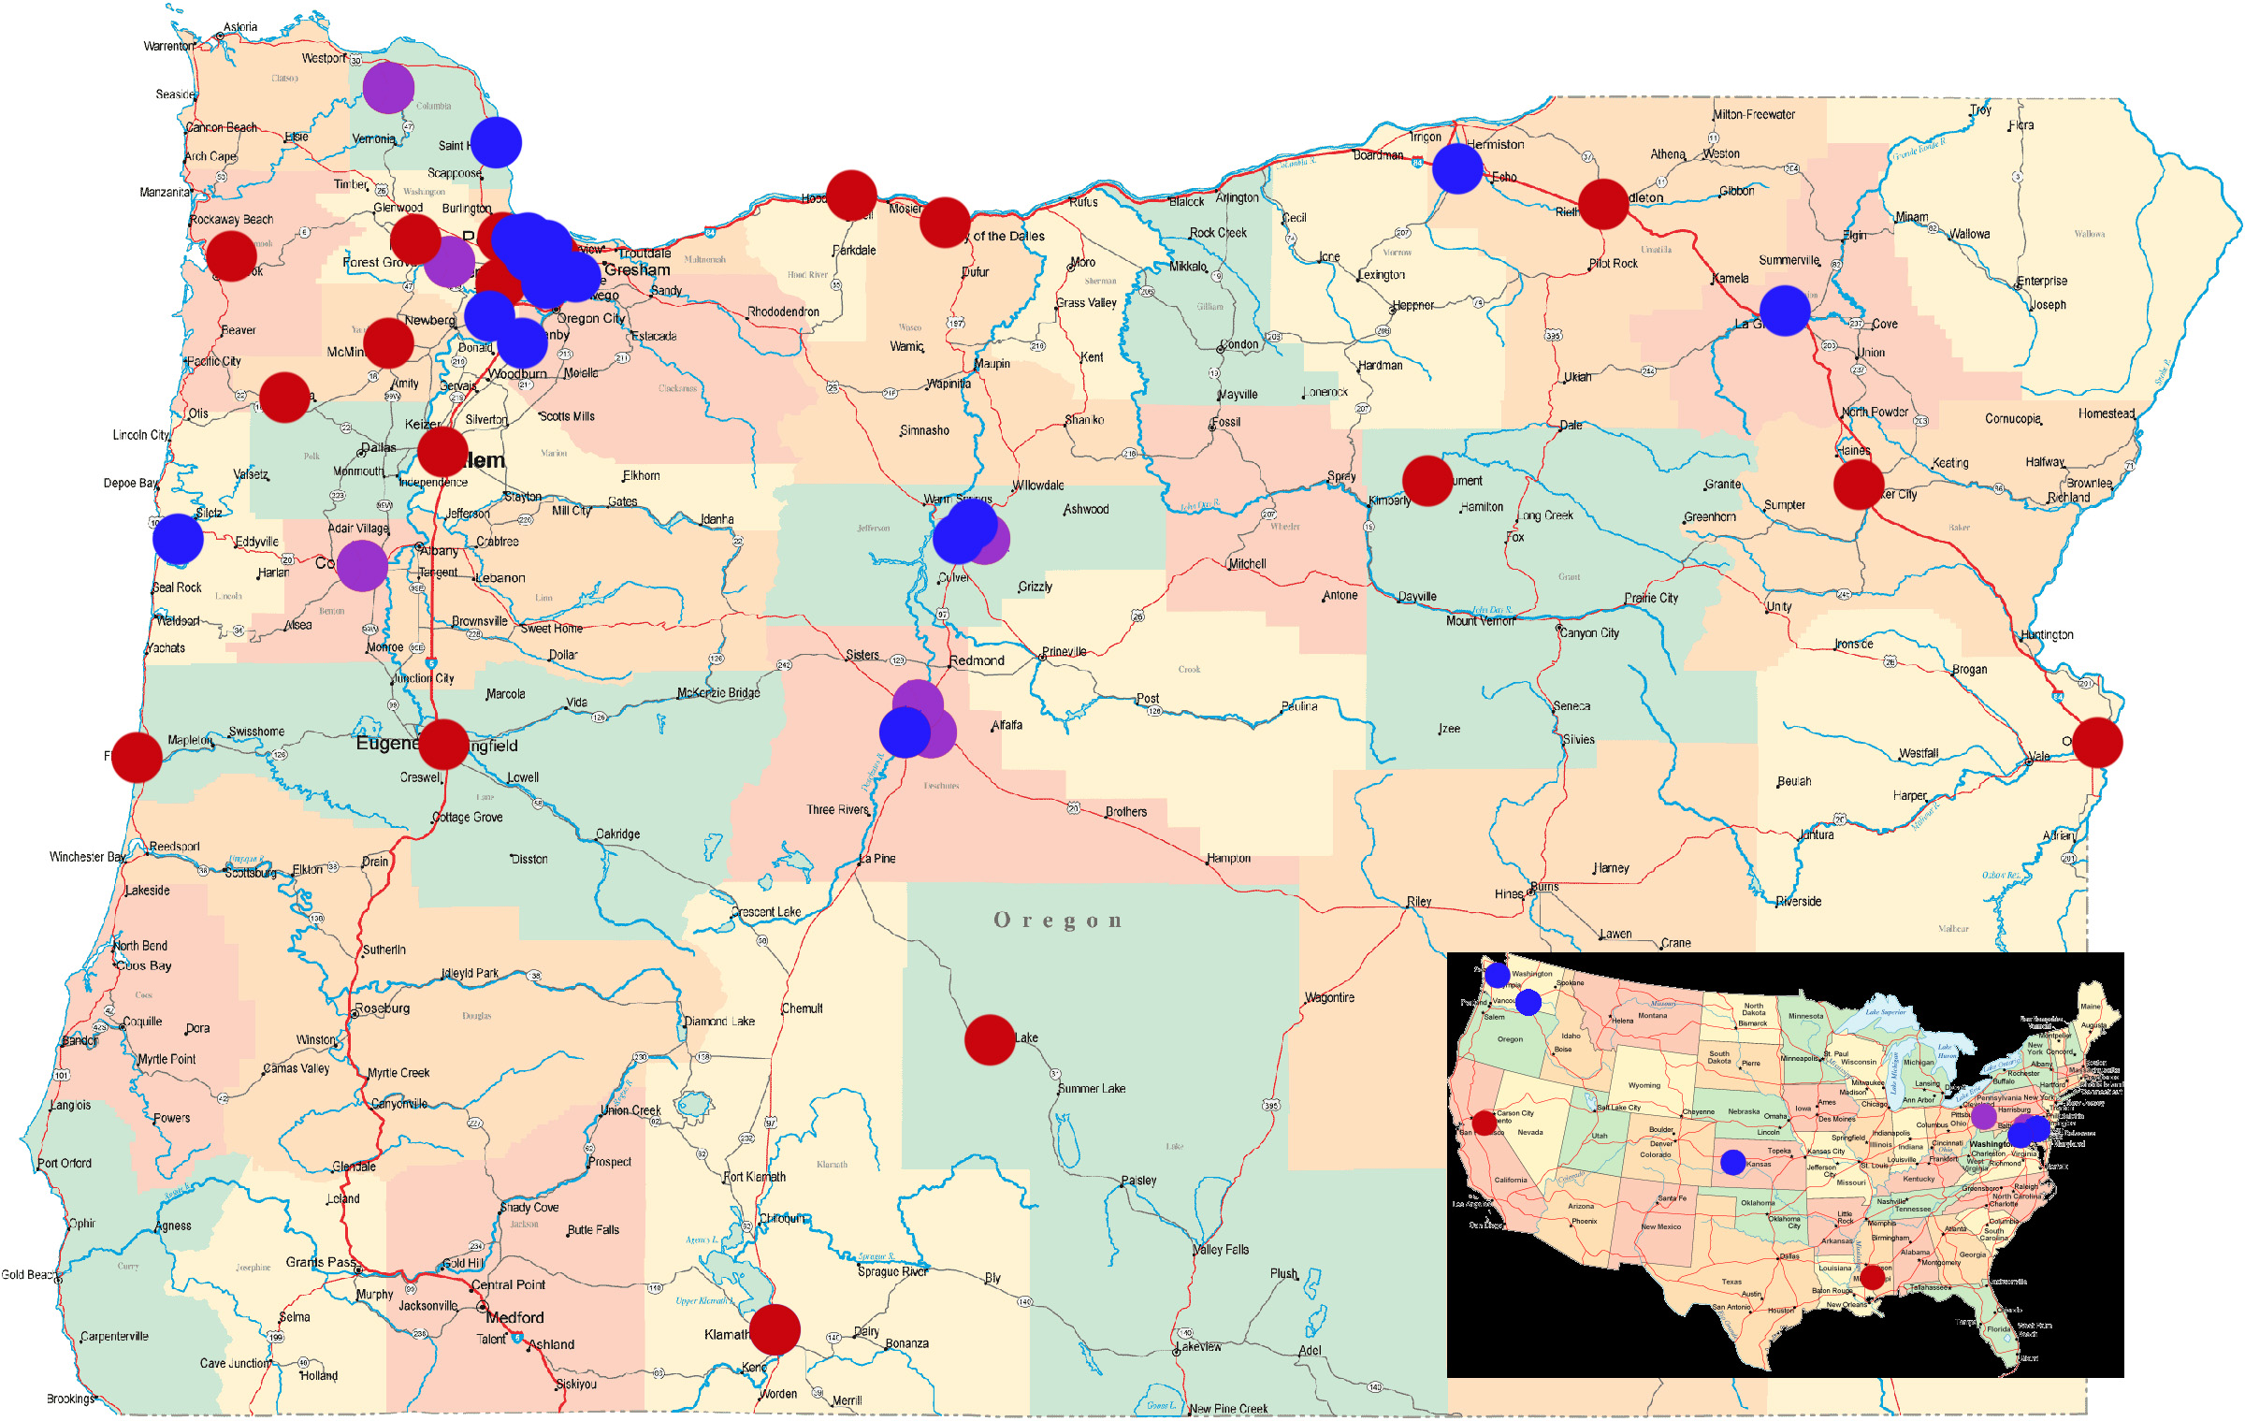
Innovation: This proposed project will leverage Let’s Get Healthy!, an established education and research exhibit at Oregon Health & Science University (OHSU), as a tool for education and data collection. Currently, attendees of this exhibit visit various interactive modules (see Table 1) to learn about their own health while contributing their anonymous data to a population database. Investigators are able to use the database to study the relationships among health factors. Let’s Get Healthy! is enormously popular with the public. Since inception of the program in 2007, there have been a total of 54 events (including 13 school events) resulting in 10,877 participants (age 2 to 100; 5,383 being students between the ages of 9-14; see Figure 1 – Note update these numbers based on the current data). Growth of Let’s Get Healthy! has been exponential, with 68 additional requests in the past two years. Specific to the current proposal, Let’s Get Healthy! has successfully partnered with multiple communities throughout rural Oregon.
Figure 1. Let’s Get Healthy! fairs held (blue) and fairs requested (red)

The Let’s Get Healthy! program at OHSU supports research, data collection, and analysis activities resulting from implementation of Let’s Get Healthy! events. At each event, an integrated computer program automatically collects participants’ data from the various modules and provides tailored feedback for participants based on their health results. In the current, Institutional Review Board (IRB)-approved version of this program, attendees receive a wristband imprinted with a random eight digit barcode. Participants scan this barcode at each research module (Table 1) they visit, which allows for all of their data to be collected and linked automatically in the Let’s Get Healthy! secure database. This use of information technology provides an enormous capacity for efficient, secure data collection and storage. While Let’s Get Healthy! has most frequently been used to collect anonymous information at community events, its ability to recruit research participants for longitudinal studies¹⁰⁻¹¹ makes the program unparalleled as an education and research tool.

Table 1. Selected Let’s Get Healthy! research modules relevant to the current proposal. Other already existing research modules can be included based on the interests of the community.
Research Module | Description
Entry Station | Participants receive a barcode wristband in order to participate in the exhibit and scan their barcode to electronically enter their age, gender, race, and ethnicity.
Diet Assessment | Computerized NHANES 2009-2010 Dietary screener. The Dietary Screener Questionnaire is composed of 26 questions that ask about the frequency of consumption in the past month of selected foods and drinks to capture intakes of fruits and vegetables, dairy/calcium, whole grains/fiber, added sugars, red meat, and processed meat.
Body Composition | Measurements of height, weight, waist circumference, body mass index, and body fat percentage.
Sleep Quality and Patterns | Participants complete up to three short, computerized, validated assessments of sleep quality (Pittsburgh Sleep Quality Index), diurnal preference (Horne-Ostburg Morningness-Eveningness Scale), and daytime sleepiness (Epworth Daytime Sleepiness Scale).
Blood Pressure and Chemistry | Participants of all ages receive blood pressure measurements and those over 18 years can receive a 6-minute fingerstick assessment of total cholesterol, HDL, LDL, triglycerides, and glucose with immediate consultation based on results. (NOTE: TAKE THIS OUT IF THIS IS A STUDENT PROPOSAL ONLY)
Cancer Risk Behaviors | Students complete two short computer-based questionnaires related to skin and lung cancer risk behaviors. The participant can complete a family tree to understand how family history can impact risk of cancer as well as play a “Mario Brothers”-type arcade game to learn more information about skin cancer risk and prevention.
Memory Function | Short-term visuospatial memory using the Corsi Block test (5 minutes)

Through the use of this flexible, computerized infrastructure, Let’s Get Healthy! has demonstrated a consistent ability to integrate new materials in order to reach a wider audience while providing research scientists with validated linked health data. Efforts are overseen by their review boards (parent advisory board, scientific advisory board, teacher review board, and external advisory board) who guide program efforts and proper management of sensitive issues, particularly with children and minority groups. The computer infrastructure also enables summary data to be returned back to communities and Safeway stores in order to guide evidence-based health decisions. A recently awarded NIH Science Education Partnership Award (SEPA) will further enables this data dissemination to be a rapid, web-based feature of the program.

