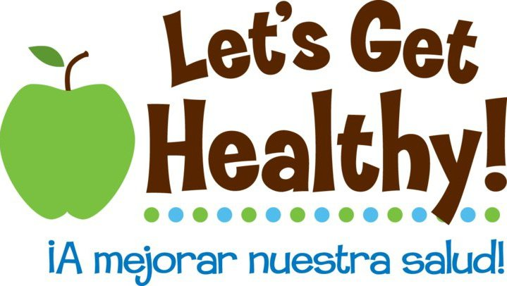
About our School Projects

“Epigenetics” – The environment can have a big impact on our genes. Many individuals are unaware that their eating habits, often established early in life, can affect the health of their future families. One of the true strengths of epigenetics (how the environment affects our genes) lies in the fact that it allows individuals to elicit more control over what were previously thought to be irreversible genetic predispositions to disease. This project introduces middle school children and teachers to epigenetics and specifically to how dietary behavior in one generation may alter disease risk for future generations. This project requires commitment to use associated lesson plans and a commitment to student and teacher evaluation.

Methods: Your school will receive a Let’s Get Healthy! fair for your students that includes our new epigenetics module and associated lesson plans. Evaluation will occur through anonymous surveys of students and teachers (at end of current school year, beginning of following school year, and end of following school year).

