Lesson Title: Cell Differentiation
Overview of Lesson Plan: As a class, students role-play as individual developing cells in an embryo to understand how cells in a human body have the same DNA, yet through epigenetics become specialized and take on a unique epigenetic profile.

Big Understanding: The changing epigenome informs gene expression in a cell. As an embryo develops, signals received over time causes increasing changes in gene expressions. Epigenetic markers create further changes in the genes expressions as the markers shut down some genes and activates others nudging a cell toward its final destiny. The epigenetic profiles of each cell grow increasingly different over time. In the end different cell types form, each with a distinct identity and specialized function.
Essential Questions:
How do developing embryo cells develop into specialized cells such as bone, muscle, and skin?
Grades: 5-8
Subjects: General
Time required: 30 minutes
Objectives: Introduce how epigenetics leads to specialized cells in a developing embryo
Background:
- Genes provide the instructions for development and maintenance of the body.
- A second set of instructions called the epigenome interact with DNA to activate or suppress the expression of particular genes.
- Certain chemicals known as epigenetic markers turn genes off or on without changing the underlining genetic code.
- Online Resources, Teacher Background, Student Background
Materials: A class set of cut-out Cell Differentiation Game Cards, Directions for Cell Game
Activities and Procedures:
- If possible, take students to a big open space
- Hand each student a number/symbol Cell Differentiation game card.
- Then have students line up with their card in a horizontal line across back of space in a random order
- Explain to the students that they all represent cells in a developing embryo. Every cell in the embryo while containing the same DNA will over time develop into specialized cells. This is due to the epigenetic markers that create changes in gene expressions as the markers shut down some genes and activates others within a cell. In the end, different cell types form, each with a distinct epigenetic profile and specialized function. For example some will become bone cells, muscle cells, skin cells, heart cells, brain cells, stem cells etc.
- Their game cards have letters which represent specific proteins in a gene.
- Remind students to take fairly uniform size steps forward and backward depending on what the symbols are called out on their card.
- Read all the “Gene Expression Instructions” out loud informing students to move forward or backward based on the letter combinations.
- While students are still in the formation created at the end of game, explain how the each symbol on their card stands for using epigenetic marker being expressed.

Assessment/Reflection: As a class or individually, have students compare and analyze their experience in the game simulation to the role epigenetics play in cell differentiation.
Epigenetic Cell Differentiation | Game Simulation – Student experiences

Early in development, genes are “poised” like runners in the starting blocks, ready to jump to action

Epigenetic markers shut down some genes and activate others as it nudges a cell toward its final fate.

Different cell experiences causes the epigenetic profiles of each cell type to grow increasingly different over time.

In the end, hundreds of cell types form, each with a distinct identity and a specialized function.

Beyond the game reflection
- Early in development, most signals come from within cells or from neighboring cells. Mom's nutrition is also important at this stage. The food she brings into her body forms the building blocks for shaping the growing fetus and its developing epigenome. Other types of signals, such as stress hormones, can also travel from mom to fetus.
- After birth and as life continues, a wider variety of environmental factors start to play a role in shaping the epigenome. Social interactions, physical activity, diet and other inputs generate signals that travel from cell to cell throughout the body. As in early development, signals from within the body continue to be important for many processes, including physical growth and learning. Hormonal signals trigger big changes at puberty.
- Even into old age, cells continue to listen for signals. Environmental signals trigger changes in the epigenome, allowing cells to respond dynamically to the outside world. Internal signals direct activities that are necessary for body maintenance, such as replenishing blood cells and skin, and repairing damaged tissues and organs. During these processes, just like during embryonic development, the cell's experiences are transferred to the epigenome, where they shut down and activate specific sets of genes.

Cell Differentiation Game - Take One Step Forward…
- If you have an A on your card take ONE step forward.
- If you have an M and an G on your card take ONE step forward.
- If you have a T or a C on your card take ONE step forward.
- If you have a K symbol on your card take ONE step forward.
- If you have a G and an R on your card take ONE step forward.
- If you have the numbers 30 or higher on your card take ONE step forward.
- If you have an H or a W on your card take ONE step back.
- If you have a V on your card take ONE step forward.
- If you have a D on your card take TWO steps back.
- If you have an A and an R on your card take TWO steps forward.
- If you have an M, T and a Y on your card take ONE step forward.
- If you have the numbers 25 or lower on your card take ONE step back.
- If you have a B or D with a number higher than 27 on your card take TWO steps forward.
- If you have a W and a Y on your card take ONE step forward.
- If you have a B and an R on your card take ONE step forward.
- If you have an A, G and T on your card take ONE step forward.
- If you have an M, B, and S on your card take ONE step back.
- If you have an H, D and Y on your card take TWO steps back.
- If you have an R on your card take TWO steps forward.
- If you have an A on your card take ONE step forward; anyone with an M take ONE step back.
- If you have a G on your card take ONE step forward; anyone with an H, W and V take ONE step back.
- If you have a C or T on your card take ONE step forward; anyone with a B and D take ONE step back.
- If you have a number higher than 32 on your card take ONE step forward; anyone with a number lower than 28 take a step back.
- If you have an R on your card take ONE step forward; anyone with a Y take ONE step back.
- If you have a K symbol on your card take ONE step forward; anyone with an S take ONE step back.
Have students look around to see who is standing near them. Based on their locations and who is closest to them, help students get into four different groups. These four groups represent the following tissues:
- Group one (the group that moved forward the most) is part of the brain cells.
- Group two (the next group) is part of the ectoderm mesoderm cells (kidney, muscle, heart, immune, etc.)
- Group three (the next group) is part of the germ cells.
- Group four (the group that moved forward the least) is part of the stem cell.
To go further in depth, share with students the following handouts on various types of cells and the graphic on “Snap Shot: Directed Differentiation of Pluripotent Stem Cells”

Stem Cell
- Germ Cells – sperm or egg cells
- Ectoderm Cells
  - Epithelial Cells - skin cells (karatinocytes) and pigment skin cells (melananocytes)
  - Vision cells (Eye Photoreceptors)
  - Hearing cells (Hair cells in the ear)
  - Brain cells
    - Neurons
      - Movement cells (Motor neurons)
        - Motor coordination cells (Pukinje cells in cerebellum)
        - Leg movement cells (spinal motor neuron)
      - Thinking and Being cells (Cortical neurons)
        - Breathing cells (brainstem cells)
        - Parkinson’s-affected cells (Dopamine neurons )
        - Memory formation cell (hippocampal neuron)
        - Memory storing cell (cortical neuron)
    - Support cells in the brain (Glial cells)
  - Eye pigment cells (retinal pigment cells)
- Endoderm Cells
  - Liver cells (hepatocytes)
  - Pancreas cells (beta cells)
  - Lining of gastrointestinal tract cells (type of epithelial cell)
  - Lung cells
- Mesoderm Cells
  - Mesoderm Epithelial cells
    - Kidney cells (nephrons)
  - Mesenchymal stem/precursor cells
    - Cartilage cells
    - Tendon cell
    - Ligament cell
    - Fat cells (adipose cells)
    - Bone cells (osteogenic cells)
    - Arm and leg muscle cells (skeletal myoblasts)
    - Smooth muscle cells (blood vessels, bladder, iris of eye)
    - Heart cells (cardiac myocytes)
  - Hemangioblast (http://www.nature.com/onc/journal/v24/n37/images/1208920f2.jpg)
    - Blood vessel lining cells (Endothelial cells)
    - Myeloid Cell
      - Red blood cell (Erythrocyte)
      - Blood clotting cells (Platelets)
      - Bacteria eating immune cell (macrophage)
      - White blood cell (first-responder type of immune cell) - (neutrophil)
      - Toxin-releasing immune cell (eosinophil)
      - Allergy (histamine-releasing) cell (basophil)
      - Nose-lining immune cell (dendritic cell)
    - Lymph System Cells (Lymphoid progenitor)
      - Antibody forming cells (B cells)
      - Immune cells (T cell)
        - Cytotoxic T cell (CD8+ immune cell)
        - Helper T cell (CD4+ immune cell)
      - Natural Killer Immune Cell (NK cell)
    - Bone eraser cell (osteoclast)

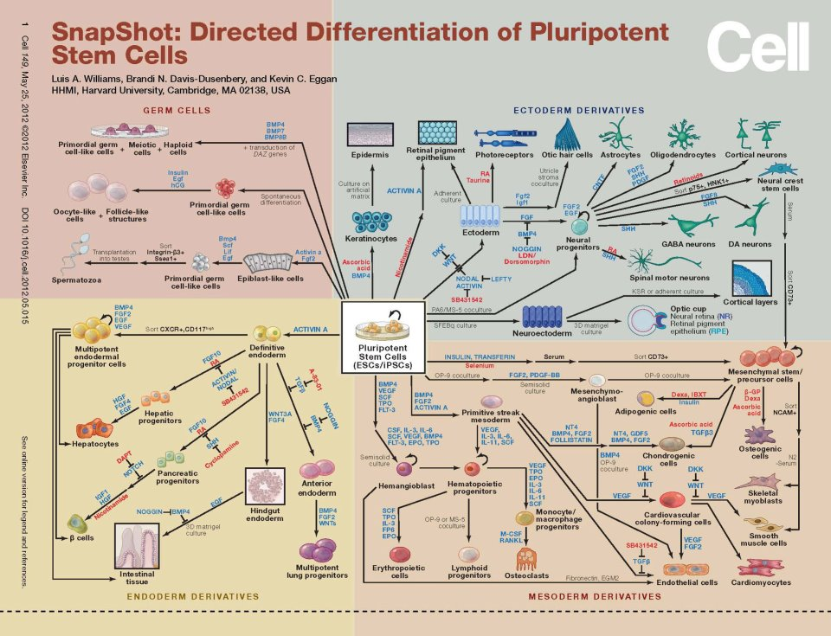

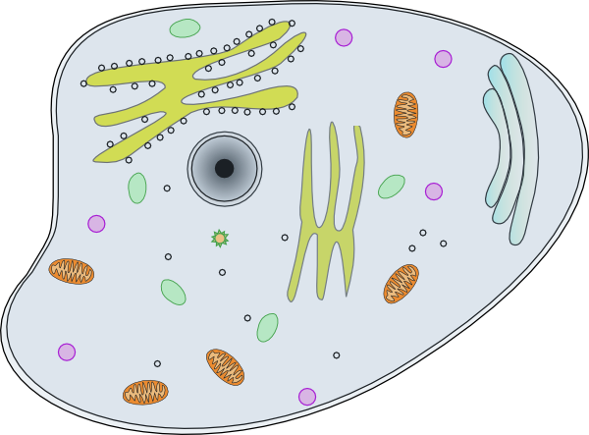  11  G  S  R  C  A | 12  M  T  K  Y  G
13  S  Y  G  C  A | 14  T  Y  S  M  G
15  K  B  Y  G  A | 16  M  W  K  R  T
17  S  Y  D  H  A | 18  C  K  R  M  G
18  S  Y  T  A  G | 20  S  M  D  Y  G
21  K  Y  T  G  A | 22  H  T  M  S  Y
23  W  K  Y  T  A | 24  S  M  R  D  G
25  S  Y  T  A  G | 26  K  Y  B  M  G
27  T  Y  S  G  A | 28  H  T  M  K  Y
29  K  Y  T  A | 30  B  M  K  R  G
31  C  K  Y  A  G | 32  D  M  Y  S  G
33  W  Y  S  T  A | 34  W  M  Y  S  T
35  K  Y  T  A | 36  S  M  Y  T  G
37  S  R  T  G  A | 38  K  B  M  Y  G
39  S  Y  G  D  A | 40  K  R  T  M  G

Online Resources for Epigenetics

VIDEO Title | Source | Link
Epigenetics | PBS - NOVA | http://www.pbs.org/wgbh/nova/body/epigenetics.html
Epigenetics I and II | PBS - NOVA (via youtube) | http://www.youtube.com/watch?v=wFsxVkuChdU (7:  http://www.youtube.com/watch?v=Xjq5eEslJhw (6:19)
Epigenetics | scishow (via Youtube) | http://www.youtube.com/watch?v=kp1bZEUgqVI&feature=youtube_gdata_player
Epigenetics makes you unique:  Courtney Griffins at TEDxOU | TEDxTALKS (via Youtube) | http://www.youtube.com/watch?v=JTBg6hqeuTg
(Audio slide show)  A Tale of Two Mice | PBS – NOVA | http://www.pbs.org/wgbh/nova/body/epigenetic-mice.html  Audio slide show and supporting web page about the aguti mice and epigenetics.
Utah Twins | The University of Utah - Genetic Science Learning Center | http://learn.genetics.utah.edu/content/epigenetics/twins/
ARTICLES Title | Source | Link
How the First Nine Months Shape the Rest of Your Life | Time Magazine  - By Annie Murphy Paul | http://www.time.com/time/magazine/article/0,9171,2021065,00.html#ixzz2Wn5nO1wE
Why Your DNA Isn't Your Destiny. | Time Magazine  - By John Cloud | http://www.time.com/time/magazine/article/0,9171,1952313,00.html
Beyond DNA: Epigenetics - Deciphering the link between nature and nurture. | Natural History  - By Nessa Carey | http://www.naturalhistorymag.com/features/142195/beyond-dna-epigenetics
Epigenetics: Tales of Adversity. | Nature - International Weekly Journal  of Science | http://www.nature.com/nature/journal/v468/n7327_supp/full/468S20a.html
WEB SITES Title | Source | Link
Learn Genetics and Teach Genetics | The University of Utah - Genetic Science Learning Center | http://learn.genetics.utah.edu/content/epigenetics/

Student Background on Epigenetics
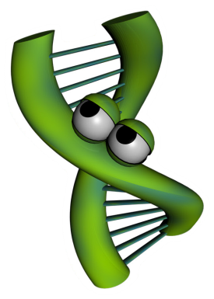
Imagine for a moment you wrote a song that rivals (insert famous singer here) and it is going viral on the Internet. People love the impressive guitar solo, which proves you can swing like the heavy hitters of the rock world. You published the music and lyrics, but unfortunately you did not protect the rights to your song. Rock n roll wannabees are taking your song and doing their best to play like you do. The results are disastrous. Even though the tune is the same, the song sounds completely different from yours. You ask yourself, “How is this possible?!” The difference comes in the interpretation of the music. Even though a note may be the same on the page, the way a note is strummed, loud or soft, at a specific moment in the song can change the overall impression the song creates. This is one way artists distinguish themselves from amateurs. Artists know where to place the musical inflections to produce musically pleasing songs. Amateurs, on the other hand, lack the artistic abilities you posses so when they play your song, the result sounds more like cats calling.
Now let’s see how music can relate to science. Interestingly, how DNA is expressed to create you is very similar to how music is played. Just like song lyrics and music can be written on paper, but sound very different based on the person playing the song, DNA can be identical, but the way DNA is “played” makes a difference in how your functions. Epigenetics is the study of how DNA is “played” and the subsequent results.
To study epigenetics, scientists use model systems. Model systems could be as simple as a Petri dish of cells or as complex as an animal. Scientists choose the lowest possible model study in order to answer their questions. For example, scientists have studied bacteria, mice and even humans to understand the mechanisms of epigenetics. One such model are identical twins. Identical twins are studied because the DNA of identical twins is, as the word indicates, identical. From birth to age three, these twins are very similar in appearance and in their behaviors, but as they grow older, the similarities between the twins begin to differ in appearance, and can even differ in their overall health. Why are identical twins different if their DNA is identical? Scientists, suspecting epigenetics, set out to find the answer to this question. Watch the following NOVA ScienceNow video to see what they discovered: http://www.pbs.org/wgbh/nova/body/epigenetics.html

Teacher Background on Epigenetics

What is epigenetics
Epigenetics is the study of the environment’s influence on our genes’ activity. DNA is often referred to as the blueprint or instruction manual for our bodies. DNA is the hardware, but epigenetics are the software. Epigenetics tell our bodies which section of the blueprint (or which page of the instruction manual) to read at a given time. Epigenetic changes do not alter the letters of our DNA, but instead change its punctuation – think like an exclamation point (!), bold, strikethrough, footnote, or comma (i.e. “Let's eat Grandpa.” this phrase with an epigenetic change might be “Let's eat, Grandpa”).

Why is it important
These “punctuation” changes can turn genes “on” or “off”, a process called gene regulation. Gene regulation is required for normal development throughout our lives. Genes that are expressed instruct cells what to become, how our organs form, how we remember material for a math test, how our bodies respond to disease and infection, and much, much more. Epigenetics is the study of how environmental factors impact gene regulation which controls gene expression. Gene regulation influences our health throughout our lifespan and new research is suggesting that epigenetic changes may extend across multiple generations to affect the health of our children, grandchildren, and possibly even great-grandchildren. Epigenetic changes are reversible, so our life choices may reverse or mitigate the effects of early epigenetic marks and prevent them from being transmitted to further generations. This is like playing a card game. Even if you are dealt a bad hand it is possible to play it well. It is also possible to mess up a good hand with the wrong life choices. This is an important concept for adolescents because it suggests that we aren’t just a product of our genes, but our environment and the choices that we make, too. We need to “nurture our nature”.

How does it work? –– Molecular Mechanisms
The mechanism of how epigenetics works is fascinating. Stretched end to end, our DNA is about 6 feet long (2 meters) and shoved into practically every cell in our bodies. It is shaped like a long ladder, twisted like a spiral staircase, then wrapped around proteins (histones) like string around spools (see diagram on next page). These wrappings (nucleosomes) are then further condensed into chromosomes. Think of our DNA like a set of encyclopedias where each chromosome is one of its volumes. If you want to “read” any of the instructions contained in one of these volumes, you need to “unfold” the DNA. Not all the DNA can be unwound at the same time, so only parts of the instructions can be accessed at any one time. Only 2-3% of our DNA is made up of genes. Genes are the instructions to make proteins (called gene expression) that make our body function. The remaining 97% of our DNA was previously thought to be “junk DNA” with no known function, though the Encyclopedia of DNA Elements Project (ENCODE) found in 2012 that at least 80% of our genome is active at some point during our lives and is likely involved with regulating gene activity. 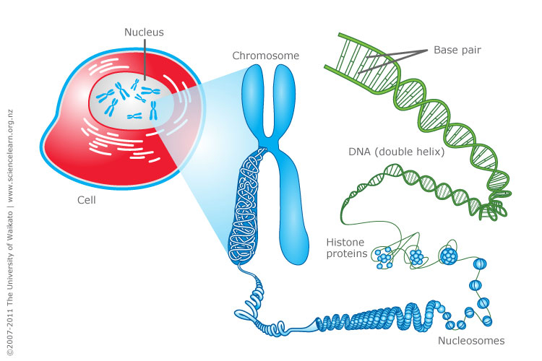
http://www.sciencelearn.org.nz/var/sciencelearn/storage/images/contexts/uniquely-me/sci-media/images/cell-chromosomes-and-dna/464336-1-eng-NZ/Cell-chromosomes-and-DNA.jpg

Epigenetics works by ‘tagging’ or making punctuation changes to our DNA. Two of the best known mechanisms are:
- Histone acetylation -- DNA is wound around chemical spools called histones. This saves space in the cell, but tightly wrapped DNA can't be read for gene expression. Chemical triggers can attach an “acetyl group” to an external part of the spool core that causes the core to open the DNA and make it available to reading. Histone acetylation refers to more gene access. Histone deacetylation removes the acetyl group and closes the DNA, so less gene access.
- DNA Methylation -- In other cases, a methyl group can be added to the DNA to “tag” it. With several methyl groups added, machinery cannot access the DNA to read it and the resulting gene is not expressed. This serves as a chemical “skip this part”. Methyl tags can be added or removed throughout the lifespan by various environmental factors discussed below.
- Note: Research is constantly finding new epigenetic mechanisms. For example, histones can be methylated or acetylated in different loci for different functions. RNA was recently found to be methylatable, too. But, the general thought is the same. Epigenetics is all about turning gene activity up or down, on or off.

How is a person impacted by epigenetics
Epigenetics affects our bodies throughout our lives because gene expression occurs every day throughout our lifespan. The epigenetic effects on our health depend on when (in our development) and where (in our bodies) our genes are turned “on” and “off”. We have learned from historical famines and population-wide studies that long-term health effects can be observed following a variety of environmental exposures. Current research suggests that the following environmental factors can affect how our genes are regulated.

Sun (ultraviolet light)
Drinking water pollutants
Auto exhaust
Radiation
Diet (methionine, choline, folate, B12)
Hormones (bisphenol A, DES, estrogen, dioxins)
Pesticides
Metals (Ni, Cr, As, Cd, Hg)
Tobacco Smoke
Social interaction

Fetal development
The experience of a fetus in the womb is a critical time for affecting development and future disease risk. For example, our kidneys are normally formed in the womb between 33 and 36 weeks. We now understand that if diet, toxins or other environmental factors disrupt growth during that critical period, the kidney cells won’t form properly and health effects can be seen later in adulthood due to low-functioning kidneys. Kidney problems can also be seen earlier in childhood, depending on the extent of the disruption. Research is now finding that there are “developmental origins of disease”, where the surrounding environment of the growing baby can affect its susceptibility to chronic disease later in life. Adult risks for obesity, cardiovascular disease, diabetes and metabolic syndrome have been linked to these early fetal development periods. Interestingly birth weight seems to be predictive of this effect, where low birth weight babies have a higher risk of obesity later in life. Babies born around eight-nine pounds seem to have the lowest risk of future disease risk. The increased risk doesn't just happen in low birth weight babies but in high birth weight babies, which may not have had the right nutrients. This "over fed, undernourished" syndrome is a special concern and is currently being studied. We have learned that effects that occur during pregnancy may persist for generations because a female’s eggs are all developed during a short time that she is in her mother's womb. These eggs will become the sons and daughters of the baby girl. The nutrition during pregnancy can not only effect a woman's baby, but also her grandchildren. Men aren’t immune to this as new evidence is suggesting epigenetic effects may occur on the sperm as well.

Early life epigenetics
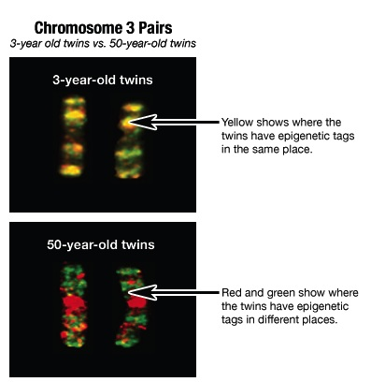
A newborn or toddler exposed to bis-phenol A (a chemical formerly used in plastic bottles and still used in the lining of tin cans) becomes vulnerable to obesity in later life. Research in rats has also shown that young rat pups groomed (licked) more frequently by their mothers had a better ability to handle stress as adults than pups groomed less frequently, a result of epigenetic control of glucocorticoid (stress) genes in the brain. Research is currently underway related to how other social interactions can affect our health – bullying, growing up with siblings, abuse, etc. A 2012 paper by Tung and colleagues showed that the dominance rank of rhesus macaques (a type of primate) was strongly associated with gene expression in their immune system, with the magnitude of gene expression actually predicting the macaques’ rank in their group over time. This effect hasn’t been explored in humans, though it highlights an important biological mechanism for how our physiology and health can interact.

Epigenetics in later life
It is fairly easy to see how something a person is exposed to might modify their epigenome. Identical twins have been used most frequently to study the long-term effects of the environment on our genes since they share the same DNA. When identical twins are young, their epigenetic tags are mostly the same. But as they age and experience different lives, their epigenetic tags are different (see image on right). Likewise, with our different environmental exposures as we age, current cancer research is looking at the epigenetic control of genes related to cell growth that may have been improperly turned “on” or “off” by the environment.

Future research and unanswered questions
http://learn.genetics.utah.edu/content/epigenetics/twins/
There are bound to be many news stories about epigenetics in the next few years. It is important to consider the credibility of the sources of these stories. Carefully designed studies from respected institutions with a clear statement of the limitations of the investigation backed up through review of other scientists are more credible than extreme claims made through the popular press without details of how the investigation was conducted or reviewed. Especially suspicious are claims made in relation to products which claim to have health benefits through epigenetic effects. Other than general dietary recommendations, it is just too early to be able to manufacture such products. Such things will take a number of years of development and would be tested in carefully controlled studies. Currently, there is solid scientific evidence of epigenetic impacts on vulnerability to hypertension, kidney disease, obesity, type II diabetes, cholesterol problems, stroke, and osteoporosis. Under investigation are links between epigenetics and vulnerability to autism, depression, and schizophrenia. Right now, the best advice is to eat a healthy diet, sleep well, avoid stress, and avoid exposure to environmental toxins. All these are familiar bits of advice that your grandmother may have given you, but now we are beginning to understand the deep molecular biology for how they work and we will be able to use that understanding to give more specific epigenetic help.

For more information on genetics or epigenetics, visit the Genetic Science Learning Center
http://learn.genetics.utah.edu and http://teach.genetics.utah.edu

