Nutrition and Your Epigenome
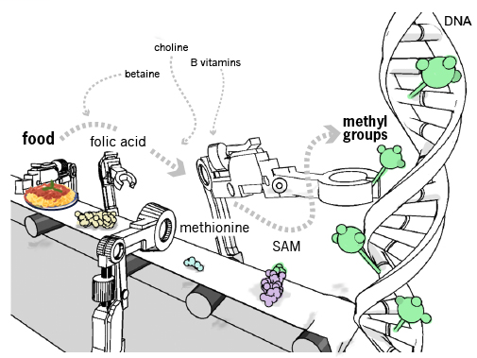
Scientists are studying how food can produce epigenetic effects. Food is digested and turned into molecules that can change the activity of our DNA. Some foods turn up activity, while others turn it down.

The Genetic Science Learning Center at the University of Utah developed this picture and table to show examples of how this works. We’re learning more everyday about new foods and their epigenetic roles. Oregon State University is currently doing a lot of research in this area.

Nutrient | Food Origin | Epigenetic Role
Methionine | Sesame seeds, brazil nuts, fish, peppers, spinach | SAM synthesis
Folic Acid | Leafy vegetables, sunflower seeds, baker's yeast, liver | Methionine synthesis
Vitamin B12 | Meat, liver, shellfish, milk | Methionine synthesis
Vitamin B6 | Meats, whole grain products, vegetables, nuts | Methionine synthesis
SAM-e (SAM) | Popular dietary supplement pill; unstable in food | Enzymes transfer methyl groups from SAM directly to the DNA
Choline | Egg yolks, liver, soy, cooked beef, chicken, veal and turkey | Methyl donor to SAM
Betaine | Wheat, spinach, shellfish, and sugar beets | Break down the toxic byproducts of SAM synthesis
Resveratrol | Red wine | Removes acetyl groups from histones, improving health (shown in lab mice)
Genistein | Soy, soy products | Increased methylation, cancer prevention, unknown mechanism
Sulforaphane | Broccoli | Increased histone acetylation turning on anti-cancer genes
Butyrate | A compound produced in the intestine when dietary fiber is fermented | Increased histone acetylation turning on 'protective' genes, increased lifespan (shown in the lab in flies)
Diallyl sulphide (DADS) | Garlic | Increased histone acetylation turning on anti-cancer genes

Learn more about epigenetics and nutrition at:
http://learn.genetics.utah.edu/content/epigenetics/nutrition/

