Help Tutorials

Welcome to the Let’s Get Healthy! data that have been collected from thousands of individuals around the country. We encourage you to play with the data and explore what it has to offer. In this document, you’ll find out how to:

Find the data 2
Use the toolbox icons to 3
Customize and filter the data 4
Take a picture of your work 6
Creating a log in 8
Save your work 11
Get more information about the data 13
Get help 14
Use SeeIt to explore distributions and correlations 15
Accessing SeeIt 15
Distributions 17
Correlations 21
Frequently Asked Questions (FAQ) 25

Find the data
- Go to www.letsgethealthy.org | 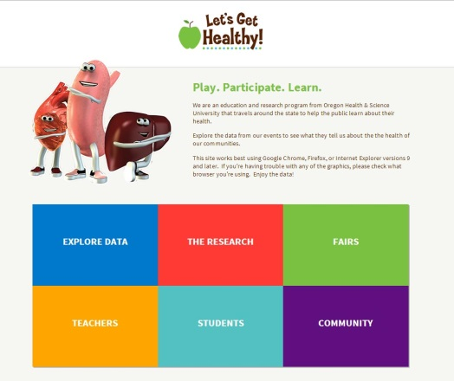
- Click on the box “Explore Data”  Note: Site works with Google Chrome, Firefox, or Internet Explorer (versions 9 and later). If you’re having trouble with any of the graphics, please check what browser you’re using. | 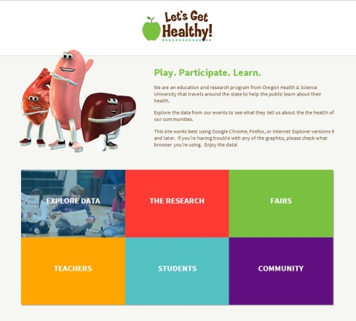
- Click on the box containing the data you want to see. For this tutorial, we’ll be looking at “Body Size” | 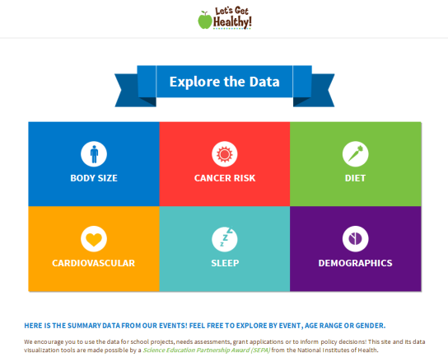
- Once you get to the “Body Size” page, you’ll see:  - Green toolbox icons on the left side that will help you navigate the data  - A grey wheel (loading icon) that shows your data are being pulled from our database. The numbers are constantly growing!  - Once the data have been loaded, you’ll see pictures of the summarized data (infographics). If you do not see images or if things look funny, check what browser you’re using!  - A colored ribbon at the top that will take you to other data categories | 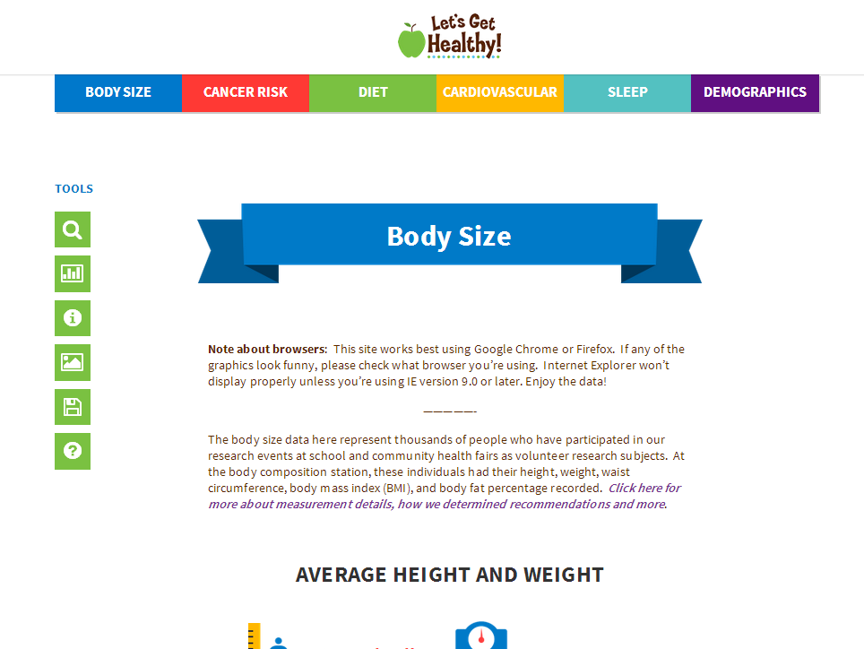

Please go to the next section to learn how to customize the data for your needs

Use the toolbox icons to

The toolbox icons will help you navigate the data.  We will go through each one below. | 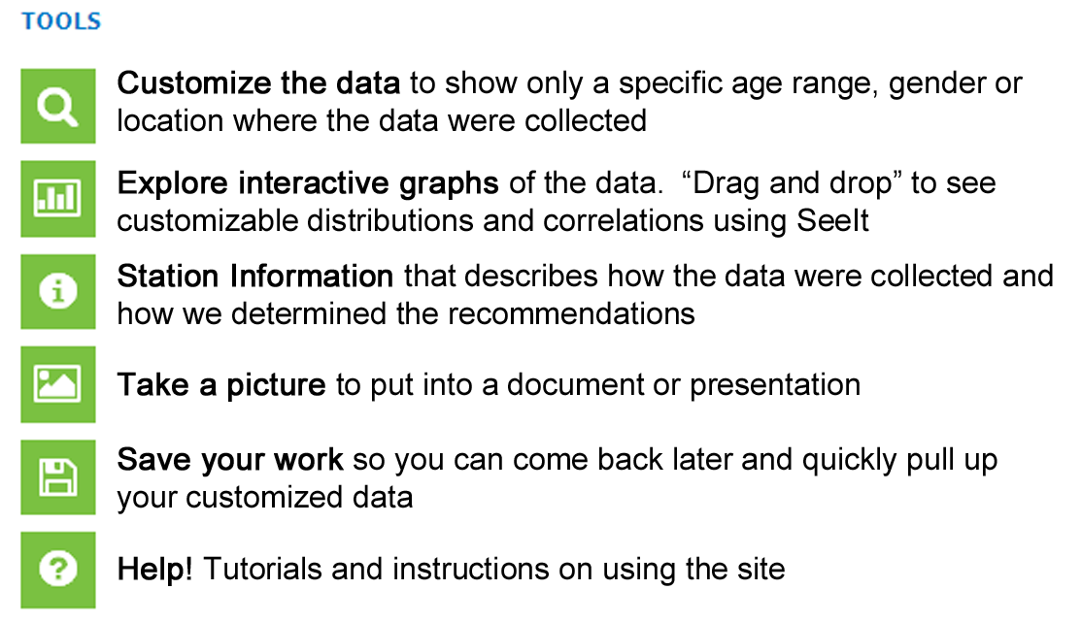

Customize and filter the data

- Once the infographics have loaded, you’ll see an image that looks similar to this: | 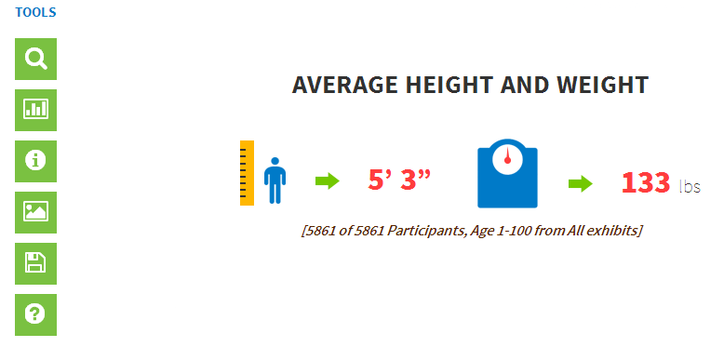
- Hover over the magnifying glass to see the “Customize the data” option. Click on it. | 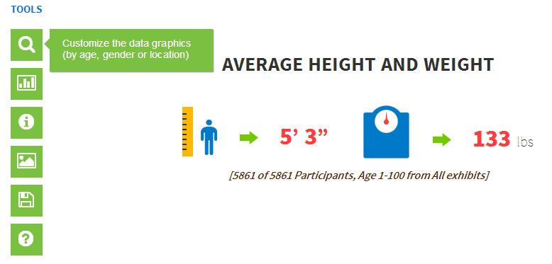
- A filter window will pop out. This is where you can select which data you want to see:  - Age: select a single age or an age range – use your mouse to move the age cutpoints  - Gender – pick one or both  - Location – we have traveled all around the country. Use the drop down menu if you want to select data from a particular event  Examples of these filter options are shown below | 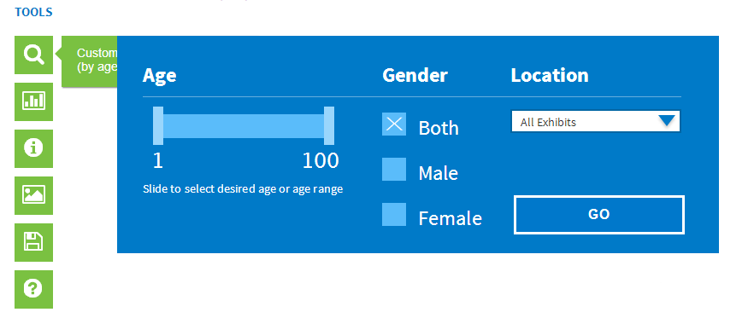
- For example, say you want to look at data from middle and high school students in Bend, Oregon.  - Use the age filter to drag your desired range, say ages 10-17. Overlap them if you wanted a single age.  - Select both genders  - Select location as “Bend Schools”. Note: Currently, you can only select one location. In the future, we would like to update this so that you can select more than one location at a time, for example like all Oregon locations or just a particular county. | 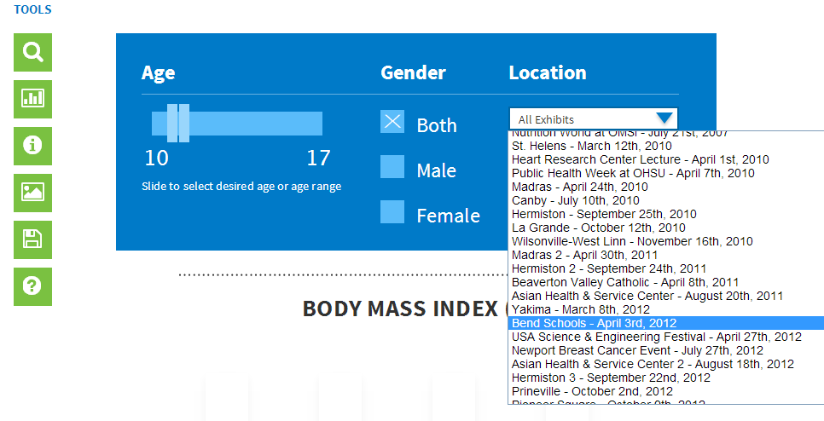
- Select “Go” | 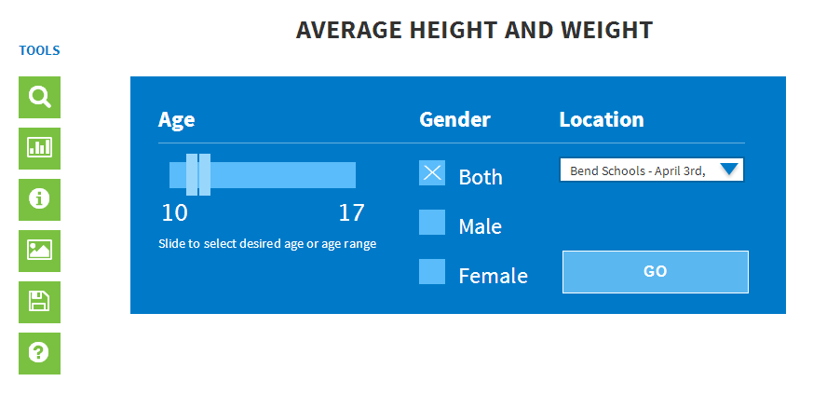
- To check to see if it worked, look at the text under the infographic. It should match your filter criteria.  Note: You’ll see that 427 people are shown with measurements for height and weight that matched your filter criteria (people aged 10-17 from Bend school fairs). However, you may notice that it says out of 492 participants. The 492 people represent all people from the Bend event that had measurements completed for height and weight. However, since they are outside the ages of 10-17, they were excluded from the infographic. | 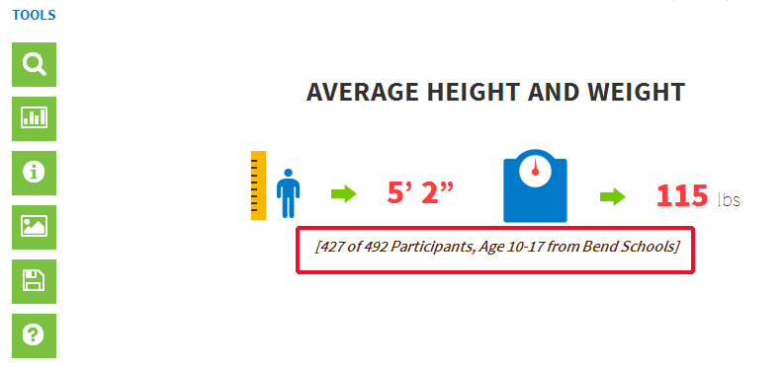

Take a picture of your work
- Once you have an image you like, you may want to save it to put into a report or a presentation. To do that, you’ll need to take a screenshot.  We use screenshots rather than using “save as picture” because these images aren’t static, but change completely based on the data selected. | 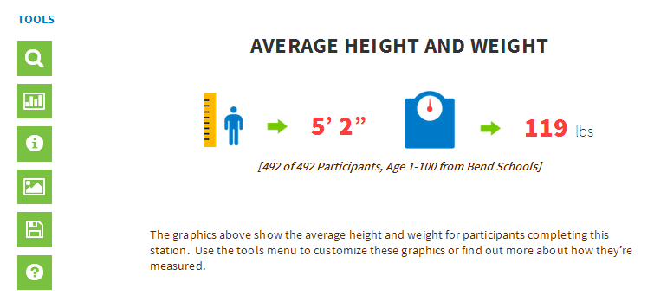
- Hover over the “Take a picture” icon in the toolbox and click on it. | 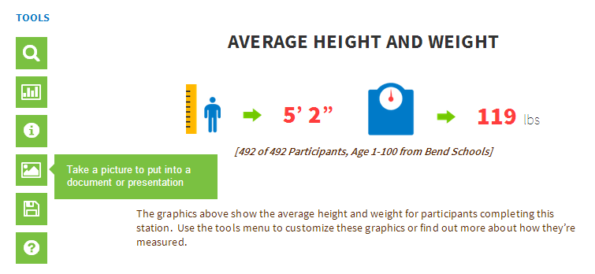
- When you click on it, this pop-up will appear with simple instructions. See below for more specific instructions for Windows and Mac. | 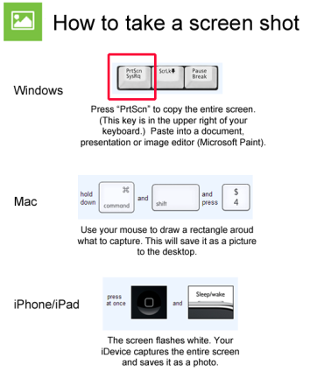

For Windows:
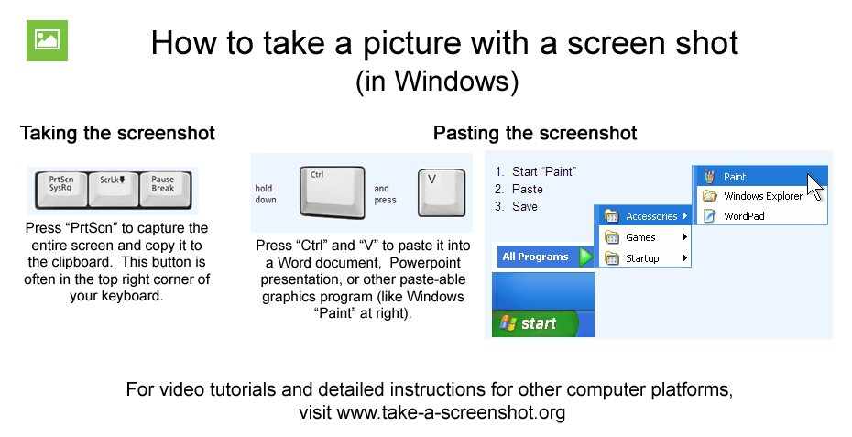
For Macs:
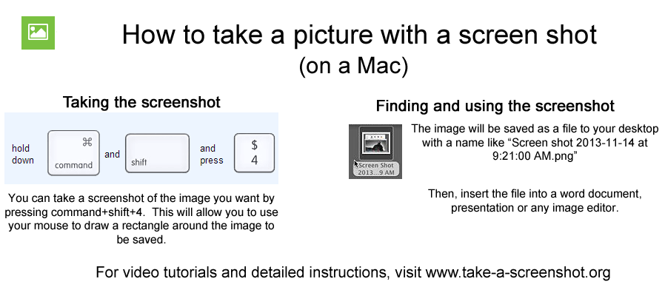

Creating a log in

- In order to save your work or post comments, you must first create a log in. Look for the “Menu” button in the top right corner and click on it. | 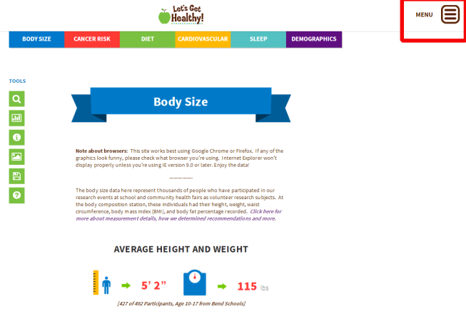
- Click on the “Log In” option in the menu bar. | 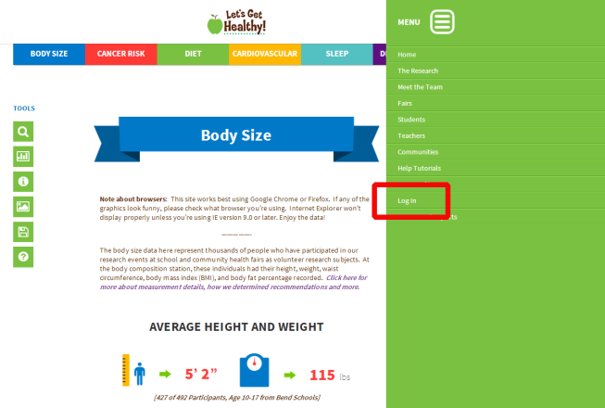
- At the Log In screen, click on the “Register” button | 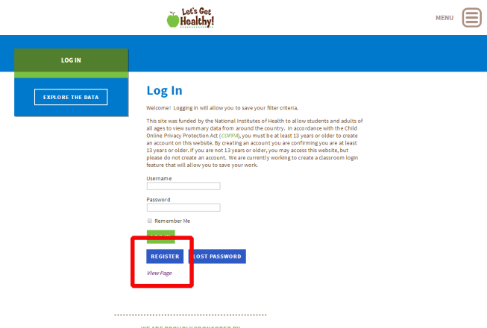
- Enter a “Username” and your email address. Please choose a password that you can remember  - Then click on “Register” | 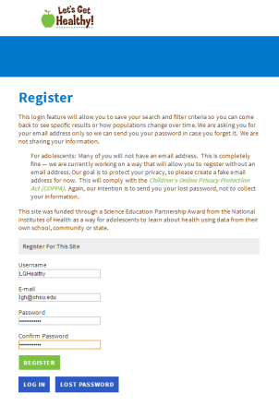
- It will then bring you back to the “Login” page. Enter the “Username” and “Password” that you just created.  - Click “Log In” | 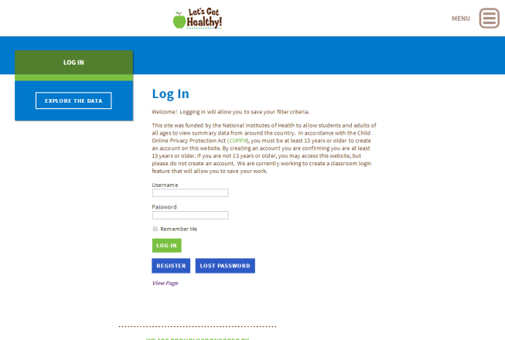
- You will then be taken to “Your Profile” page that you can enter any information about yourself.  You are now able to save your work or post comments to the page | 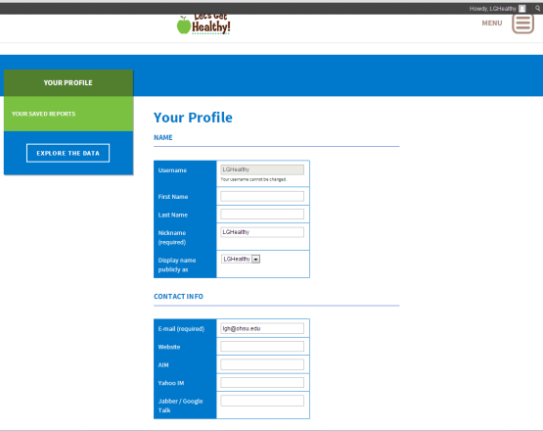

Save your work
Note: You will need to login to use this feature. See instructions for “Creating a Log In” before you begin this section.

- Once you have the data you want, you can come back to it another time. The “Save” button allows you to save your search criteria.

This works to:
- come back to a specific set of data or an image without having to re-enter your search criteria.
- track how a population changes as new data are entered, say average BMI for 11-12 year old girls
- Hover over the “Save” button and click it | 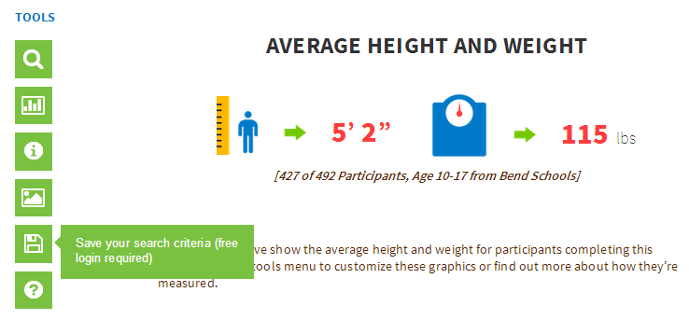
- A pop-up will appear that asks you to “Please name your report”. You will want to give it a name that will help you to identify it later.  - Press “OK” | 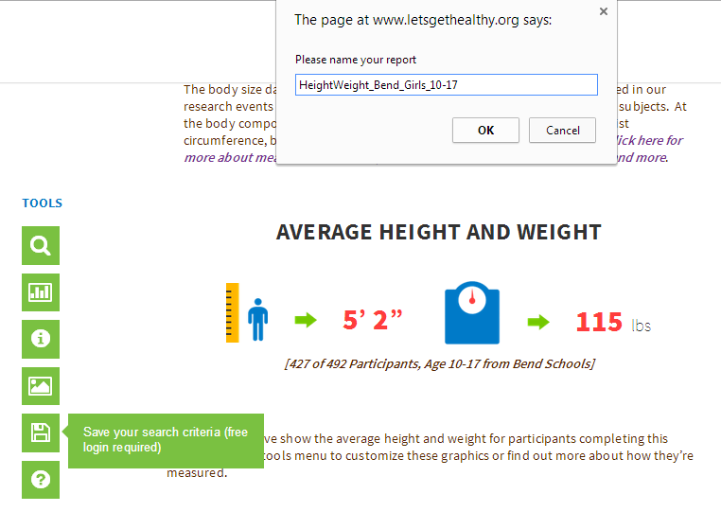
Note: If you have not yet created a log in, you will receive this screen. Select “OK”  - Refer to the section with instructions for “Creating a Log In” | 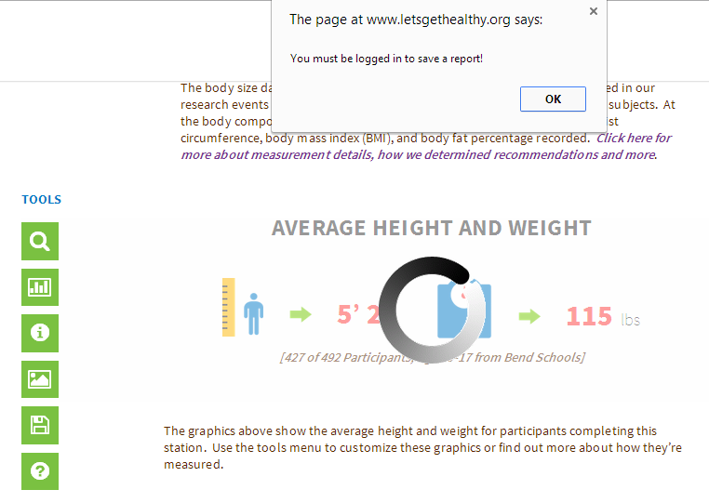
- If you were logged in, you will receive the “Report saved!” message. Click “OK”. | 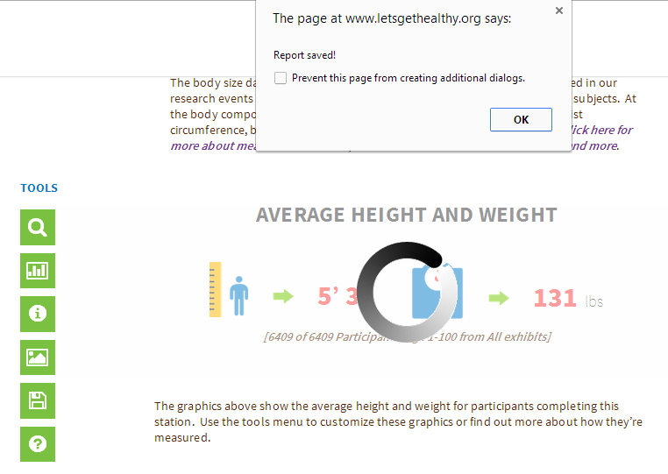
- To find your report, click on “Menu” button in top right corner.  - Click on “Your Saved Reports” | 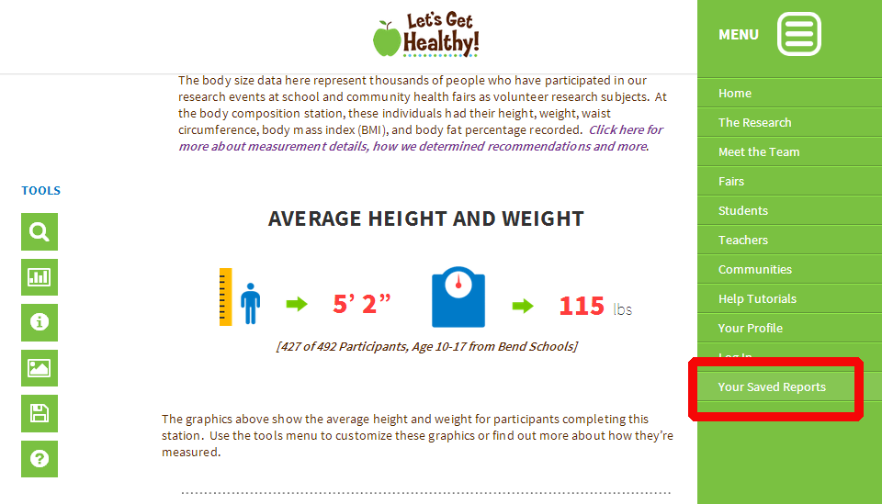
- You will see a list of your saved reports. Click on the one you would like to view.  - You can then take a picture of the infographics using the “picture” tool. | 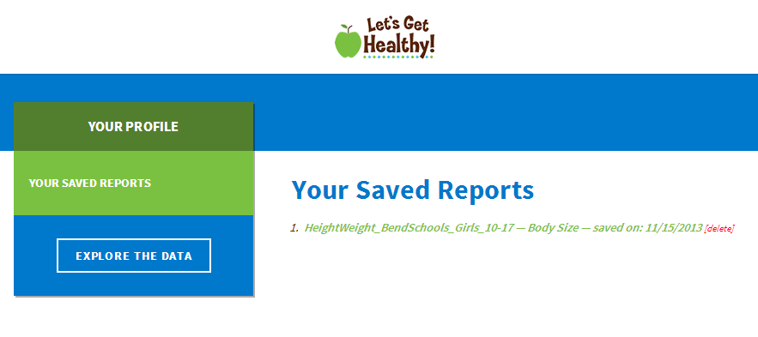

Get more information about the data
As you’re exploring the data, you may be curious about:
- what the measurement is
- how the data were collected
- how we determined recommendations or categories
- where to get more information
These answers can be found under “Station Descriptions”.
- Hover over the information icon and click on “Station Descriptions” | 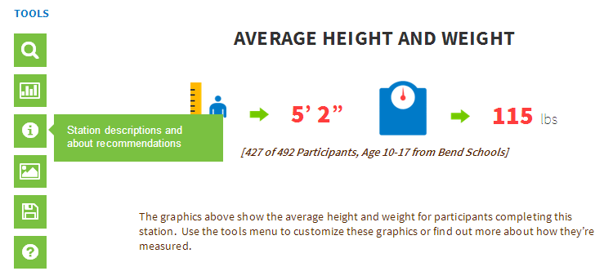
- Each station has its own page with more information. You can use the left menu bar to go to the information pages of other stations.  - You can also scroll down to see more information about  - how the data have been used  - types of research studies  - our data dictionary | 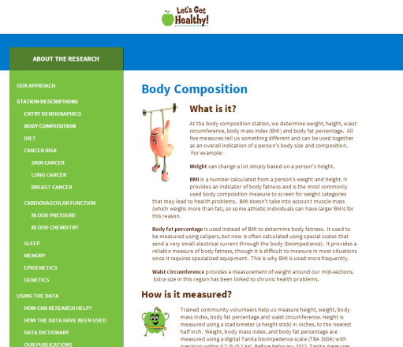

Get help

- If you get stuck at any point, just click on the “Help!” button.  You can also find “Help” in the drop down menu found at the top right of the screen.  - Either will take you to our tutorial pages, which are constantly under development. Just click on the help option that is right for you!  If you have any questions or suggestions, please contact us at lgh@ohsu.edu | 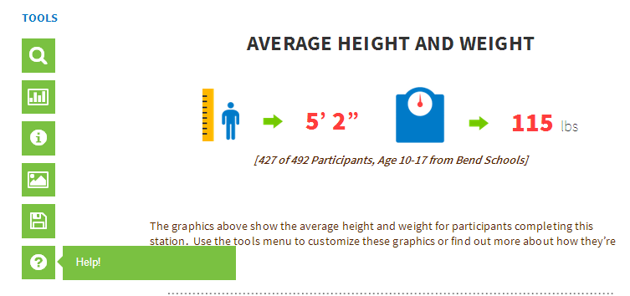

Use SeeIt to explore distributions and correlations
SeeIt is a data visualization and manipulation tool that was developed by Marco Molinaro’s project team at the University of California – Davis. It allows the user to quickly explore data distributions and correlations between variables using drag and drop procedures. All statistical and graphical representations are modified in real time. With every new Let’s Get Healthy! fair, more data are added to SeeIt!

Use SeeIt to explore:
Distributions – which represent the data in dot-plots and/or histograms. There is an extensive feature set that allows you to explore mean, median, mode, user defined groups, and box plots. A sampling engine was also added which allows you to see the effects of sample size on the measures of central tendency.

Correlations – which allow any two datasets to be graphed as an XY pair if they share a common descriptor (for instance, dairy intake versus BMI can be graphed for participants who completed both measures). Use the tools to estimate and/or measure the strength of correlation. A user-defined line and user-defined “balloon” can be used to subjectively visualize the data trend and general fit. For a more objective approach, a median-median line can be drawn. Lastly, a least-squares regression can be graphed along with r-value. As with Distributions, an edit mode allows the user to readily observe the effect of outliers on r-value and regression line in realtime as the data is edited. Lastly, two different regressions can be compared side by side.

Accessing SeeIt
- Hover over the graph icon and click on “SeeIt” | 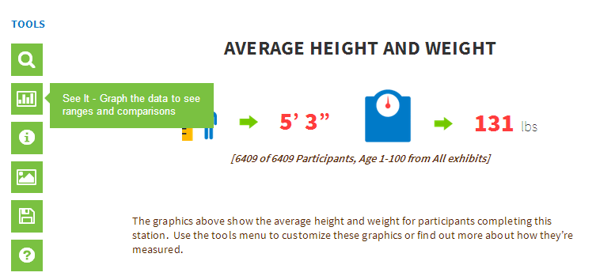
- A pop up will appear with a brief description of what SeeIt does.  Click “Proceed to SeeIt” or select the option to start with the overview and tutorial. | 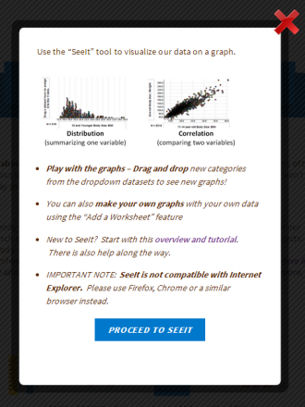
- SeeIt will begin to load and show its progress as “Loading __%”. Remember, it’s pulling data from ALL of our participants, so it will take a little bit to load.  If you close the screen by clicking the red X in the top right of the box, it will go back to the page you were on originally. | 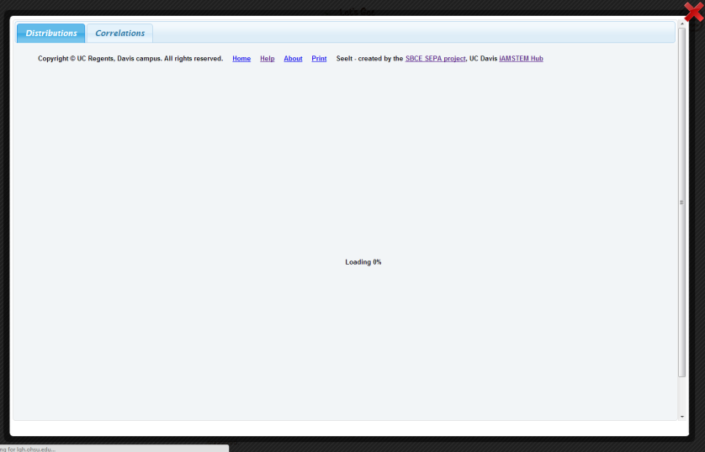

Distributions
Starting with Distributions.  - SeeIt will start with distributions and will load the data from the screen you were just on. (For example, if you came from “Body Size”, it will show body size data. If on the Diet page, it would show diet data.)  - Please note that every computer set up is a little different, so if you can’t see the X axis (horizontal axis), scroll down using the sidebar. | 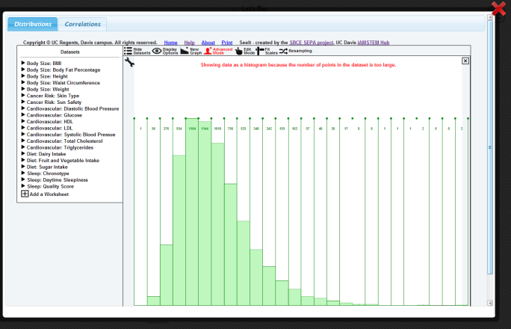
Orienting to the Axes  - Once you see the X axis, you’ll be able to see:  - What is being graphed (in this case, Overall BMI, shown in red box)  - The number of participants that have data for this measurement, shown in blue box  - You’ll also be able to see the data displayed on the histogram. | 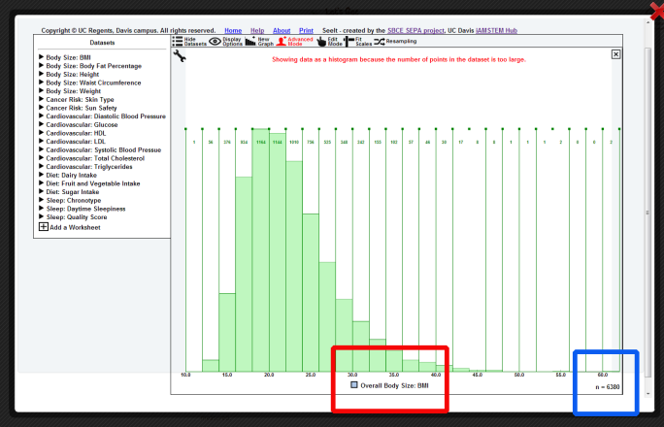
Expanding Datasets  - You’ll notice there are datasets featured in the left side panel. Click on a triangle to expand one of the datasets. For each dataset, you have the following options available:  - Overall  - Female  - Male  - 10 and younger (both genders, representing elementary school)  - 11-14 years old (both genders; representing middle school)  - 15-18 years old (both genders, representing high school)  - Adults (over 18, both genders)  You’ll notice it will tell you the sample size for each. | 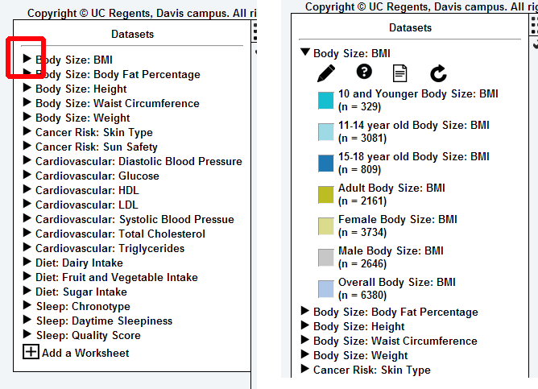
Selecting different data  - Select a different age range (or dataset) by dragging and dropping the desired data onto the X axis (bottom axis). This will put both datasets on the same axis.  - Remove the undesired data by dragging it off the X axis and back towards the datasets. | 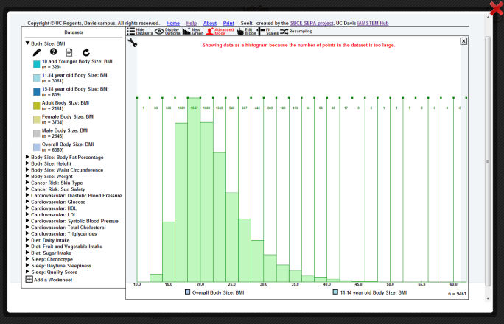
- You will be left with just your desired data (in this case, BMI for 11-14 year olds) | 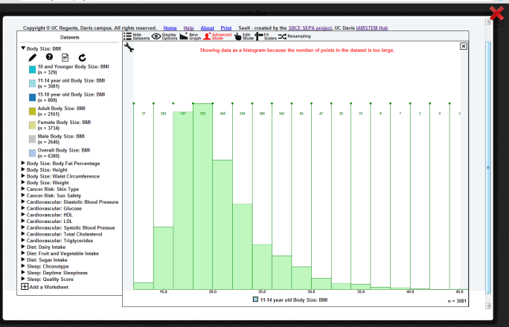
Understanding your data  - Click on the “wrench” (red box) to view the data tools | 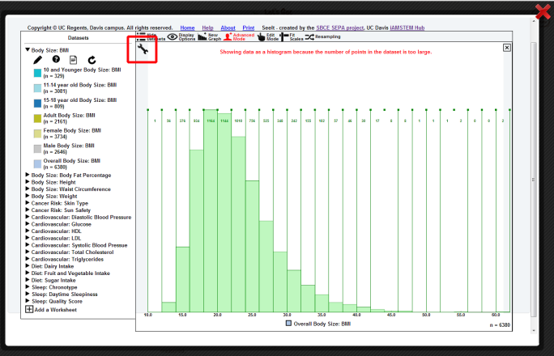
- A drop down menu will appear (descriptions provided below).  Use these tools to play with the data. There are a lot of features available! | 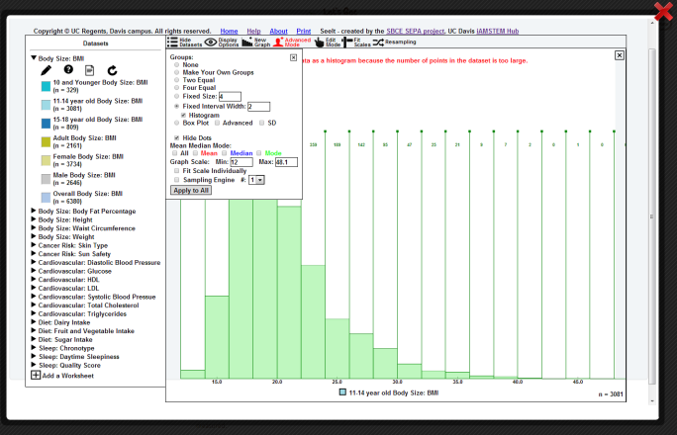
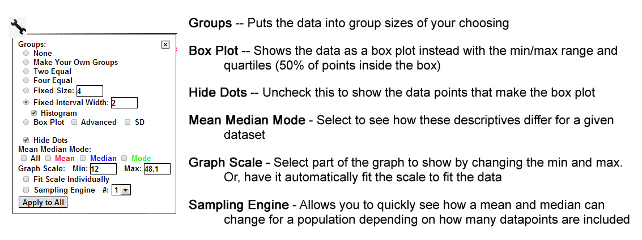
Add a new graph  - Compare two data sets by clicking on “New graph” in the top menu (red box).  - Then drag and drop the data you want into the empty graph space. This will allow you to compare two populations, including how their mean and medians differ. | 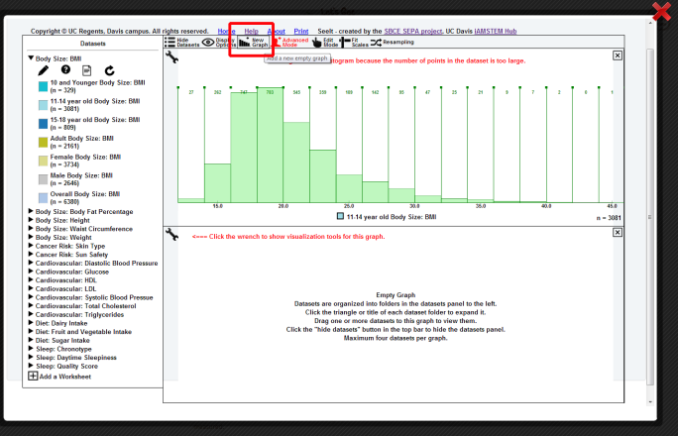
Resampling  - From the “Wrench” toolbox, select “Sampling Engine” at the bottom and #”2”.  This will draw points from the population to show how the mean and median can shift based on the number of datapoints available – and why having more data can provide a better representation of a population’s characteristics. | 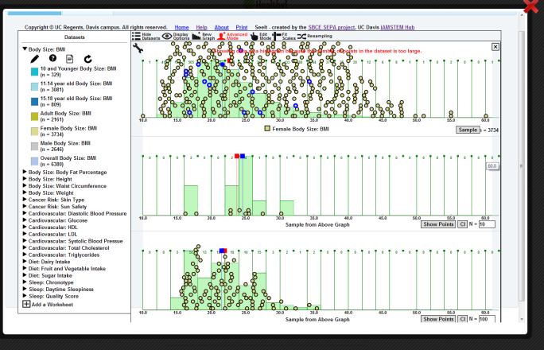

As you can see, there’s a lot of data and options with these tools, so have fun exploring the data! If you have any questions or comments, contact us at lgh@ohsu.edu

Correlations
Moving to Corrrelations  - Click on the “Correlations” tab to load the data needed to explore the relationships between data variables.  - SeeIt will begin to load and show its progress as “Loading __%”. Remember, it’s pulling data from ALL of our participants, so it will take a little bit to load. | 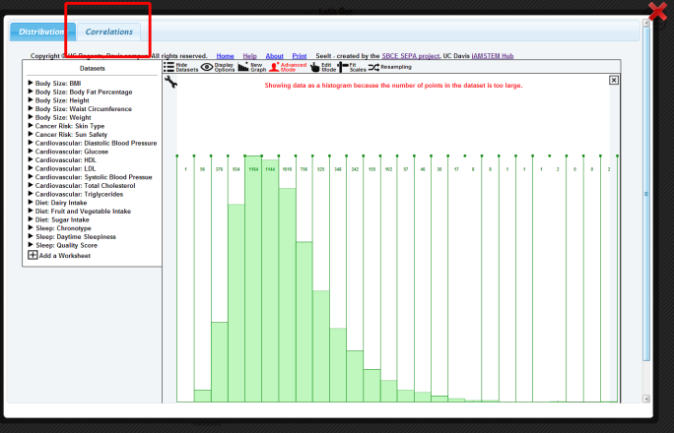
Orienting the Graph  - Please note that every computer set up is a little different, so if you can’t see the X axis (horizontal axis), scroll down using the sidebar. | 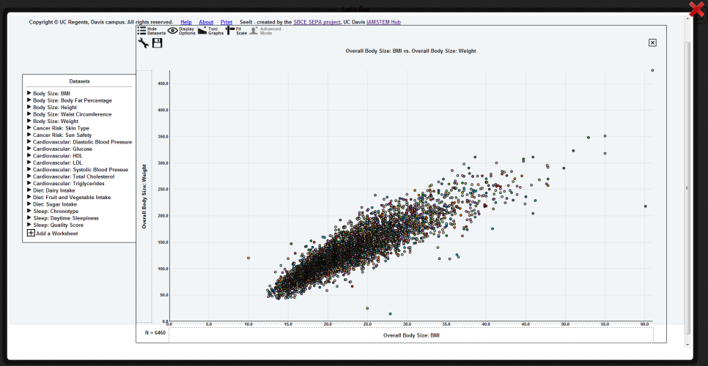
Orienting to the Axes  - Once you see the X axis, you’ll be able to see:  - What is being graphed -- in this case, Overall BMI, (shown in red box) versus Overall Body Weight (shown in blue box)  - The number of participants that have data for both of these measurements, shown in green box. | 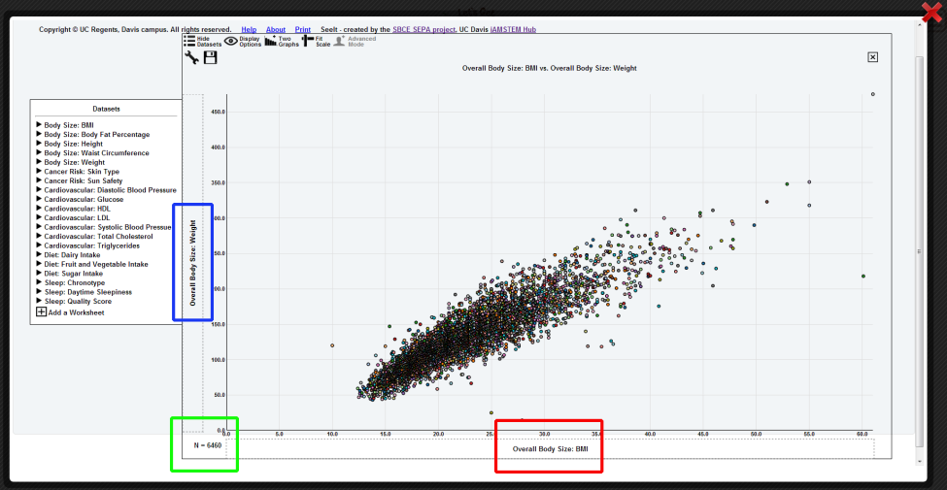
Expanding Datasets  - You’ll notice there are datasets featured in the left side panel. Click on a triangle to expand one of the datasets. For each dataset, you have the following options available:  - Overall  - Female  - Male  - 10 and younger (both genders, representing elementary school)  - 11-14 years old (both genders; representing middle school)  - 15-18 years old (both genders, representing high school)  - Adults (over 18, both genders) | 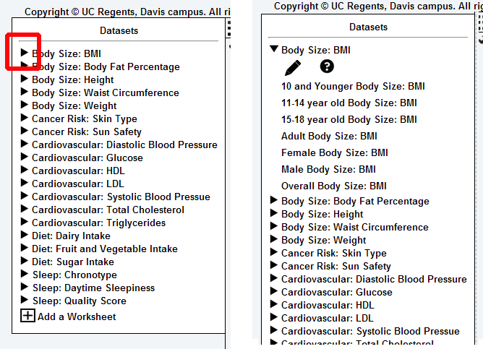
Selecting different data  - Select a different age range (or dataset) by dragging and dropping the desired data onto the X axis (horizontal axis) or Y axis (vertical axis  You’ll notice that the participant number will change a lot. This is because the graph will only show the people who have data for both measures. So even though it is 11-14 year olds on the X axis, it will only be pulling Weight data from those same participants. | 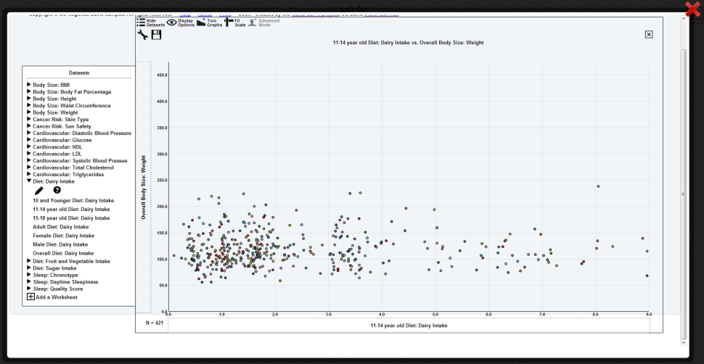
Showing data on a single axis  - You can show a distribution from the correlation data by dragging one of the axis variables away from the graph. In this case, “weight” was removed to leave only “Dairy intake” data from 11-14 year olds | 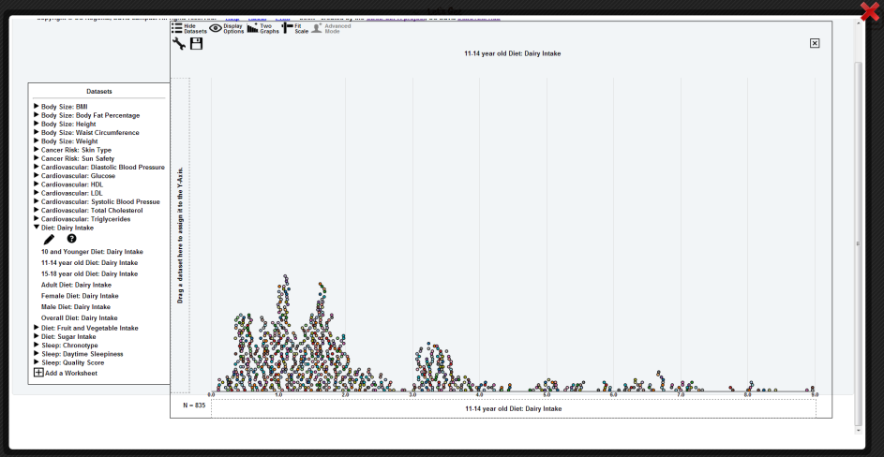
Understanding the data  - Learn more about your data by clicking on the “Wrench” (red box). Note: the “Overall Weight” data were returned to the Y axis for this demonstration. | 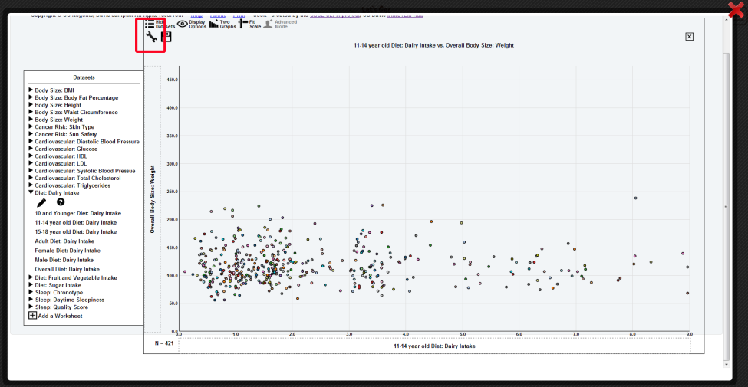
Wrench tools  - These tools are to visualize the strength of a relationship between two variables. If you want to find out the strength of a correlation, select “Least squares” and click on “show line”, “show equation” and “show r value” | 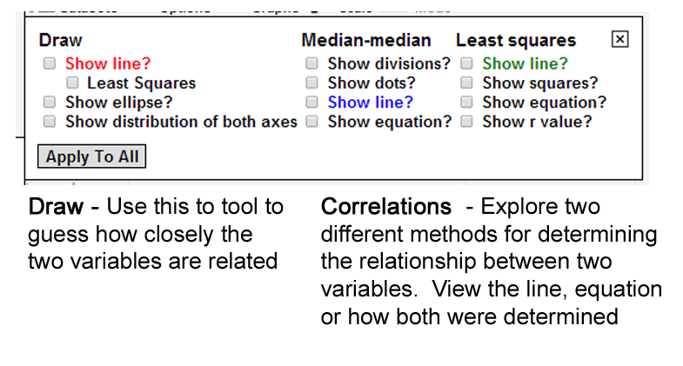
Finding a correlation  - Often, you won’t be able to see the equation because it’s covered by dots. Hover over the line to see the equation and “r” value, which is the linear correlation coefficient and measures the strength and direction of a linear relationship between two variables. | 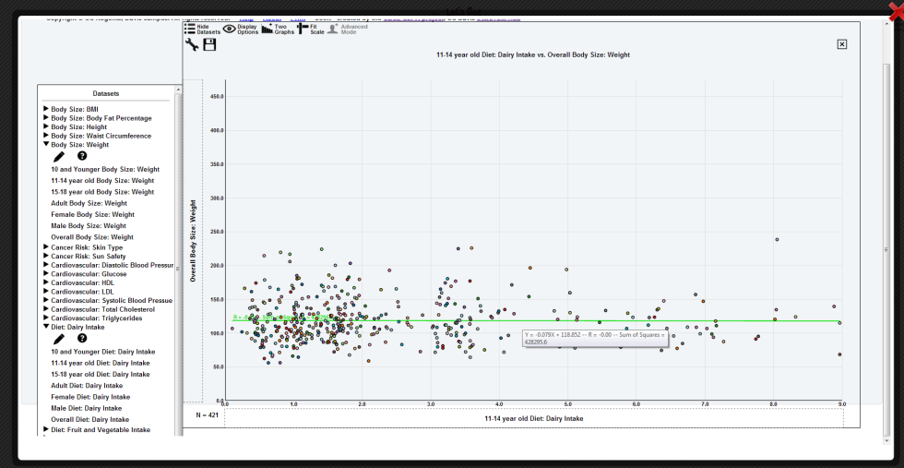
Interpreting a correlation  You can have a positive or negative correlation, or no correlation whatsoever. Look at the r value to determine how closely two variables are related. Keep in mind that an r value of -0.8 is still a strong correlation, just a strong negative correlation! | Strength of Relationship r value  Perfect 1.0  Strong 0.8  Moderate 0.5  Weak 0.3  None 0.1
Other features
- Use “Display Options” to increase dot size or text size.
- Select “Add a Graph” to compare two datasets.
- Select “Fit Scale” to have it autoscale based on the data’s axes

The University of California – Davis team have created a lot of help tutorials and videos for SeeIt. This contains just the basics! Don’t forget to look at some of their help content also!

Frequently Asked Questions (FAQ)

Why aren’t the pictures displaying properly and everything look funny?
This is a browser issue. You’re likely using Internet Explorer, version 8 or below. Try Google Chrome, Firefox, or even updating your browser to a newer version, which is usually free!

I want to select data from our entire state. Can I do that?
Not yet. Currently, you can only select data from one location. In the future, we would like to update this so that you can select more than one location at a time. For example, look at all Oregon locations or all locations from just a particular county.

In the “Explore Data” infographics, it’s showing “427 out of 492 participants”. What does that mean?
You’ll see that 427 people are shown with measurements for height and weight that should match your filter criteria (for instance, people aged 10-17 from Bend school fairs). However, you may notice that it says out of 492 participants. The 492 people represent all people from the Bend event that had measurements completed for height and weight. However, since they are outside the ages of 10-17, they were excluded from the infographic.

I have a lot more questions. Who can I ask?
Send us an email at lgh@ohsu.edu We will update the FAQs with your question as someone else likely has the same one!

