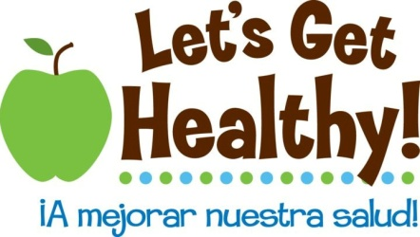

Manipulatives about Epigenetics

There are many excellent genetics models that can be modified to show epigenetic effects. Here are some that we use.

Explaining Methylation
Manipulative models that show how DNA is folded and can be “tagged” with epigenetic marks. Adhesive Velcro is attached to the cytosines and then “tags” can be added and removed as necessary.

Original  DNA starter kit from 3D Molecular Designs  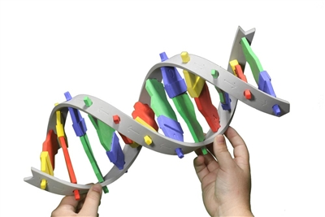  (DNASK20111111) |  | Adapted  Sewed small fabric “methyl” groups that can be attached (left) or removed (right)  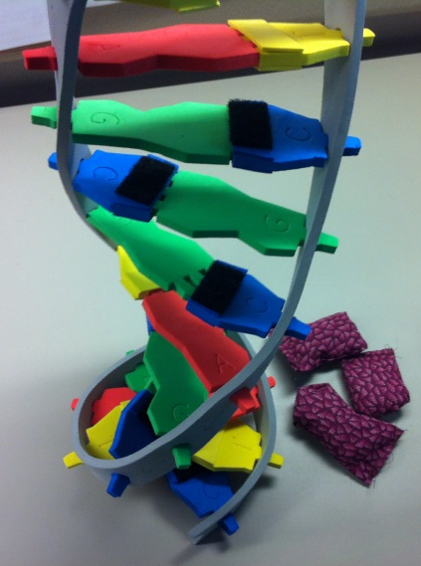
Explaining Histone Acetylation
DNA is wound around histone proteins as a way to regulate transcriptional activity. When it is wrapped tightly, DNA activity is turned down. When it is loose, transcriptional machinery can access the DNA and activity is turned up.

Original  Modeling mini toobers from 3D Molecular Designs  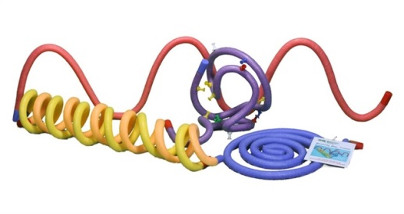  (http://www.3dmoleculardesigns.com/Education-Products/Modeling-Mini-Toobers.htm) | Adapted  Sewed small fabric histones that can be tightened or loosened. As an extension activity, we sewed small magnets inside of fabric the same color (not shown) to show how histone acetylation can change the local charge to repel DNA and loosen it from histones. Optional: can add places to add acetyl groups)

Explaining Epigenetics in General Terms
We often ask if students have any family members who may have an old cookbook that is all marked up. Most will say yes. We then explain how DNA is like that cookbook. In order for it to be “read”, the book has to be open. But with a recipe, often a cook’s previous experience will guide how that recipe is prepared. For example, say you were to make a layer cake. It may say in the cookbook margins that cocoa powder makes a better cake than chocolate chips. Or that the amount of salt should be reduced. Or that if you want to make a big layer cake, you’ll want to double or triple the recipe to be able to make more layers. These are all “epigenetic” effects, where the recipe is still the same on the page, but how that recipe is modified by the cook to give a different product.

Original  An old book from any used store  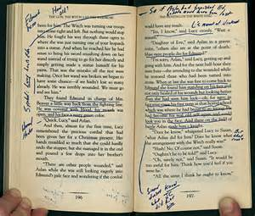 | Adapted  An old cookbook that was covered in brown paper so students wouldn’t get distracted by the cookbook cover. Then, the book is annotated on the inside for ways to improve the recipe. Note: it’s a fine line in this analogy since ingredient substitutions could be considered a “genetic” change (mutation), but this analogy seems to work well as a first pass since the letters of the book are all still there – it’s just the way that they are interpreted which is different.  