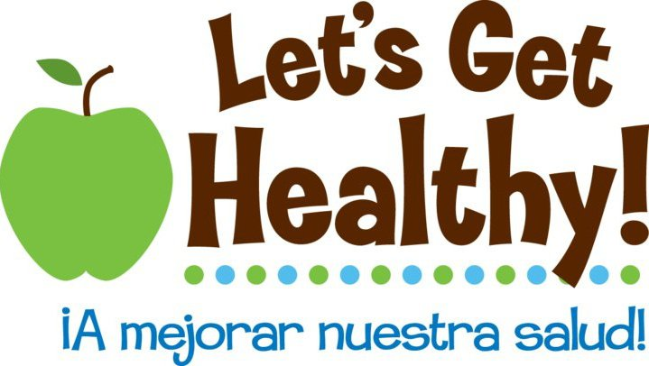 |  | Fair Request Application  For schools

Thank you for your interest in Let’s Get Healthy! Based out of Oregon Health & Science University, Let’s Get Healthy! helps participants learn about their own health while contributing to scientific research. This application enables event requests to be evaluated in a transparent, equitable and systematic manner. While we do offer one-day school events, student impact is strongest when bookended by lessons and discussions in the classroom. Thus, the most successful school applications integrate our overall program rather than requesting an event alone.

NUMBER OF EVENTS A YEAR: We are primarily grant-funded, which means that our grants dictate the number of events and the audience that we’re able to serve in a given time period. Please refer to our website (http://lgh.ohsu.edu) to see the number of events we are able to offer in the coming years.

PLANNED REVIEW SCHEDULE: Applications are reviewed by our Application Committee three times a year in accordance with the following schedule. The schedule is designed to permit ample time to prepare together for your event.
Application Due Date | Application Review | Notification Date | For Fair Dates
January 1 | January 15 | January 20 | September – December (fall fairs)
May 1 | May 15 | May 20 | January – May (spring fairs)
November 1 | November 15 | November 20 | June – August (summer fairs)

SELECTION PROCESS: Our Application Committee includes representatives from OHSU, schools, communities, and workplaces (please see our website for a current list). Applications are reviewed based on:
- Matching the audience with the scope of our grants. For example, if we are only funded to conduct school events during a spring period, then we give priority to school audiences during that period.
- Unmet need. We give priority to applications from schools with one or more of the following characteristics: rural location, low socioeconomic status, high racial or ethnic diversity, high health need (as determined by high obesity rates, poor dietary practices, or other characteristics that makes your population qualify as high health need).
- Commitment to partnership and impact. The strongest applications are from groups who will play an active role in extending the impact of their event. For schools, this could involve using the lesson plans and supporting materials to bookend the experience and/or using the data for needs assessments, writing grant proposals or helping to guide program and/or policy decisions.
- Commitment to evaluation. We place high priority on schools who can assist us in evaluating the impact of the event. This evaluation piece is critical to our research in education and scientific areas. It is also a requirement for all of our grant-funded projects.
- Considerations about winter travel. We use a large rental truck to transport our equipment and staff. Safety is a high priority, and we will not travel if roads are closed due to snow/ice. Please plan your fair date to account for the weather in your region.

If you have questions, please don’t hesitate to contact us! We look forward to receiving your application!

About our School Projects
We are currently have two grant-funded school projects for which we are looking for secondary school partners. More information on what each of these projects entails (including timelines, incentives and expectations) can be found on our website. Our teacher guide and lesson plans can also be found on the website.

We recognize that these specific projects may not be right for your school. If so, please feel free to submit your application as a request for a general school event (see page 6 for requirements), that is, an event not connected with either of the projects detailed below.

“CHIDR Chatter” -- The Community Health Interactive Data Resource (CHIDR) provides teachers and students web-based access to community-specific research data generated from the Let’s Get Healthy! education and research event held in their school/community. Schools will be able to use the data-gathering fair and student analysis of local data on CHIDR as a method of engaging students in understanding how personal and group decisions can impact heath issues. Through partnerships within the community, students can participate in the translation of research data into policy or education that supports public health in their own community.

Methods: Your school will receive a Let’s Get Healthy! fair for its students that opens to the public (parents, community members) later that evening or the following day. To prepare for this event, your school will create a five-member working group to plan and develop goals for how you’d like to use the resulting data. The goal of this group is to help the school and its students use the data gathered from the fair for policy, community education, or future grant applications that improve health and awareness about local issues in the school or community.
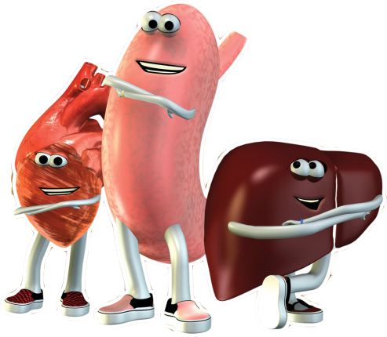
- This working group will participate in two single-day workshops held in your community – one in summer; the other two months after your fair (stipend/substitute costs covered; we will attend and bring experts to help you with the process). Your working group should consist of a mix of school and community partners who provide a range of experience. Examples could include school partners (teachers, school nurses, librarians, administrators); public health partners (public health practitioners, public health officials, local or regional decision-makers); and other facilitators (individuals or organizations who have specialized training or experience in communication, public relations, and translation of research into policy or educational applications). We can help you identify potential partners in your community, if needed.
- Evaluation will occur through anonymous surveys of students and teachers (at end of current school year, beginning of following school year, and end of following school year). Working group members will also participate in interviews.

“Epigenetics” – The environment can have a big impact on our genes. Many individuals are unaware that their eating habits, often established early in life, can affect the health of their future families. One of the true strengths of epigenetics (how the environment affects our genes) lies in the fact that it allows individuals to elicit more control over what were previously thought to be irreversible genetic predispositions to disease. This project introduces middle school children and teachers to epigenetics and specifically to how dietary behavior in one generation may alter disease risk for future generations. This project requires commitment to use associated lesson plans and a commitment to student and teacher evaluation.

Methods: Your school will receive a Let’s Get Healthy! fair for your students that includes our new epigenetics module and associated lesson plans. Evaluation will occur through anonymous surveys of students and teachers (at end of current school year, beginning of following school year, and end of following school year).

Fair Request Application
For schools

ABOUT YOU
- Please tell us how we can contact you as a representative of your school.
School Name:
Contact Name:
Contact Email Address:
Phone Number
Best time to reach you

TIMEFRAME OF EVENT:
- This application is for:
Fall Term: |  | Spring Term: |  | Summer Term:

- Please indicate the project(s) for which you would like to be considered. If you are interested in multiple projects, please rank them.
CHIDR Chatter | Yes: |  |  | Rank
Epigenetics | Yes: |  |  | Rank
General Event | Yes: |  |  | Rank

- Would you like to be notified about being involved with future projects?
 | Yes: |  | No
Since we are grant-funded, we often look to partner with schools on new grant applications. These typically involve the school writing a letter of support for Let’s Get Healthy! indicating potential interest in the project. Projects vary in scope and could include, for example, hosting an event or helping develop a new module. Indicating “yes” is not binding and does NOT affect the chances of your current application being selected or deferred. You would be able to learn about the project before agreeing to participate!
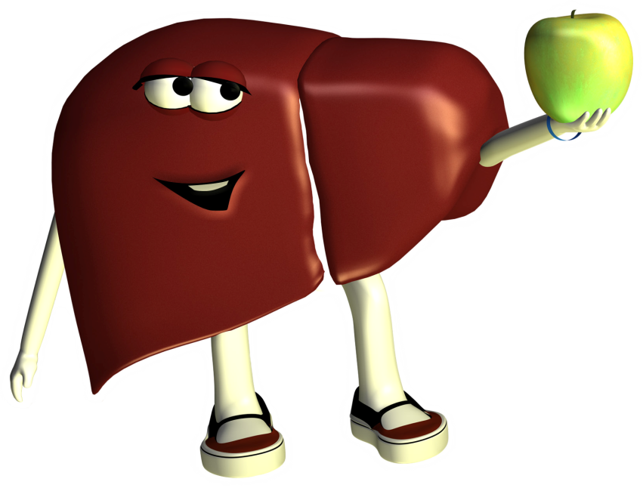

ABOUT YOUR SCHOOL

- Please tell us more about your school.
Address
City, State & Zip
Phone Number
Principal’s Name
District
Grades served

- Please supply the following information based on reports to your District and your state’s Department of Education. Your school secretary should be able to help you with these. We have also provided an online resource for additional information.
- Total student enrollment at your school (please indicate source and year of data)
________________________________________________________________________
- Please describe the race and ethnicity of your population.
You can also find these data from: http://nces.ed.gov/globallocator/.
 | Number of students | % of total students
American Indian/Alaska Native
Asian/Pacific Islander
Hispanic or Latino
Black, non-Hispanic
White, non-Hispanic
More than one race
Unknown or Not Reported

Source and Year of Data
- What percent of the school’s students qualify for free and reduced lunch?
Free eligible (%)
Reduced eligible (%)
- What percent of your school’s students qualify for ESL (English as a Second Language) or
ELL (English Language Learner) support? __________________

ABOUT YOUR EVENT

- When would you ideally like to hold your event? Please note that school events are typically held in the spring and/or fall.
We have a specific date(s) in mind for our event.
We have a preferred date(s), but could be flexible.
The event date(s) is/are very flexible.

- Please describe the date(s) of your event. If you have flexibility, please indicate other month(s)/date(s) you would consider.

- Have you (or another member of your school) previously applied for a Let’s Get Healthy! event?
No: |  |  | Yes: |  |  | If so, when?:

- Have you (or another member of your school) previously attended or been involved in a Let’s Get Healthy! event?
No: |  |  | Yes: |  |  | If so, where?:

- Has your school previously hosted events similar to Let’s Get Healthy! (for example, wellness fairs, science fairs, etc.)? If so, please briefly describe.

- Please briefly describe your desired event and audience. Please indicate if the desired event involves one school or multiple schools within your district.

- How many people do you expect to participate in your Let’s Get Healthy! event? How did you come up with this estimate?

FEASIBILITY AND IN KIND SUPPORT
Running a Let’s Get Healthy! event is Very Fun! and also very time-intensive. A successful school event requires the active participation of the partnering school during the planning and implementation process. Please explain how your school will provide each of the following. If you are unable to do so, please explain why not (your application will still be considered).

- Who is your event’s dedicated point of contact? Please select a person who will be a reliable and responsive point person. This person can be a school counselor, science teacher, school administrator, parent representative, etc. He/she will be the go-to person to plan and implement your school’s event, including helping us with: reserving the space, determining the school bell schedule, coordinating with teachers about the event, and conducting the pre- and post-event evaluations.
Name
Email Address:
Phone Number:
Method of preferred contact:

- Please describe the location for your event. Include general dimensions and number of electrical outlets. Events are typically held in a school gymnasium or community center.

Is the space wheelchair accessible? | Yes: |  |  | No:
Are there bathrooms nearby? | Yes: |  |  | No:
Can this location be reserved 6-18 hours in advance (overnight set-up) and 3 hours after the event to allow for breakdown? | Yes: |  |  | No:
Does a floor plan for this space already exist? | Yes: |  |  | No:
Can you provide tables for the event? (typically 15-30) | Yes: |  |  | No:
Can you provide chairs for the event? (typically 30-60) | Yes: |  |  | No:

- We can accommodate more students through the stations when we’re able to borrow school computers for the event. Please describe if you are able to loan computers for the event and, if so, approximately how many. Please also indicate if your school has a technical support person who would facilitate this loan. Our website has more information about system requirements.

- Parental Involvement and Notification: Because we are an education and anonymous RESEARCH exhibit, it is very important that parents are well-informed about the event. Please indicate if you would offer an opt-in or opt-out permission slip process to inform parents. Please note that the schools manage this process to maintain student anonymity.
Opt-in: |  |  | Opt-out:

- Volunteer Recruitment and Marketing: Our events are volunteer-run and, while we provide the training, we need your help with recruitment of parents and community volunteers. Please describe how your school would assist with volunteer recruitment and promoting the event. (Parent Teacher Student Association, partners in the community, automated home phone calls, school or town newsletter, etc). We typically have 12 or more volunteers per 4 hour shift, or 24 throughout the school day.

- Evaluation: We evaluate all of our efforts – for our research and for our grant funders. Evaluation typically occurs through pre- and post-surveys given to students and teachers. These surveys are anonymous and administered by teachers as part of the school day (10-15 min). These surveys are typically given the end of the previous school year (which provides an age-matched control group), at the beginning of the subsequent school year (pre-test) and then again at the end of the school year (post-test). We provide survey packets to schools well-labeled and the school secretary helps us by managing the distribution and return of the surveys.
Is your school committed to helping us with these evaluation efforts?

STATEMENTS OF SUPPORT
Please submit with this application the following materials. If you’re interested in applying for multiple projects (e.g. CHIDR and Epigenetics), please complete only the CHIDR set of documents and adjust your one-page statement to reflect interest in both projects. You only need ONE letter of support from your principal.

For CHIDR Chatter:
- A letter of support for your application from your principal.
To help you with this, we have enclosed briefing pages for your principal about the program, the incentives, and expectations. (pages 7 and 8 of this document)

- A one page statement about why your school is interested in the program, including but not limited to:
- How the event will be supported in the classroom and fit with other classroom and school activities
- How you will use the associated curriculum and lesson plans (see website for details)
- How your school would use your resulting fair data to meet your school’s health or wellness goals

- A brief description about who would make up your five-member working group:
Please select a mix of school and community partners who would provide a range of experience. Examples could include school partners (teachers, school nurses, librarians, administrators); public health partners (public health practitioners, public health officials, local or regional decision-makers) and other facilitators (individuals or organizations who have specialized training or experience in communication, public relations and translation of research into policy or educational applications). This group will work together throughout the year and participate in two single day workshops held in your community. If you have questions about who to include or need suggestions, please contact Lisa Marriott (marriott@ohsu.edu/503-494-8775).

- A letter of support from a community partner who would be on your working group.
To help you with this, we have enclosed briefing pages for you to give to this person (pages 9 and 10 of this document)

For Epigenetics:
- A letter of support for your application from your principal.
To help you with this, we have enclosed briefing pages for your principal about the program, the incentives, and expectations. (pages 7 and 8 of this document)

- A one page statement about why your school is interested in the program, including but not limited to:
- How the event will be supported in the classroom and fit with other classroom and school activities
- How you will use the associated curriculum and lesson plans (see website for details)
- Student/teacher background with genetics/epigenetics (applications from groups with no or minimal background will still be considered)

For General Events:
- A letter of support for your application from your principal.
To help you with this, we have enclosed briefing pages for your principal about the program, the incentives, and expectations. (pages 5 and 6 of this document)

- A one page statement about why your school is interested in the program, including but not limited to:
- How the event will be supported in the classroom and fit with other classroom and school activities
- How you will use the associated curriculum and lesson plans (see website for details)
- How the event fits within your school’s health or wellness goals.

Please mail the application and statements of support in one envelope by the deadline on page 1 to:
Let’s Get Healthy! - OHSU
3181 SW Sam Jackson Park Road, L606
Portland, OR 97239
https://lgh.ohsu.edu

Principal Information Sheet and Request for Statement of Support

School Involvement and Your Statement of Support:

You are being given these information pages because one of your staff is applying to have a Let’s Get Healthy! education and research event at your school and needs a statement of support from you.

Each year of the program, we will select 2-3 middle schools to participate. Because we want to be sure the school environment is supportive of participation, we need a letter from you indicating any strengths or abilities that make your school a particularly good candidate for this program and affirming that you understand that your school (if selected):
- will receive an interactive education and anonymous RESEARCH event for your students
- will assist with the implementation of the event (e.g. parental notification, space arrangements, logistics, volunteer recruitment)
- will receive a teacher guide and lesson plans for use with your students
- will receive summary data about the health of your school – but not information about individual students
- will be asked to conduct an anonymous survey of teacher and student attitudes and understandings regarding health topics. These surveys occur at the end of this current school year (age-matched control test), at the beginning of the next school year (pre-test) and again at the end of the school year (post-test). This assessment of outcomes is required for our research and federally-funded grant.

If your school applied and is selected for the “CHIDR Chatter” project, your school will also:
- receive an additional community event to be held after your school’s event for parents and the public
- select community group partners to enhance the impact of these events
- have representative(s) from your school participate in two one-day workshop meetings – one during the summer and the other during the school year (stipend/substitute costs covered by the grant)
- receive a stipend of $1000 to implement the program events. Money can be used for facility rental fee (if not in school gym), organizational costs, or other fair costs identified by the five-member working group.

Please provide a brief letter stating your support of your school’s participation. Place the letter in a sealed envelope, with your signature on the flap, for your school to include with the application.

Please also include this sheet with your signature below.

By signing below, you are confirming that you have read the conditions outlined above, which will apply should your school be accepted to the Let’s Get Healthy! program. You also acknowledge the research aspects of this project.

Signed | Date

If you have questions or comments, please contact Lisa Marriott, Ph.D., OHSU Let’s Get Healthy!
503-494-8775, marriott@ohsu.edu

Principal Information Sheet

About the Let’s Get Healthy! Program:
Let’s Get Healthy! is an education and research program at OHSU that invites the public of all ages to learn about their own health while contributing to scientific research. Attendees are invited to enroll as ANONYMOUS research participants where they learn about the research process and receive immediate feedback about the quality of their own diet, sleep, body composition, and other health measures. We do not ask for names of participants, but instead collect data on their age, gender, race, and ethnicity. Attendees can contribute their anonymous health information to a population database that researchers can use to the study the relationships among these health factors. Schools and communities also have access to the anonymous data, which can be used to teach scientific inquiry to students (using authentic, local data) and to encourage healthy living in their communities.

Let’s Get Healthy! fairs are run by volunteers of all backgrounds. They often take place in a school gymnasium in collaboration with participating school and communities (there is a three-minute video about our school events on our website). Since 2007, more than 10,000 people around the country have participated in the health fairs and enrolled as research participants. The program is made possible by grants from the National Institutes of Health (NIH). We currently have two projects ongoing in schools. Both require a commitment to using associated lesson plans and anonymous evaluation of teachers and students:

“CHIDR Chatter” – The Community Health Interactive Data Resource (CHIDR) provides teachers and students with web-based access to community-specific research data generated from the Let’s Get Healthy! education and research event held in their school and community. Schools are able to use the data-gathering fair and student analysis of local data on CHIDR as a method of engaging students in understanding how personal and group decisions can impact heath issues. Through partnerships within the community, students can participate in the translation of research data into policy or education that supports public health in their own community.

“Epigenetics” – The environment can have a big impact on our genes. Many individuals are unaware that their eating habits, often established early in life, can affect the health of their future families. One of the true strengths of epigenetics (how the environment affects our genes) lies in the fact that it allows individuals to elicit more control over what were previously thought to be irreversible genetic predisposition to disease. This project introduces middle school children and teachers to epigenetics and specifically to how dietary behavior in one generation may alter disease risk for future generations.

Jackilen Shannon, PhD, OHSU  program director  Lisa Marriott, PhD, OHSU  program associate director  Berk Moss, MST  science education consultant | Paul McGinnis, MPA, OHSU  community liaison  Adam Lipus, BA, OHSU  program coordinator  Stephano Cetola, BA, OHSU  program informatics | Raina Croff, PhD, OHSU  project evaluation  Zunqiu Chen, MA, OHSU  project evaluation  Marco Molinaro, Ph.D, UC Davis  program collaborator

“CHIDR Chatter:”
Community Health Interactive Data Resource

https://lgh.ohsu.edu

Community Partner Information Sheet and Request for Statement of Support

Community Involvement and Your Statement of Support:

You are being given these information pages because a member of your local school is applying to have a Let’s Get Healthy! education and research event for their students and community and needs a statement of support from you.

Each year of the program, we will select 2-3 middle schools to participate. Because we want to be sure the community environment is supportive of the school’s participation and can help in expanding the use of the resulting data, we need a letter from you indicating any strengths or abilities that make your school and community a particularly good candidate for this program and affirming that you understand that your community (if selected):
- will receive a free interactive education and RESEARCH event for the school. This event opens to the public later that evening or the following day so that parents and other community members can attend as well.
- will receive summary data about the health of your school and community – but not information about individual students or community members
- will work with your local school to enhance the impact and reach of these data collection events
- will provide representation from your community who will participate in two one-day workshop meetings – one during the summer and the other during the school year (minor stipend covered by the grant)
- will participate in pre-/post-interviews and evaluation surveys to understand how school and community use of data are being received (evaluation component for our grant)

Please provide a brief letter, stating your support of your school’s participation and your involvement as a community partner. Place this letter in a sealed envelope, with your signature on the flap, for your local school to include with their application.

Please also include this sheet with your signature below.

By signing below, you are confirming that you have read the conditions outlined above, which will apply should your school and community be accepted to the Let’s Get Healthy! program. You also acknowledge the research aspects of this project.

Signed | Date

If you have questions or comments, please contact Lisa Marriott, Ph.D., OHSU Let’s Get Healthy!
503-494-8775, marriott@ohsu.edu

“CHIDR Chatter:”
Community Health Interactive Data Resource

Community Partner Information Sheet

About the Let’s Get Healthy! Program:
Let’s Get Healthy! is an education and research program at OHSU that invites the public of all ages to learn about their own health while contributing to scientific research. Attendees are invited to enroll as research participants where they learn about the research process and receive immediate feedback about the quality of their own diet, sleep, body composition and other health measures. Attendees can contribute their anonymous health information to a population database that researchers can use to the study the relationships among these health factors. Schools and communities also have access to the anonymous data, which can be used to teach scientific inquiry to students using authentic, local data and encourage healthy living in their communities. All information collected is completely anonymous.

Let’s Get Healthy! fairs are run by volunteers of all backgrounds. They often take place in a school gymnasium in collaboration with participating school and communities (there is a three-minute video about our school events on our website). Since 2007, more than 10,000 people around the country have participated in the health fairs and enrolled as research participants. The program is made possible by grants from the National Institutes of Health (NIH).

You have been identified as a potential community partner for:

“CHIDR Chatter” – The Community Health Interactive Data Resource provides teachers and students with web-based access to community-specific research data generated from the Let’s Get Healthy! education and research event held in their school and community. Schools are able to use the data-gathering fair and student analysis of local data on CHIDR as a method of engaging students in understanding how personal and group decisions can impact heath issues. Through partnerships within the community, students can participate in the translation of research data into policy or education that supports public health in their own community.

Jackilen Shannon, PhD, OHSU  program director  Lisa Marriott, PhD, OHSU  program associate director  Berk Moss, MST  science education consultant | Paul McGinnis, MPA, OHSU  community liaison  Adam Lipus, BA, OHSU  program coordinator  Stephano Cetola, BA, OHSU  program informatics | Raina Croff, PhD, OHSU  project evaluation  Zunqiu Chen, MA, OHSU  project evaluation  Marco Molinaro, Ph.D, UC Davis  program collaborator

